**Project Title: DIA Library System**

**Name: Apurba Debnath**

**NCC-ID: 00155430**

# Abstract

Now day’s proficient computerized library management system will improve the adequacy of the library. A decent library management system should empower librarian to manage library resources in a more effective way to save time and effort. So that, I am interested to make such computerized library management system in order to enhance the presentation of a library and reduces the chance of all kind of human mistakes and reduce the cost of managing a library and also saves time and all kind of effort belongs with it.

Table of Contents

Abstract 2

Acknowledgement: 9

1. Project Initiation 10

Project Description: 12

Problems with the current system are given below: 12

Proposed solutions for the problems: 13

Alternative solution: 14

Chosen solution: 15

Aims and Objectives: 15

The following objectives of proposed system: 16

Justification of Methodology 17

Dynamic System Development Method (DSDM): 18

2. Feasibility Study 19

Economic feasibility: 20

Operational feasibility: 21

Technical feasibility: 22

Ethical feasibility: 23

3. Requirement Specification 24

Introduction: 24

Functional requirements: 24

Non-functional requirements: 25

Prioritization of functional requirements 26

Use case diagram: 28

System Architecture: 30

Technical architecture: 30

Overview of the technical architecture for this system development: 31

Class diagram: 32

Summary: 32

4. Design Specification 33

Introduction: 33

Activity diagram: 33

Entity Relationship Diagram: 40

Data dictionary: 41

Summary: 45

5. Test plan 45

Introduction: 45

Test plan objectives: 45

Functions to be tested: 46

Test Strategies: 47

Unit testing: 47

Integration testing: 48

System testing: 48

6. Development 49

Introduction: 49

Platform specific development: 49

Reason for the chosen platform: 49

Summary: 50

7. Test execution and results 50

Integration testing: 58

System Testing: 68

Sign up or User registration portion testing: 68

Part-1: 68

Description: 68

Part-2: 69

Description: 69

Part-3: 70

Description: 70

Part-4: 71

Description: 71

Part-5: 72

Description: 72

Login portion testing: 73

Part-1: 73

Description: 73

Part-2: 74

Description: 74

Part-3: 75

Description: 75

Password retrieves portion testing: 76

Part-1: 76

Description: 76

Part-2: 77

Description: 77

Part-3: 78

Description: 78

Part-4: 79

Description: 79

Part-5: 80

Description: 80

Part-6: 81

Description: 81

Home page testing: 82

Part-1: 82

Description: 82

Part-2: 83

Description: 83

Part-3: 84

Description: 84

Part-4: 85

Description: 85

Part-5: 86

Description: 86

Part-6: 87

Description: 87

Part-7: 88

Description: 88

New Book portion testing: 89

Part-1: 89

Description: If the fields are empty. 89

Part-2: 90

Description: If the fields are empty. 90

Part-3: 91

Description: In order to add new book information. 91

Part-4: 92

Description: 92

Part-5: 93

Description: In order to update a book’s information. 93

Part-6: 94

Part-7: 95

Description: In order to delete a book’s information. 95

Part-8: 97

Part-9: 98

Description: 98

New Student portion testing: 99

Part-1: 99

Description: If the fields are empty. 99

Part-2: 100

Description: 100

Part-3: 101

Description: In order to add new student information. 101

Part-4: 102

Description: 102

Part-5: 103

Description: In order to update a student’s information. 103

Part-6: 104

Part-7: 105

Description: In order to delete a student’s information. 105

Part-8: 108

Part-9: 109

Description: 109

Borrow Book portion testing: 110

Part-1: 111

Description: 111

Part-2: 112

Description: 112

Part-3: 113

Description: 113

Part-4: 114

Description: 114

Part-5: 115

Description: 115

Part-6: 116

Description: 116

Part-7: 117

Description: 117

Part-8: 118

Description: 118

Part-9: 119

Description: 119

Part-10: 120

Description: 120

Part-11: 121

Description: 121

Part-12: 122

Description: 122

Part-13: 123

Description: 123

Return Book portion testing: 124

Part-1: 125

Description: 125

Part-2: 126

Description: 126

Part-3: 127

Description: 127

Part-4: 128

Description: 128

Part-5: 129

Description: 129

Part-6: 130

Description: 130

Part-7: 131

Description: 131

Part-8: 132

Description: 132

Statistics portion testing: 133

Part-1: 133

Description: 133

Part-2: 135

Description: 135

Part-3: 136

Description: 136

Part-4: 137

Description: 137

Part-5: 138

Description: 138

Part-6: 139

Description: 139

Part-7: 140

Description: 140

Part-8: 141

Description: 141

Part-9: 142

Description: 142

Part-10: 143

Description: 143

Part-9: 144

Description: 144

Part-1: 145

Description: 145

Part-2: 146

Description: 146

Part-3: 147

Description: 147

Usability testing: 148

8. Implementation 150

Introduction: 150

Implementation Plan: 150

These are described below: 151

Data Migration: 152

Training: 152

9. Critical Appraisal 153

Introduction: 153

System strengths: 153

System weakness: 153

Further development: 154

Conclusion: 154

References: 155

Appendices 156

1. Requirement Catalogue: 156

2. Use Case description: 157

About use case diagram: 157

Explanation of the use case diagram of the system: 157

3. Test script 158

User Guide 168

# Acknowledgement:

First of all, I am grateful to my God for blessing me which help me to do this project properly. Then, I am thankful to our module instructor Mohammad Azizur Rahman sir for his proper guidelines and instructions. Without his support, it was totally hard to complete without any previous experience and within this short time also. He was so much helpful to us. After that, I want to thank my parents for their support and caring.

# 1. Project Initiation

**Introduction:**

Due to make a computerized library management system, first of all, I have made necessary investigation of my current project. I have researched on many library management systems like web and mobile application of it. This documentation part will provide the information about the background study of project, the main description of my project, the problems related to this current system, aims and objectives of the proposed system, methodologies and techniques which are considered for the better development of the project and about all the justification and feasibility of the project.

**Project background Study:**

Today an integrated and computerized Library system is essential for schools, colleges and universities library. It helps to increase the efficiency of the library and reduces the cost of managing a library and also reduces the all kind human mistake for managing a library. It also saves time and effort. (Mazonde, 2017) So I want to make such system which include many useful features for managing a library and which is also important for students and teacher for their learning purpose. The System will help librarian to manage a library in an easy way and it will avoid all types of human mistakes. Students can easily borrow and return book according to their requirement from librarian and librarian can easily store those information. Librarian can add book’s information and also can add student’s Information. According to that information, librarian can also store all the information about Issued and Return details of book and also provide book for each student in an effective way. It will enhance the presentation of the library. It also saves time and cost of managing library. Librarian can also print the current report about issued book details and return book details and can also take screenshot of that current report.

# Project Description:

# Problems with the current system are given below:

1. The library management system required to be secure and securely logged. So, all the complexity of security need to considered. It shouldn’t accessible publicly and for all. Only authenticate user can be logged in that system.
2. After that, there should be a password recovery system so that the only authenticate user can retrieve their password with a security requirements if they forgot.
3. After that, In order to make user friendly GUI and standard system software, a home page as like as a dashboard is required for the system so that the only authenticate user such a librarian can easily find all required information in one place.
4. Library means there are many books and there can be huge information about each book. So, every book should be uniquely identified. But among them specific which book is required for a specific student this should be checked instantly as the requirement for a student.
5. Another important fact is only registered student can issued any book from this system. So, it is necessary to make such checking system whether the student is valid for this service or not.
6. On the other hand, it should be also considered that which book is issued by which student and the book is returned in timely or not.
7. Another fact is that there should be a statistic of borrow and return details as a report and also required a printing capability of that report.

The system I have proposed is called “DIA Library System”. The primary features of this system is to make a securely login system for the user. So that only authenticate user can be logged on this proposed system. This user can be a librarian of a library. The system will required to fulfill all the functionality that I have find out as a current problems of this proposed system.

# Proposed solutions for the problems:

1. At first, I will develop such system where user that means librarian has to register with a specific username and password and a security question. If librarian or user forgot that password, I will create such system in the login section so that librarian can easily retrieve that password with the answer of that security question.
2. In order to make user friendly GUI as homepage, I will create some sections like “Add New book”, “Add New Student”,” Borrow Book”, “Return Book” ,” Statistics” and “About”. In “Add New book” section as like as a dashboard which will help the authenticate user such a librarian to find all required information in one place easily.
3. In “Add New book” section, I will create such system where librarian can easily store all information about every book in the library and also will create a table in that section where all the information will show.
4. In “Add New Student” I will create such system where section librarian can easily store all the information about the students as like as “Add New Book” section.
5. In” Borrow Book” section, I will create such system where only registered student can borrow a book and have to return that book within a limited time and all the issued information will show on a table. Librarian can also search that Book and that specific student with the “Book ID” and “Student ID” in order to provide a book to a student.
6. In “Return Book” section, librarian can easily store all the return information. I will make such system in this section, when a student will come to return a book than librarian can search with the issue id of that specific student Id and get all the information about that student and also know which book has issued by that student. When librarian confirmed that return, all the return details with that return date will save and show in a table and will also delete this specific information from borrow details.
7. In “Statistics” section librarian can easily get all the information about issued and return details. In this section I will create a screenshot and print function so the user can easily take the screenshot or print any current report of those details.

# Alternative solution:

Alternative solution may be a web based application or a mobile based application. A web based application can be used from both indoor and outdoor sources. That means it can be used from anywhere via internet. But without internet connection a web based application cannot use. Today internet is available for all. So, it is the better alternative solution for this purpose. Another solution is mobile based application. For this, everyone in this system boundary will be required a supported mobile device. Now it is also available. But I have made this proposed system mainly for a library manager for a specific library so that he can easily managed his library with this computerized way.

# Chosen solution:

I have chosen a desktop based application for my project. Because I have made this proposed system mainly for a library manager for a specific library so that he can easily managed his library with this computerized way.

# Aims and Objectives:

The following **aims** of proposed system:

1. Make efficient computerized library management system.
2. Make a secure application for authorized user only.
3. Make a user friendly GUI.
4. Make a system which will help library manager to manage the whole library system in an easy and efficient computerized way.
5. Make a registration system for all book and student in order to checking a student is authorized for this service or not.
6. Make a computerized borrow and return book system in order to reduce the chance of human mistakes.
7. Make a statistics of that borrow and return details in order to make a report.

# The following objectives of proposed system:

1. To create such system, this can receive input and generate output automatically in a short time and an easy way.
2. To create such monitoring system that is capable to monitor and manage all library operation efficiently.
3. Provide an opportunity to librarian to reduce mistake that always happen during manual operation.
4. To store properly all library items in order to maintain their security.
5. To handle easily for types of daily activities of the library:

* Manage account module.
* Search record module.
* Book borrowing system module.
* Report generate module. (nasuharaizam, 2012)

# Justification of Methodology

There are many popular methodologies that can be followed for the development of the proposed system. These are given below:

* SSADM
* DSDM
* Prototyping

**Structured System Analysis and design Method (SSADM):**

I haven’t chosen this methodology because this is used for large project that takes a long time. SSADM separate an application development project into modules, stages, steps, tasks and gives a framework for describing that project in a manner suited to manage that project. (Rouse, n.d.)

**Prototyping:**

I haven’t chosen prototyping for my application development because there may be many problems such as.

* It may take excessive time of development.
* Other fact may occur such as user confusions.
* Too much focus on one part of the system.

(Teach-ICT, n.d.)

# Dynamic System Development Method (DSDM):

In order to complete this project within a short period of time which may takes 2-3 months, I have chosen this methodology for the development of my project. Because, it is the most suitable methodology for fulfill this task within this limited time and on budget. DSDM is a popular methodology for providing the system solution within the limited time and on budget. (Marc Clifton, 2003)

**Summary:**

In this phase of documentation involves many important topics such as identify problems and find out the possible solutions of those problems, aims and objectives, justification of a suitable methodology for the development of the proposed system. . These are so much useful to decide and for analysis of the proposed system.

# 2. Feasibility Study

**Feasibility study:**

Feasibility Study is an analysis that determines how much successfully a project can be completed and accounting for some factors that affect it like as economic, technological, legal and scheduling factors. It is also used to determine potential positive and negative ideas of a project before investing considerable amount and time. (investopedia.com, n.d.)

# Economic feasibility:

Economic feasibility includes an assessment that is actually the analysis of cost and benefits of the proposed system which will provide and whether it is logical and possible to complete this project or not. (businessdictionary.com, n.d.) The proposed system can be considered as economically feasible because:

1. The required budget for proposed system is lower than the benefits that will provide by the proposed system.
2. Since it is a computerized system user don’t have to spend money to any additional person for any managing activities manually of library or no payment will required for the membership.
3. The system is also user friendly and more efficient for user. So user doesn’t need to take training about it and that saves the cost of training.
4. The market value is also considered as highly due to an efficient computerized library system.

# Operational feasibility:

Operation feasibility is the measure of how well a proposed system framework solves the problems and satisfied the requirements of business that are indentified in requirement analysis phase of the system development. (Katimuneetorn, 2008)

The proposed system is feasible in operationally also. It provides many operational and functional tasks to the users which are really essential for users. As it is a computerized system, user doesn’t need to manage any task manually and this reduces the all kind of human mistake such as search a book or student, find all information about borrow and return details instantly . The system also has essential security functionality for the user so that the only authenticate user can only access on that system.

# Technical feasibility:

Technical feasibility is about the whole study of the project in the terms of input, process, output, fields, program and produces. It is so much useful tool for long term planning and trouble shooting. It is most importantly support the financial information about the project. The following fields are generally considered when writing a technical feasibility report.

* The brief description of the business.
* Examination about the part of the business.
* The two factors such as human and economic factors.
* Proper solution of the problems. (evirtualservices.com, n.d.)

On the other hand, this technical assessment will help to give answer about this question whether this technology is required for the system exist or not and how much difficult to build it and whether the firm has enough experience to use that technology or not. (Katimuneetorn, 2008)

The following proposed system is technically feasible also because it will run on any desktop based devices like windows OS, MAC OS and Linux OS etc. The proposed application is very user friendly to use so there is no need any kind of user training.

# Ethical feasibility:

Ethical feasibility is an assessment how much a project is ethical or logical from the both company perspective and as well as developer perspective.(michaelbierman, 2017)

The proposed system is also ethically feasible for both perspectives because the system will provide privacy for all user information such as user can securely login and log out form the system. So, there is no chance to disclose information. The system will provide everything in an easy and effective computerized way, so there is also no chance to do any kind of human mistakes. In a word, there is no unethical issue for the proposed system from both perspectives.

**Summary:**

Feasibility study is a very important topic before starting a project. It determines how successfully a project can be completed. It also determine in both positive and negative perspective and ideas of the project before investing effort and money. So, this is the vital step before starting a project. So that, in this phase of documentation feasibility study is considered in many views such economic, operational, technical and ethical.

# 3. Requirement Specification

# Introduction:

This is the documentation where I will explain about the functional requirements and non-functional requirements. After that, one use case diagram will provide to show the all requirements and will also provide a high level overview of that system architecture. After that, one overall class will show to represent the whole functionality of those requirements of that proposed system.

# Functional requirements:

Functional requirements represented the all solutions about the proposed system that system should do. These are given below:

* User registration.
* User login system.
* Retrieve password system.
* User can manage book’s information.
* User can manage student’s information.
* User can search a specific book.
* User can search a specific student.
* User can add borrow book details.
* User can add return book details.
* User can print borrow books details
* User can print return books details.
* User can take screenshot of the statistic.

# Non-functional requirements:

Non-functional requirements determine some features those represents how well the whole functional requirements will be worked. That means the non-functional requirement describe how the system works. These are given below:

* Scalability
* Availability
* Security
* Recoverability
* Maintainability
* Manageability
* Usability
* Data Integrity
* Environmental
* Portability
* Testability

# Prioritization of functional requirements

In order to do this task in the limited time period of the proposed system, first of all I have to prioritize the most required functional requirements. There are many techniques for prioritization. I have chosen MoSCoW prioritization in order to prioritization for functional requirements of that proposed system. The following prioritization is shown below:

|  |  |
| --- | --- |
| **Types of Moscow prioritization** | **Example that can be explain** |
| **Must have requirements:**  These are the primary objectives of the project and minimum usable subset of requirements and must be delivered. | * User login, user Registration, retrieve password , * Add, Update and delete book’s and student’s information. * Keep records of borrow book details and return book details. * Print records of those.   -these are the must have requirements of the proposed system. |
| **Should have requirements:**  Which are essential but system can be useful without them. | * Print function. * Showing details to a table. |
| **Could have requirements:**  Which features can be included but not so important. | * Current date and time function. * Screenshot function. |
| **Won’t have this time requirements:**  Which are expected but not into delivered solution still now and not this time around. | * Add late fees for late return. * Email validation. |

(DSDM Atern Handbook (2008), n.d.)

# Use case diagram:

Use case diagram is a methodology of system analysis that described the interaction between the each elements of the system. It identifies, clarify and organize system requirements. A use case diagram contains four components.

1. Actor
2. Use case
3. The relationship between actor and use case.
4. System boundary.

The use case diagram of the proposed system is given below.

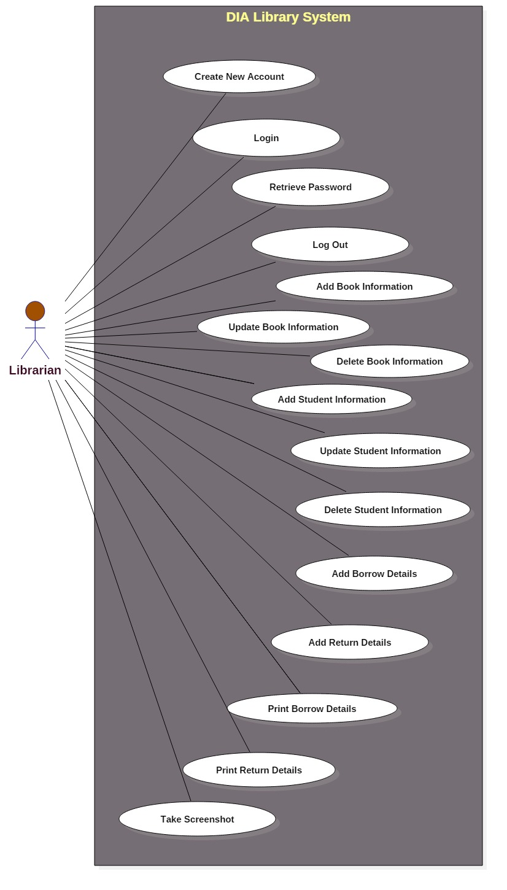

**Figure No.1:** Use case diagram of the proposed system.

# System Architecture:

Here, I have described about the overview of the technical architecture for this system development and implementation.

# Technical architecture:

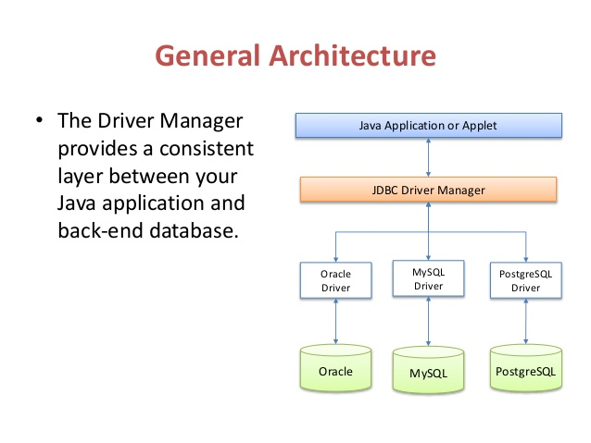

(google.com, n.d.)

**Figure No.2:** The technical architecture for the system development

# Overview of the technical architecture for this system development:

Here, I have used java as programming language and sqllite as database. I have also used JDBC driver manager for connection build up between them. How it actually work shown in the above image. The java application mainly connected with database with the help of JDBC driver manager. The JDBC driver manager builds a route between the java application and back-end database.

# Class diagram:

A class diagram static structured diagram that represents the whole structure of this proposed system by showing all classes of the system, their attributes, their operations and the relationship between objects. The following class diagram of the proposed system is given below.

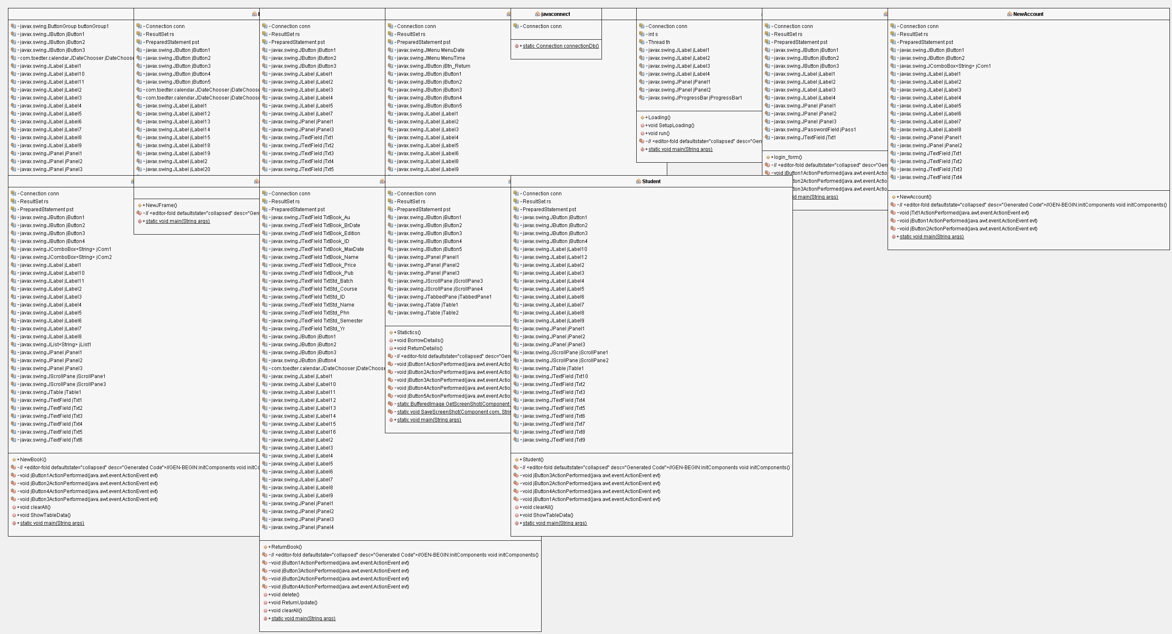

**Figure No.3**: Class diagram of the proposed system.

# Summary:

The part of documentation describes the functional, non-functional requirements, prioritization of functional requirements, use case diagram and class diagram of proposed system architecture.

# 4. Design Specification

# Introduction:

In this phase of documentation I will provide activity diagram based on the overall activities of the proposed system and requirements also. After that, the entity relationship diagram and data dictionary will provide based on the normalization of the proposed system scenario.

# Activity diagram:

Activity diagram is a diagram about the activities or the operations of the system. It is as like as flowchart which represent the flow from one activity to another activity. The control flow represents the operation between two activities. It is also known as behavioral diagram which describe the dynamic aspect of the system.

The overall activity diagram of the proposed system and some activity diagram for the important specific portion of the proposed system are given below.

Activity Diagram of the overall proposed System.

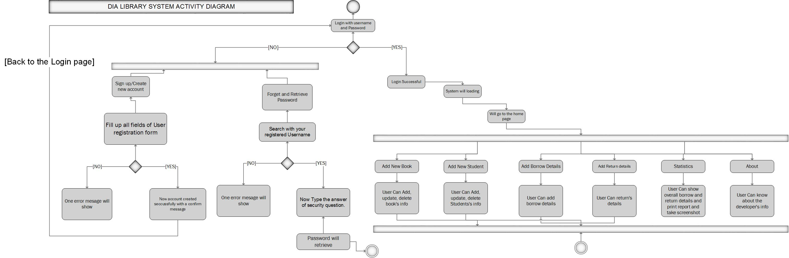

**Figure No.4:** Activity Diagram of the overall proposed System.

“New Book” functions:

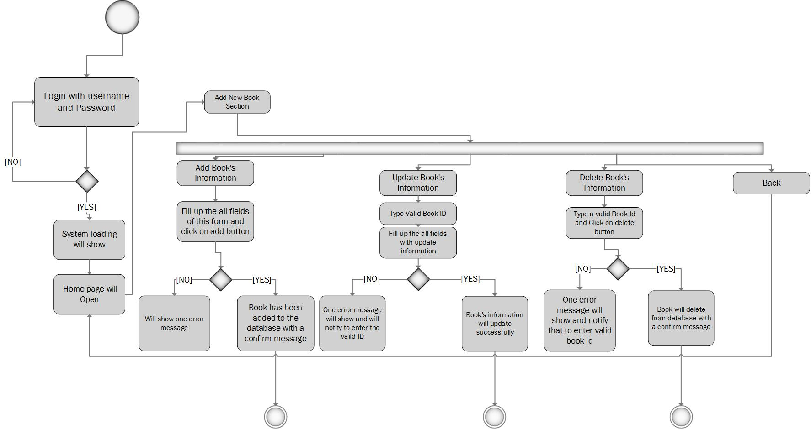

Figure No.5: Activity Diagram of “New Book” functions.

“New student” functions:

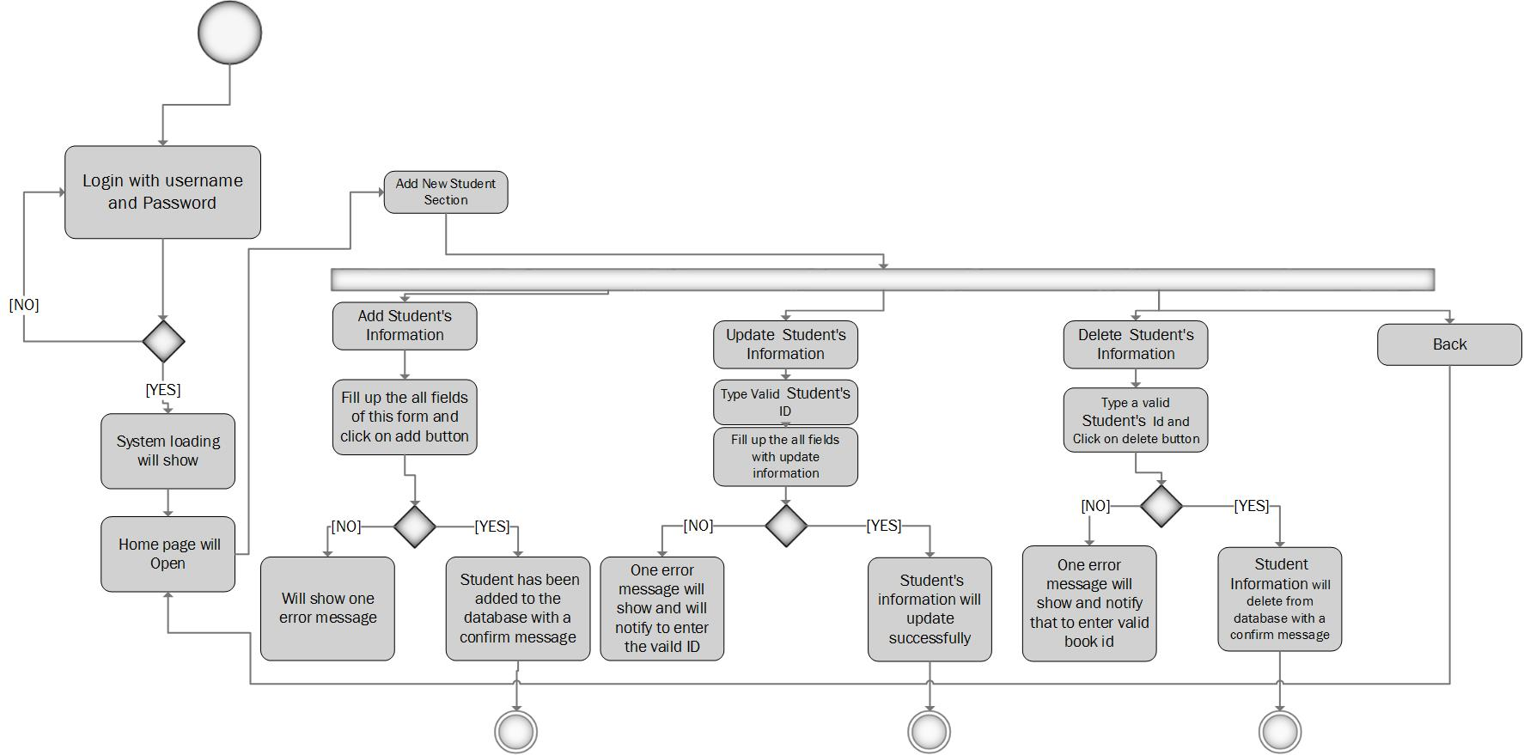

Figure No.6: Activity Diagram of “New Student” functions.

“Borrow Book” functions:

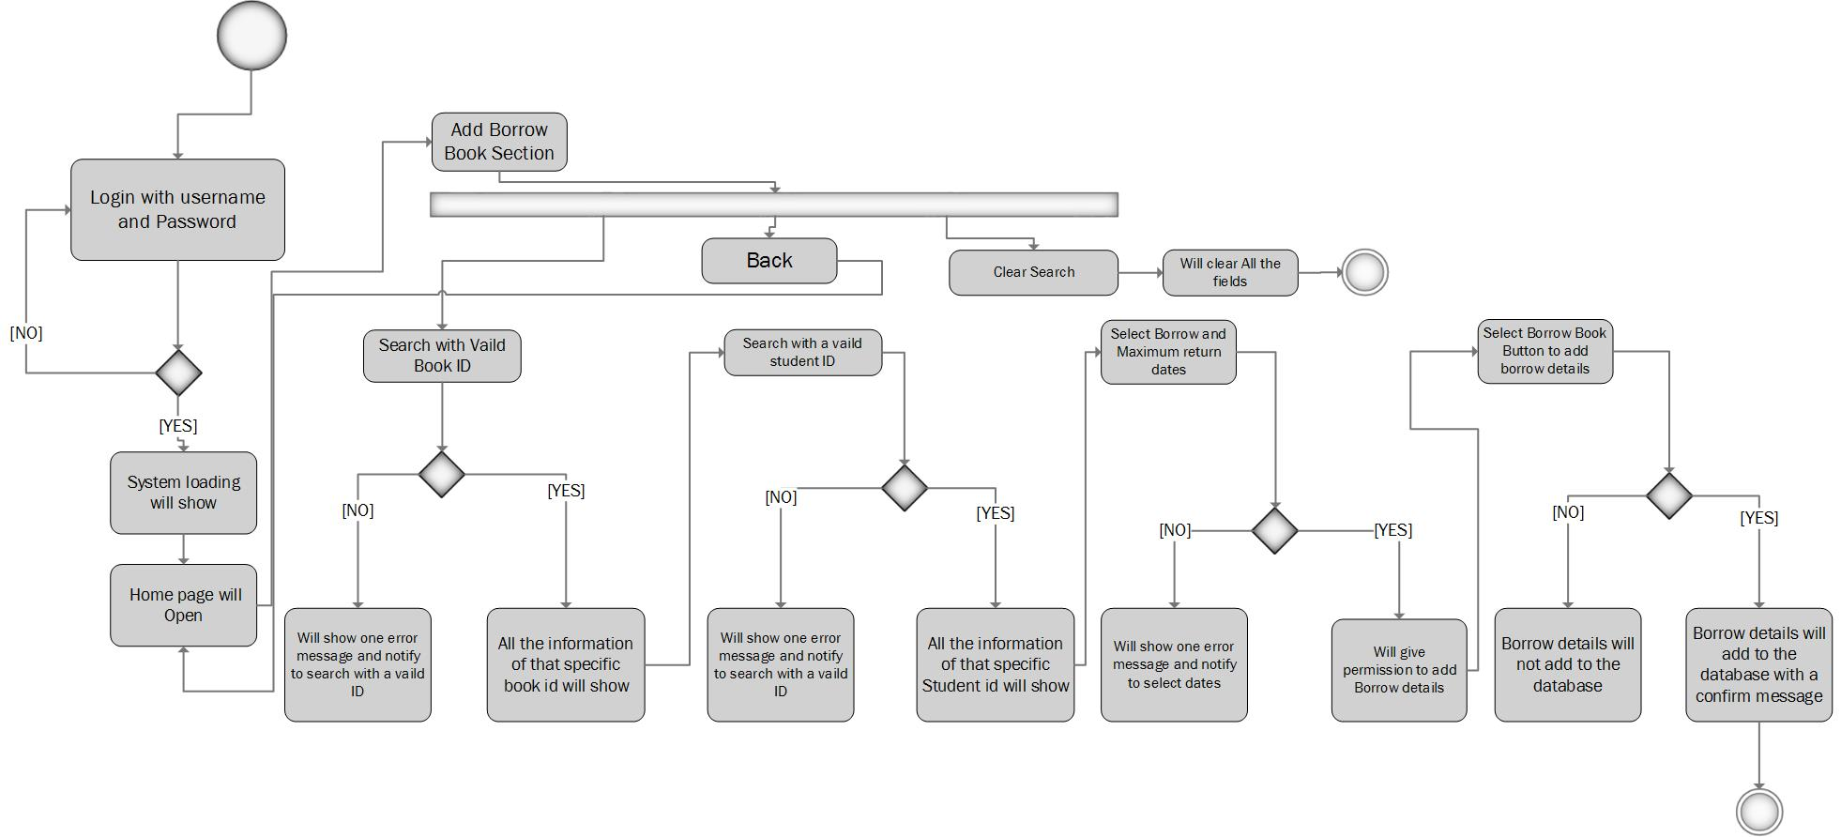

Figure No.7: Activity Diagram of “Borrow Book” functions.

“Return Book” functions:

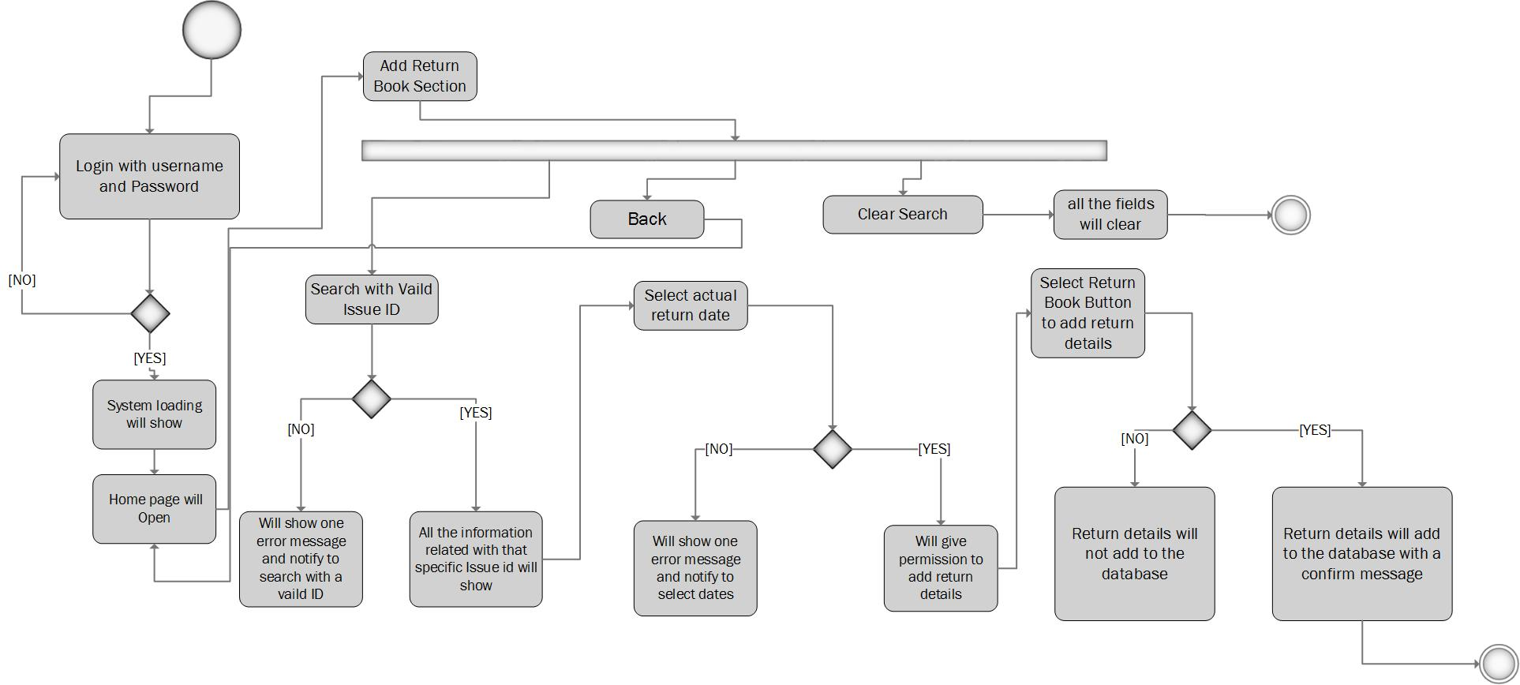

Figure No.8: Activity Diagram of “Return Book” functions.

Statistics function:

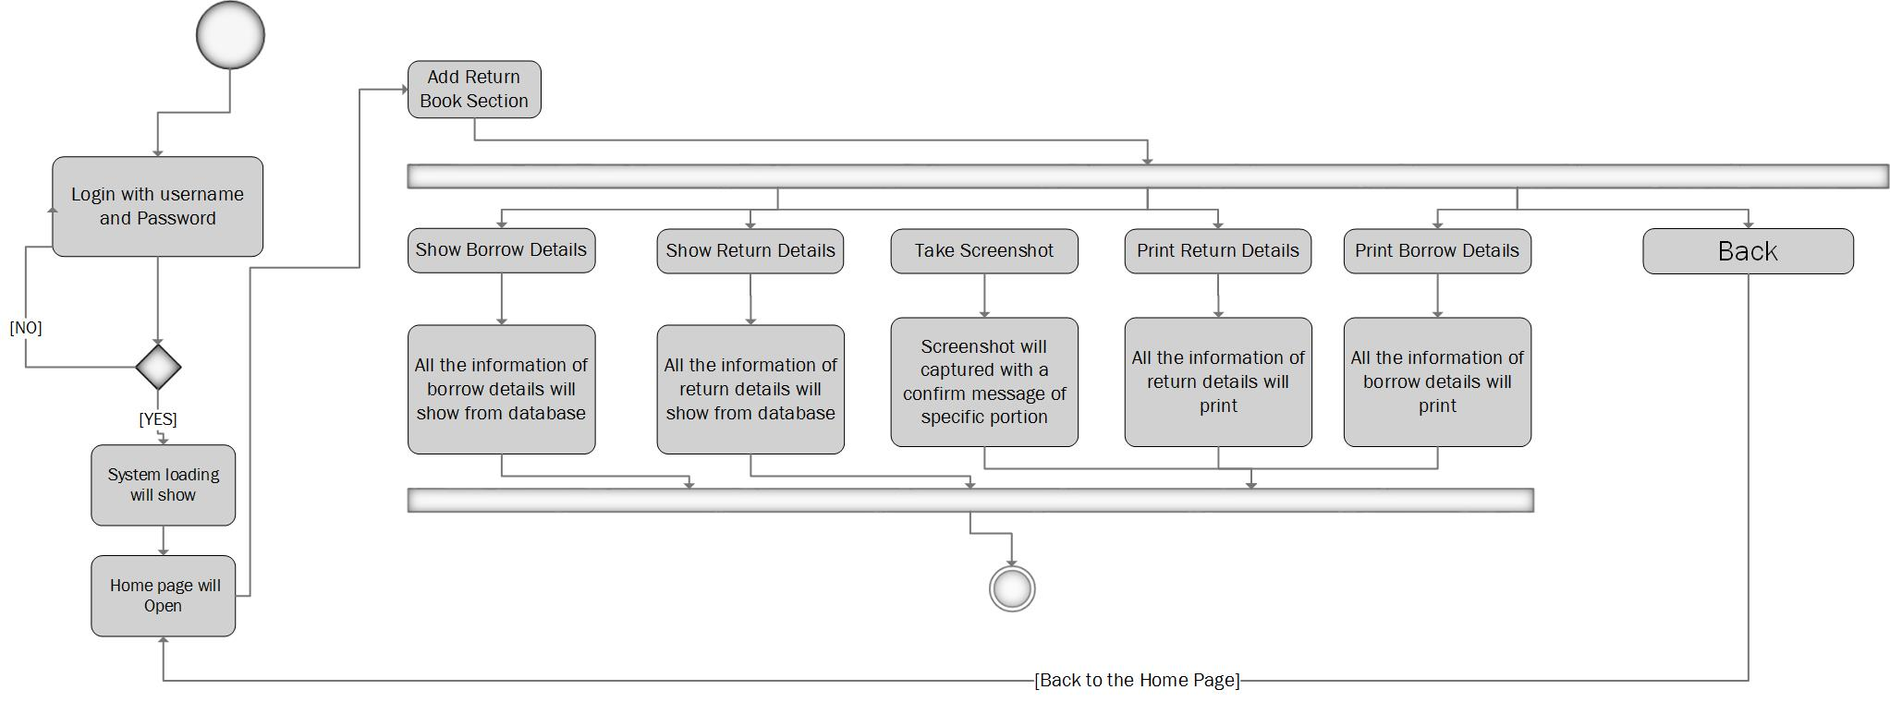

Figure No.9: Activity Diagram of “Statistics” functions.

# Entity Relationship Diagram:

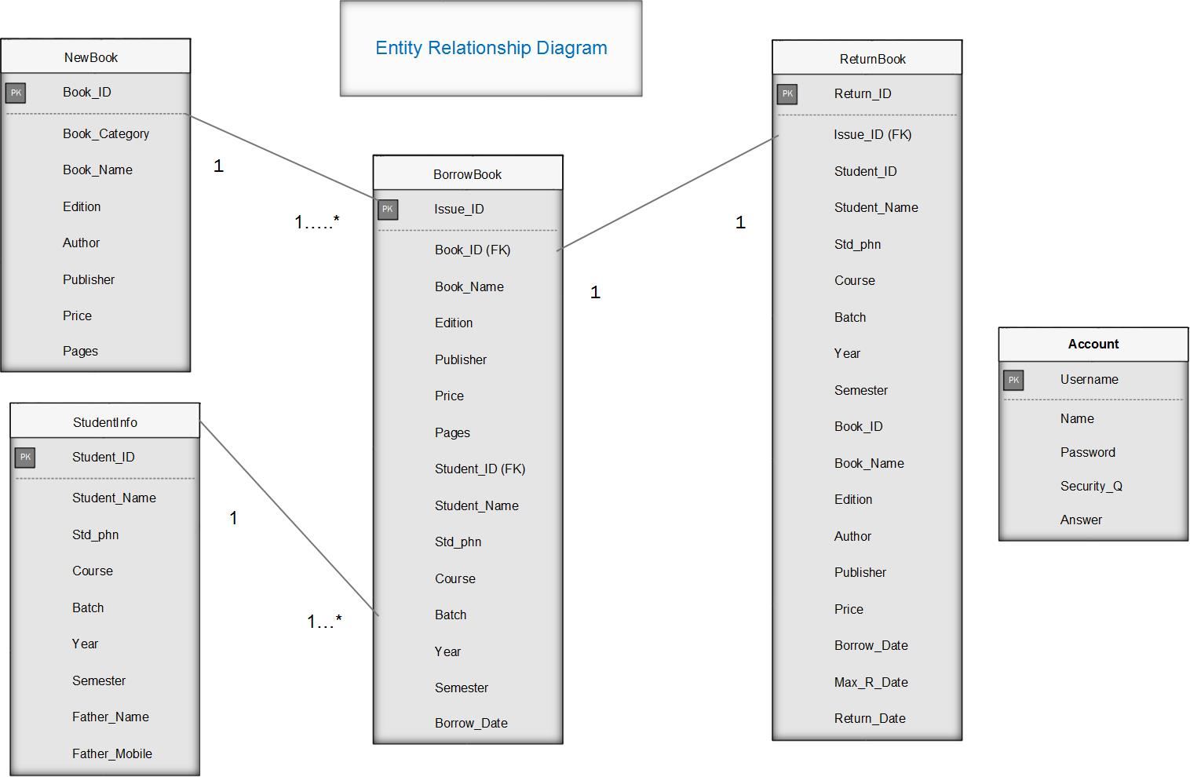

Figure No.10: Entity Relationship Diagram Of the proposed System.

# Data dictionary:

**Account**:

|  |  |  |  |  |  |  |
| --- | --- | --- | --- | --- | --- | --- |
| Attribute | | Data Type | Length | Primary Key | Foreign Key | Reference table |
| Username | | VARCHAR | 25 | Yes |  |  |
| Name | | VARCHAR | 25 |  |  |  |
| Password | | VARCHAR | 12 |  |  |  |
| Security_Q | | VARCHAR | 20 |  |  |  |
| Answer | VARCHAR | | 15 |  |  |  |

NewBook

|  |  |  |  |  |  |  |
| --- | --- | --- | --- | --- | --- | --- |
| Attribute | | Data Type | Length | Primary Key | Foreign Key | Reference table |
| Book_ID | | INTEGER | 12 | Yes |  |  |
| Book_Category | | VARCHAR | 12 |  |  |  |
| Book_Name | | VARCHAR | 12 |  |  |  |
| Edition | | VARCHAR | 12 |  |  |  |
| Author | VARCHAR | | 12 |  |  |  |
| Publisher | VARCHAR | | 12 |  |  |  |
| Price | VARCHAR | | 10 |  |  |  |
| Pages | VARCHAR | | 12 |  |  |  |

StudentInfo

|  |  |  |  |  |  |  |
| --- | --- | --- | --- | --- | --- | --- |
| Attribute | | Data Type | Length | Primary Key | Foreign Key | Reference table |
| Student_ID | | VARCHAR | 12 | Yes |  |  |
| Student_Name | | VARCHAR | 12 |  |  |  |
| Std_phn | | VARCHAR | 12 |  |  |  |
| Course | | VARCHAR | 12 |  |  |  |
| Batch | VARCHAR | | 12 |  |  |  |
| Year | INTEGER | | 5 |  |  |  |
| Semester | VARCHAR | | 12 |  |  |  |
| Father_Name | VARCHAR | | 12 |  |  |  |
| Father_Mobile | VARCHAR | | 12 |  |  |  |

BorrowBook:

|  |  |  |  |  |  |  |
| --- | --- | --- | --- | --- | --- | --- |
| Attribute | | Data Type | Length | Primary Key | Foreign Key | Reference table |
| Issue_ID | | INTEGER | 12 | Yes |  |  |
| Book_ID | | INTEGER | 12 |  | Yes | NewBook |
| Book_Name | | VARCHAR | 12 |  |  |  |
| Edition | | VARCHAR | 12 |  |  |  |
| Author | VARCHAR | | 12 |  |  |  |
| Publisher | VARCHAR | | 12 |  |  |  |
| Price | VARCHAR | | 10 |  |  |  |
| Pages | VARCHAR | | 12 |  |  |  |
| Student_ID | INTEGER | | 12 |  | Yes | StudentInfo |
| Student_Name | VARCHAR | | 12 |  |  |  |
| Std_phn | VARCHAR | | 12 |  |  |  |
| Course | VARCHAR | | 12 |  |  |  |
| Batch | VARCHAR | | 12 |  |  |  |
| Year | INTEGER | | 5 |  |  |  |
| Semester | VARCHAR | | 12 |  |  |  |
| Borrow_Date | INTEGER | | 25 |  |  |  |

ReturnBook

|  |  |  |  |  |  |  |
| --- | --- | --- | --- | --- | --- | --- |
| Attribute | | Data Type | Length | Primary Key | Foreign Key | Reference table |
| Return_ID | | INTEGER | 12 | Yes |  |  |
| Issue_ID | | INTEGER | 12 |  | Yes |  |
| Student_ID | | INTEGER | 12 |  |  |  |
| Student_Name | | VARCHAR | 12 |  |  |  |
| Std_phn | | VARCHAR | 12 |  |  |  |
| Course | | VARCHAR | 12 |  |  |  |
| Batch | VARCHAR | | 12 |  |  |  |
| Year | INTEGER | | 5 |  |  |  |
| Semester | VARCHAR | | 12 |  |  |  |
| Book_ID | INTEGER | | 12 |  |  |  |
| Book_Name | VARCHAR | | 12 |  |  |  |
| Edition | VARCHAR | | 12 |  |  |  |
| Author | VARCHAR | | 12 |  |  |  |
| Publisher | VARCHAR | | 12 |  |  |  |
| Price | VARCHAR | | 10 |  |  |  |
| Borrow_Date | INTEGER | | 25 |  |  |  |
| Max_R_Date | INTEGER | | 25 |  |  |  |
| Return_Date | INTEGER | | 25 |  |  |  |

# Summary:

Analysis and design part of the proposed system is covered through a series of many diagram and data models.

# 5. Test plan

# Introduction:

This is the detail documentation about test strategies, objectives, required resource for testing, testing schedule, test estimation and test deliverables. This is the essential part of the system development. In order to ensure whether each part of the proposed system is error free and working properly or not, there are several procedures of testing such as unit testing and integration testing etc. In order to get an error free system the following testing procedures are required to be carried out.

# Test plan objectives:

* All the procedures and standard which are identified required to be tested.
* Test of validation has to be defined.
* The entire error or defect test has to be identified.
* Authenticate test has to be identified.
* Test that all the function of the system is verified.
* All the bugs and faults have to be identified.
* Test all the functions of the system is verified or not.

# Functions to be tested:

* Check that user registration is working or not.
* Check that user can login after registration or not.
* Check that user can securely login to the system or not.
* Check that user can add, delete and update book’s information or not.
* Check that user can add, delete and update student’s information or not.
* Check that user can search a book and a student by the system’s search function or not.
* Check that user can show all the records on the table or not.
* Check that all the information about borrow and return details is shown or not on table.
* Check that user can print borrow and return details or not.
* Check that whether the user is taken a screenshot of borrow and return details or not.
* Check that whether the current date and time function is working currently or not.

# Test Strategies:

This is the essential part of the system testing. Before develop test strategy, there are two main things for consideration.

These are given below.

1. Should follow some steps.

The steps are given below:

* Define the scope of testing.
* Identified testing type.
* Document risk and issues.
* Create test logistics.

1. Determines testing efforts and costs.

In order to ensure whether each part of the proposed system is error free and working properly or not, there are several procedures among them:

# Unit testing:

Unit testing means to test the smallest piece of an application called units. It can be done manually but now it is automated also. Here, each unit of the proposed system will be tested separately.

**Usability testing:**

Usability testing refers to evaluating any product by testing it with representative user.

# Integration testing:

It is a testing strategy where individual software are combined as module and tested as a group.

# System testing:

It is a testing strategy which conducted on a complete, integrated system to evaluate the system compliance with its specified requirements. Each part of the proposed system will be tested from the start.

The **unit testing**, **integration testing** and then the **system testing** of the proposed system is described in the “text execution and results” part of the documentation. After that, **usability testing** is also given in that part.

**Test schedule is given below:**

|  |  |  |
| --- | --- | --- |
| Test Phase | Time | Carried out by |
| Unit testing | **1 day** | **Developer** |
| Integration testing | **1 day** | **User/ Developer** |
| System testing | **1 day** | **Developer** |

# 6. Development

# Introduction:

In this section, I have to describe about what platform is used for this system development and what the reasons for choosing this kind of platform here.

# Platform specific development:

This proposed system is mainly built for a library manager or a person who administrates or manages a library. So, a desktop based application can be the better option for this purpose. This kind of applications commonly used in offline. So, I have made a desktop based application for this purpose using Java as programming language and Sqlite as database creation. It can be run on many platform such as windows, Linux Os, UNIX, Mac etc.

# Reason for the chosen platform:

* First of all, it is built for a Library manager or Library Administrative in order to use it personally.
* Very easy to installed.
* Very fast and portable.
* Easily implementable.
* Hardware compatibility.
* Doesn’t need any internet connection for run this application.
* Easily used and more efficient for a library management.
* User friendly.

# Summary:

In this section of documentation I have described about why I have chosen this platform and why. On the other hand, I have already developed my proposed application which can be so much efficient for a library management in computerized way. In the next section, I have to test the each part of my application and about their results.

# 7. Test execution and results

**Introduction:**

In this section, I will test the proposed system using several testing strategies such as unit testing procedure, system testing and usability testing.

**Unit testing:**

In unit testing strategy I have described the testing function, expected result and actual result of the each portion of my system providing a test code.

**Unit testing of this system is given below.**

|  |  |
| --- | --- |
| Test ID: | Test-0001 |
| Test Function: | New account creation |
| Expected Result: | User will able to create account successfully. |
| Actual Result: | New account created Successfully. |

|  |  |
| --- | --- |
| Test ID: | Test-0002 |
| Test Function: | Login |
| Expected Result: | User will able to login to system successfully. |
| Actual Result: | Successfully login to the system. |

|  |  |
| --- | --- |
| Test ID: | Test-0003 |
| Test Function: | Logout |
| Expected Result: | User will able to logout from system successfully. |
| Actual Result: | Successfully logout from the system. |

|  |  |
| --- | --- |
| Test ID: | Test-0004 |
| Test Function: | Retrieve Password |
| Expected Result: | User will able to retrieve password successfully. |
| Actual Result: | Password retrieved Successfully. |

|  |  |
| --- | --- |
| Test ID: | Test-0005 |
| Test Function: | Loading page or progress bar. |
| Expected Result: | User will able to show a progress bar successfully. |
| Actual Result: | progress bar is working successfully. |

|  |  |
| --- | --- |
| Test ID: | Test-0006 |
| Test Function: | Menu Items from menu bar is working or not. |
| Expected Result: | User will able to use more options from menu bar successfully. |
| Actual Result: | Menu Items are working successfully. |

|  |  |
| --- | --- |
| Test ID: | Test-0007 |
| Test Function: | Show correct current date and time. |
| Expected Result: | User will able to show correct current date and time successfully in home page. |
| Actual Result: | Successfully shown current date and time. |

|  |  |
| --- | --- |
| Test ID: | Test-0008 |
| Test Function: | Add Book’s information |
| Expected Result: | User will able to add book’s information successfully. |
| Actual Result: | New Book’s information added Successfully. |

|  |  |
| --- | --- |
| Test ID: | Test-0009 |
| Test Function: | Delete Book’s information |
| Expected Result: | User will able to delete book’s information successfully. |
| Actual Result: | New Book’s information deleted Successfully. |

|  |  |
| --- | --- |
| Test ID: | Test-00010 |
| Test Function: | Update Book’s information |
| Expected Result: | User will able to update book’s information successfully. |
| Actual Result: | New Book’s information updated Successfully. |

|  |  |
| --- | --- |
| Test ID: | Test-00011 |
| Test Function: | Add student’s information |
| Expected Result: | User will able to add student’s information successfully. |
| Actual Result: | New student’s information added Successfully. |

|  |  |
| --- | --- |
| Test ID: | Test-00012 |
| Test Function: | Update student’s information |
| Expected Result: | User will able to update student’s information successfully. |
| Actual Result: | Student’s information updated Successfully. |

|  |  |
| --- | --- |
| Test ID: | Test-00013 |
| Test Function: | Delete student’s information |
| Expected Result: | User will able to delete student’s information successfully. |
| Actual Result: | Student’s information deleted Successfully. |

|  |  |
| --- | --- |
| Test ID: | Test-00014 |
| Test Function: | Take screenshot of Statistics. |
| Expected Result: | User will able to take screenshot of Statistics. |
| Actual Result: | Image is captured. |

|  |  |
| --- | --- |
| Test ID: | Test-00015 |
| Test Function: | Add borrow book’s information |
| Expected Result: | User will able to add borrow book’s information successfully. |
| Actual Result: | New borrow Book’s information added Successfully. |

|  |  |
| --- | --- |
| Test ID: | Test-00016 |
| Test Function: | Update borrow Book’s information |
| Expected Result: | User will able to update borrow book’s information successfully. |
| Actual Result: | New borrow Book’s information updated Successfully. |

|  |  |
| --- | --- |
| Test ID: | Test-00017 |
| Test Function: | Delete borrow Book’s information |
| Expected Result: | User will able to delete borrow book’s information successfully. |
| Actual Result: | New borrow Book’s information deleted Successfully. |

|  |  |
| --- | --- |
| Test ID: | Test-00018 |
| Test Function: | Add return book’s information |
| Expected Result: | User will able to add return book’s information successfully. |
| Actual Result: | New return Book’s information added Successfully. |

|  |  |
| --- | --- |
| Test ID: | Test-00019 |
| Test Function: | Update return Book’s information |
| Expected Result: | User will able to update return book’s information successfully. |
| Actual Result: | New return Book’s information updated Successfully. |

|  |  |
| --- | --- |
| Test ID: | Test-00020 |
| Test Function: | Delete return Book’s information |
| Expected Result: | User will able to delete return book’s information successfully. |
| Actual Result: | New return Book’s information deleted Successfully. |

|  |  |
| --- | --- |
| Test ID: | Test-00021 |
| Test Function: | Print borrow book’s information |
| Expected Result: | User will able to print borrow book’s information successfully. |
| Actual Result: | New borrow Book’s information printed Successfully. |

|  |  |
| --- | --- |
| Test ID: | Test-00022 |
| Test Function: | Print return book’s information |
| Expected Result: | User will able to print return book’s information successfully. |
| Actual Result: | New return Book’s information printed Successfully. |

# Integration testing:

|  |  |  |  |  |
| --- | --- | --- | --- | --- |
| Integration Testing-1 | | | | |
| Test class-  User | **Designed by: Apurba Debnath** | | | |
| Data source:  User Entry | **Objectives:**  **Module-1**  **(The basic functionalities)** | | **Tester: Apurba Debnath** | |
| Test case | **Description** | **Task** | **Expected result** | **Actual Result** |
| 1. | **User Registration** | User will click on “sign up” button and one sing up form will appear and then when user fill the all fields and click on create button, it will create a new user account. | If user filled up the all fields then all the records will save on the database and will show a confirm message whether “fill up the all fields and select your security question” will show as a message. Functions are integrated here. | Record added to database  Successfully. |
|  |  |  |  |  |
| Integration Testing-2 | | | | |
| Test class-  User | **Designed by: Apurba Debnath** | | | |
| Data source:  User Entry | **Objectives:**  **Module-1**  **(The basic functionalities)** | | **Tested by: Apurba debnath** | |
| Test case | **Description** | **Task** | **Expected result** | **Actual Result** |
| 1. | **User login**  Functions are integrated here. | User will type their specific user name and password for login and after login user will able to enter the system. | If user type the correct username and password and click on “login” button then the user can login to the system otherwise one error message will show as “Incorrect username or password”. Functions are integrated here. | If user give correct username and password than the user can login to the system otherwise not. |

|  |  |  |  |  |
| --- | --- | --- | --- | --- |
| Integration Testing-3 | | | | |
| Test class-  User | **Designed by: Apurba Debnath** | | | |
| Data source:  User Entry | **Objectives:**  **Module-1**  **(The basic functionalities)** | | **Tested by: Apurba debnath** | |
| Test case | **Description** | **Task** | **Expected result** | **Actual Result** |
| 1. | Retrieve password.  Functions are integrated here. | If user forgot password and try to retrieve it then user need to click on forget password button. After that, user will retrieve that by the correct username and the answer of the security questions. | If user write the correct username and press on search button than name and security question will automatically retrieve and then user need to give the answer of that question and have to click on “retrieve ” button then the password will retrieve automatically.  Functions are integrated here. | Correct password will retrieve for giving correct information. |

|  |  |  |  |  |
| --- | --- | --- | --- | --- |
| Integration Testing-4 | | | | |
| Test class-  User | **Designed by: Apurba Debnath** | | | |
| Data source:  User Entry | **Objectives:**  **Module-1**  **(The basic functionalities)** | | **Tested by: Apurba debnath** | |
| Test case | **Description** | **Task** | **Expected result** | **Actual Result** |
| 4. | Progress bar or loading page is working or not.  Functions are integrated here with login page. | After login to the system one progress bar or a loading page will show. | After login on the system on progress bar will show. Functions are integrated here with login page. | Progress bar has showed after login to the system. |

|  |  |  |  |  |
| --- | --- | --- | --- | --- |
| Integration Testing-5 | | | | |
| Test class-  User | **Designed by: Apurba Debnath** | | | |
| Data source:  User Entry | **Objectives:**  **Module-2**  **(The main functionalities)** | | **Tested by: Apurba debnath** | |
| Test case | **Description** | **Task** | **Expected result** | **Actual Result** |
| 1. | Home Page  Testing  Functions are integrated here with pages belongs with it. | After showing progress bar, user will show a home page. Here, user will get many buttons and will show a menu bar and current date and time. | If user comes to the home page then user will show many button for essential works as his requirements and also show current date and time and an option menu bar. Everything will work correctly. | Everything of the home page is working perfectly as the user requirements. |

|  |  |  |  |  |
| --- | --- | --- | --- | --- |
| Integration Testing-6 | | | | |
| Test class-  User | **Designed by: Apurba Debnath** | | | |
| Data source:  User Entry | **Objectives:**  **Module-2**  **(The main functionalities)** | | **Tested by: Apurba debnath** | |
| Test case | **Description** | **Task** | **Expected result** | **Actual Result** |
| 1. | “New Book” portion testing.  Functions are integrated here. | If user will need to add new book or update or delete any book from system database than user will be required to click on “New Book” portion of home page and user will do all the task. | User fills up the all fields and tries to add or update information then system will add or update that information and will provide confirmation message otherwise will provide error message. For update or delete valid book id is required to type otherwise error will occur. | User can add, delete, update book’s information successfully and for update and delete without a valid id error will be occurred. |
| Integration Testing-7 | | | | |
| Test class-  User | **Designed by: Apurba Debnath** | | | |
| Data source:  User Entry | **Objectives:**  **Module-2**  **(The main functionalities)** | | **Tested by: Apurba debnath** | |
| Test case | **Description** | **Task** | **Expected result** | **Actual Result** |
| 1. | “New Student” portion testing.  Functions are integrated here with login page. | If user will try to add new student or update or delete any student from system database than user will be required to click on “New Student” portion of home page and user will do all the task. | User fills up the all fields and tries to add or update information then system will add or update that information and will provide confirmation message otherwise will provide error message. For update or delete, valid student id is required to type otherwise error will occur. | User can add, delete, update student’s information successfully and for update and delete without a valid id error will be occurred. |

|  |  |  |  |  |
| --- | --- | --- | --- | --- |
| Integration Testing-8 | | | | |
| Test class-  User | **Designed by: Apurba Debnath** | | | |
| Data source:  User Entry | **Objectives:**  **Module-2**  **(The main functionalities)** | | **Tested by: Apurba debnath** | |
| Test case | **Description** | **Task** | **Expected result** | **Actual Result** |
| 1. | “Borrow Book” portion testing.  Functions are integrated here with login page. | If user wants to add borrow information then   1. Required to search with valid book id or will get error. 2. Required to select 2 dates. | If user do this task perfectly then user can add borrow book for a specific student id otherwise system will give error message. | User can add borrow information for a valid student and book id successfully. |

|  |  |  |  |  |
| --- | --- | --- | --- | --- |
| Integration Testing-9 | | | | |
| Test class-  User | **Designed by: Apurba Debnath** | | | |
| Data source:  User Entry | **Objectives:**  **Module-2**  **(The main functionalities)** | | **Tested by: Apurba debnath** | |
| Test case | **Description** | **Task** | **Expected result** | **Actual Result** |
| 1. | “Return Book” portion testing.  Functions are integrated here with login page. | If user wants to add return information then   1. Required to search with valid student id or will get error. 2. Required to select return date also. | If user do this task perfectly and click on “Return “button then user can add return book for a specific student id otherwise system will give error message. | User can add return information for a valid student and book id successfully. |

|  |  |  |  |  |
| --- | --- | --- | --- | --- |
| Integration Testing-9 | | | | |
| Test class-  User | **Designed by: Apurba Debnath** | | | |
| Data source:  User Entry | **Objectives:**  **Module-2**  **(The main functionalities)** | | **Tested by: Apurba debnath** | |
| Test case | **Description** | **Task** | **Expected result** | **Actual Result** |
| 1. | “Statistic” portion testing.  Functions are integrated here with login page. | If user wants to show all return and borrow details information, user will require click on “Statistic” button. | Here, user can show details of return and borrow information and can print that information and also can take screenshot. | User can show all return information and borrow information successfully and can also print that or can take screenshot successfully. |

# System Testing:

In this phase of testing I will test the every portion of my system and its execution and results. After that, I will provide screenshots of that every portions and will provide a short description also.

# Sign up or User registration portion testing:

# Part-1:

# Description:

First of all, users have to create a new account from here in order to login to the system. User has to click on sign up button and this page will show to the user for making a new account.  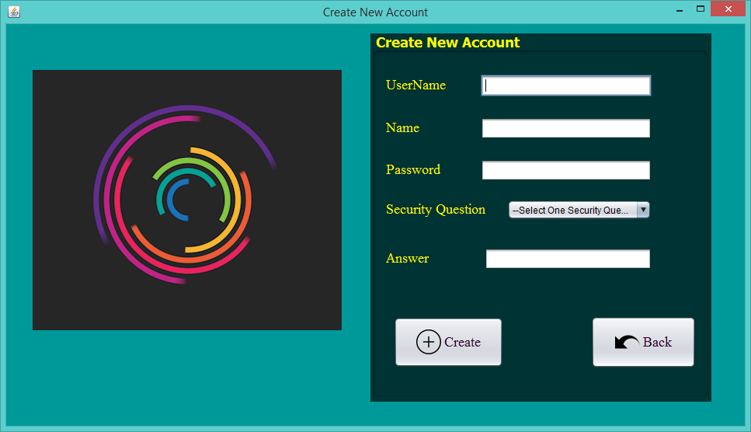

**Figure No.11: Testing sign up or user registration page.**

# Part-2:

# Description:

If any field is empty than this message will show to the user by clicking on the “Create” button.

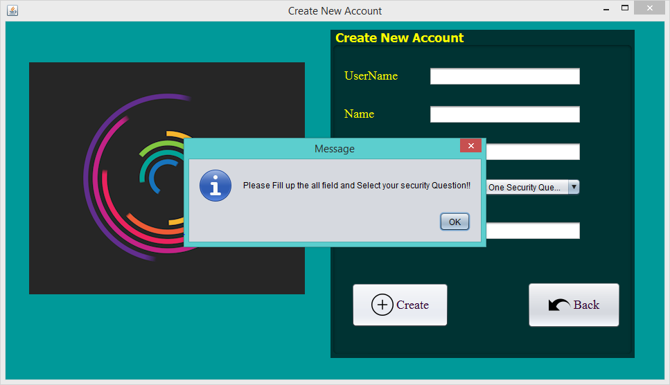

**Figure No.12: Testing sign up or user registration page.**

# Part-3:

Description:

After fill up the all information and fields than user have to click on the “Create” button. After clicking on the create button one success message will show to the user.

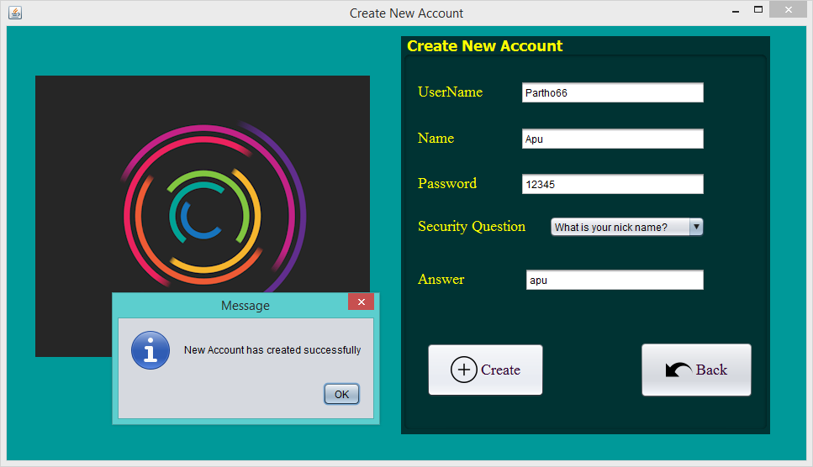

**Figure No.14: Testing sign up or user registration page.**

# Part-4:

Description:

If any user give the same username than he cannot create that account for the duplication of the username than this warning message will show to the user.

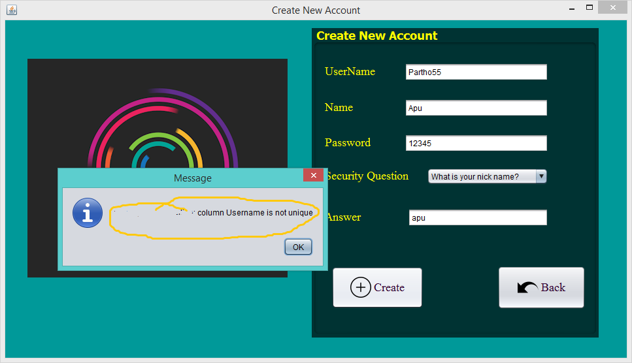

**Figure No.15: Testing sign up or user registration page.**

# Part-5:

Description:

If user click on his ok button of this popup window of message after creating a new an account it will automatically go to the login in page.

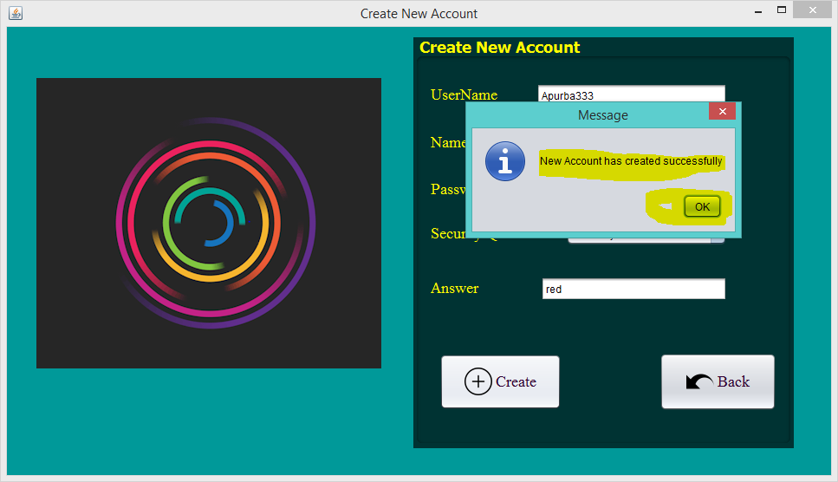

**Figure No.16: Testing sign up or user registration page.**

**After click on “Ok” than automatically come to this login page…**

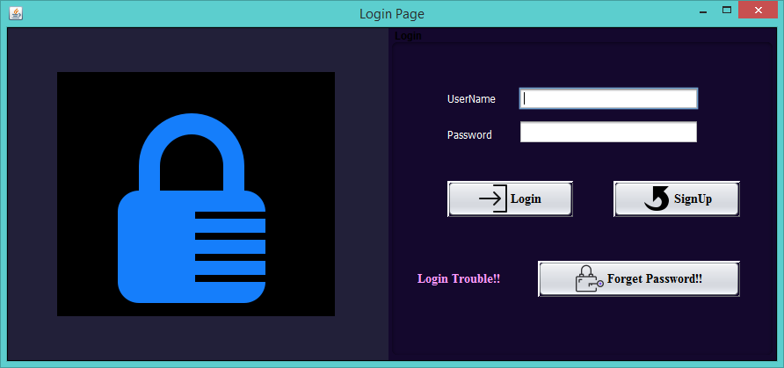

**Figure No.17: Testing sign up or user registration page.**

# Login portion testing:

# Part-1:

# Description:

If the user doesn’t type the username and password and click on the login button than this message will show.

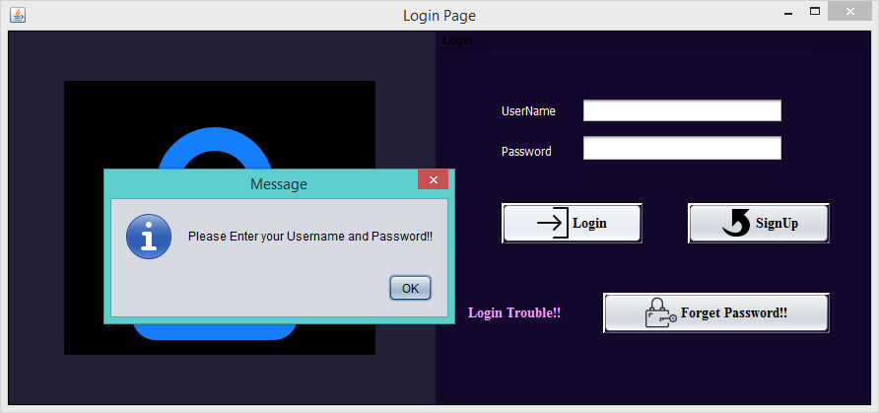

**Figure No.18: Testing login page.**

# Part-2:

# Description:

If the user does type the wrong username and password and click on the login button than this message will show.

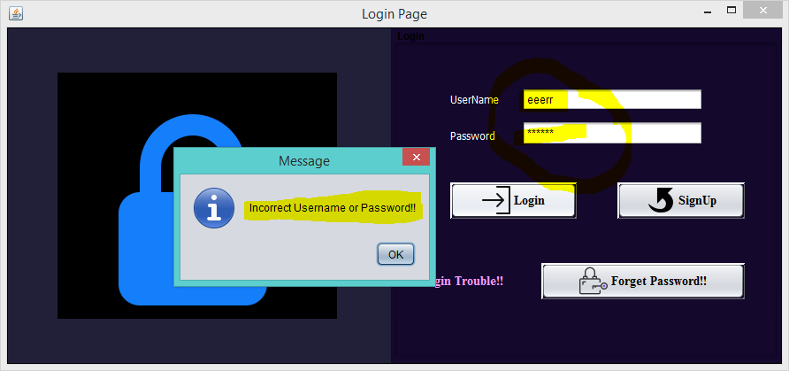

**Figure No.19: Testing login page.**

# Part-3:

# Description:

If the user does type the correct username and password and click on the login button than user can logged to the system and this progress bar will show.

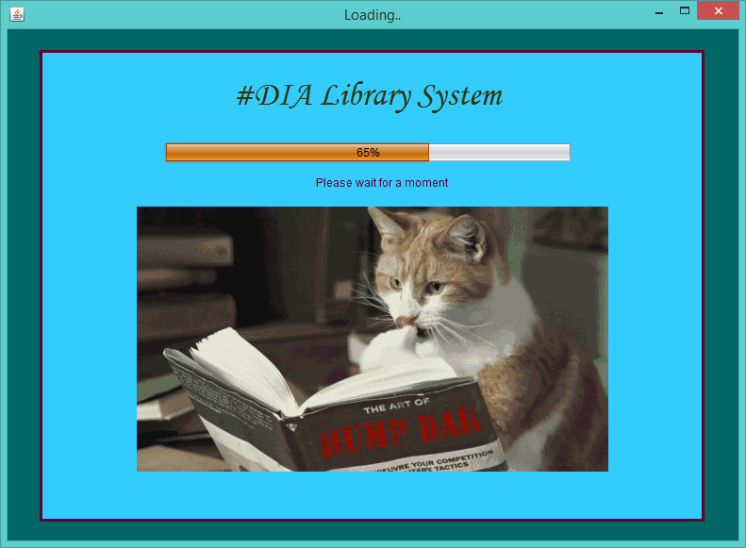

**Figure No.20: Testing login page.**

# Password retrieves portion testing:

# Part-1:

# Description:

If the user forgot the correct username and password and click on the “forget password button” than user will show this window.

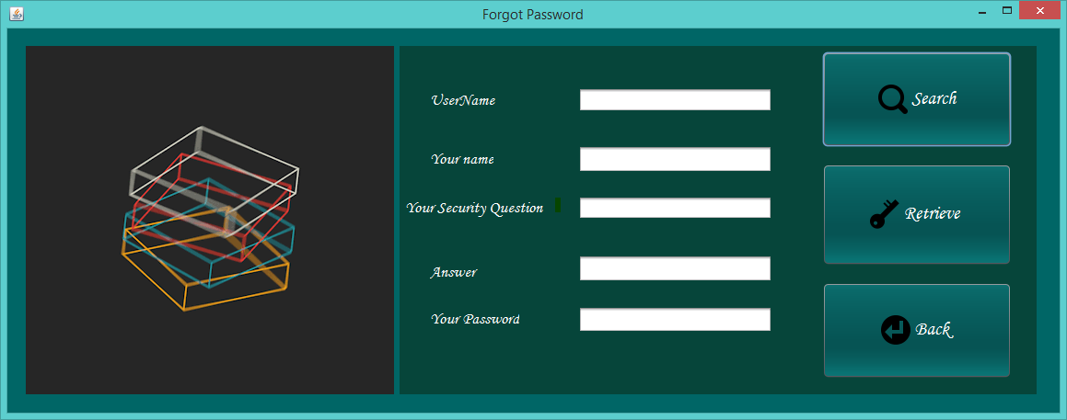

**Figure No.21: Testing Password retrieves portion.**

# Part-2:

# Description:

If the user doesn’t type any username or type the incorrect username in order to retrieve the password and click on the “search button” than user will show this message.

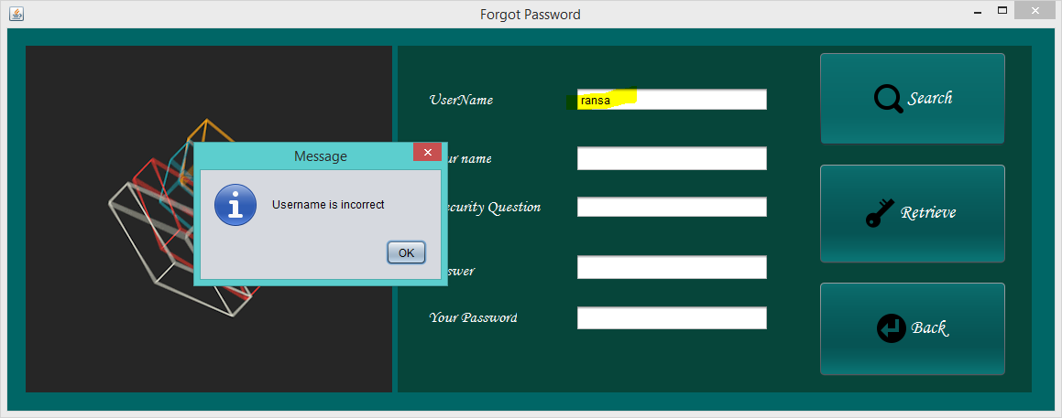

**Figure No.22: Testing Password retrieves portion.**

# Part-3:

# Description:

If the user does type the correct username in order to retrieve the password and click on the “search button” than user will show his name and security question.

User enters the correct username.

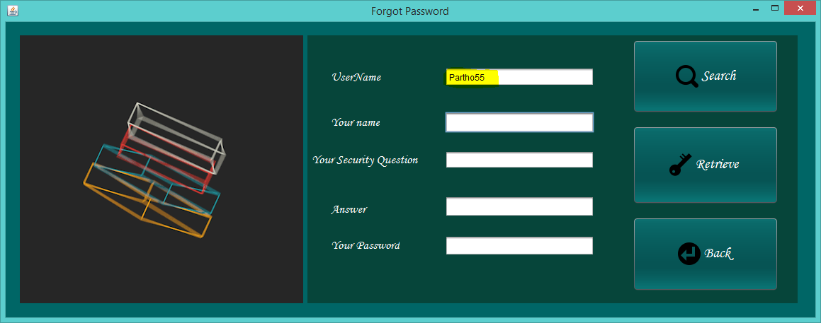

**Figure No.23: Testing Password retrieves portion.**

User will retrieve his name and security questions. And you have to give the answer of that security question as his registration.

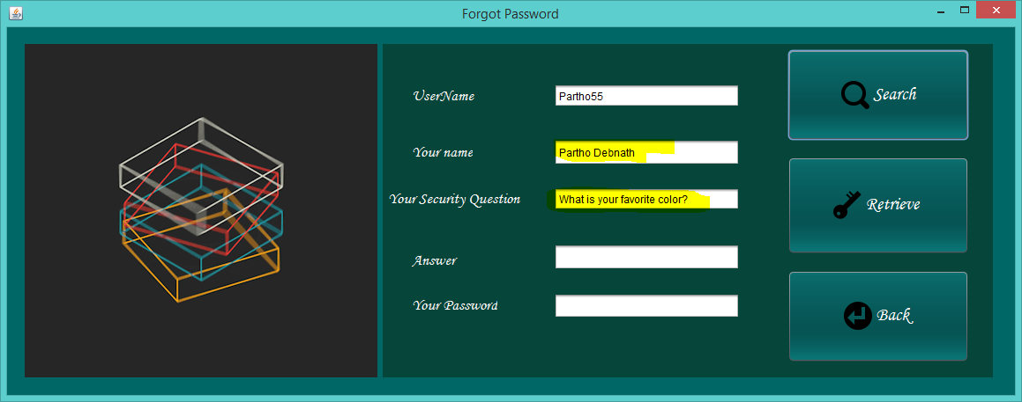

**Figure No.24: Testing Password retrieves portion.**

# Part-4:

# Description:

If the user doesn’t type the correct answer of the security question in order to retrieve the password and click on the “Retrieve button” than user will show this warning message.

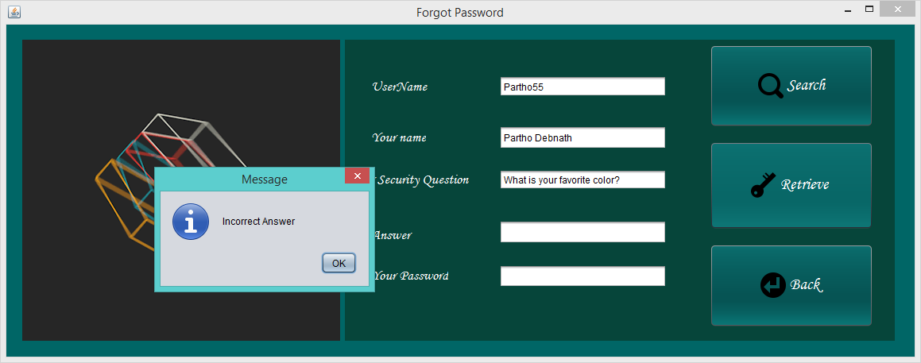

**Figure No.25: Testing Password retrieves portion.**

# Part-5:

# Description:

If the user does type the correct answer of the security question in order to retrieve the password and click on the “Retrieve button” than the specific password of that user name will retrieved and shown to the password field

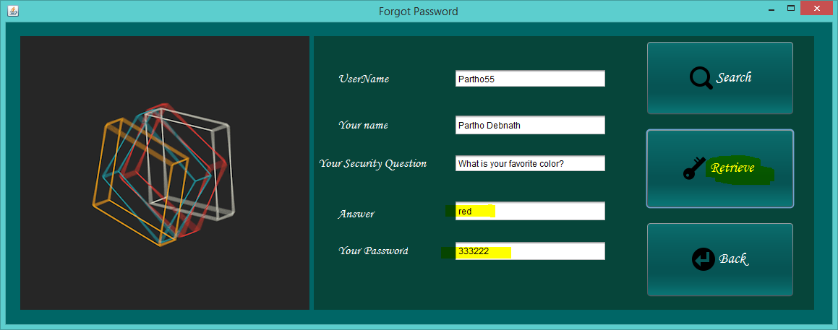

**Figure No.26: Testing Password retrieves portion.**

# Part-6:

# Description:

If the user will click on the “Back” button it will come to the login page.

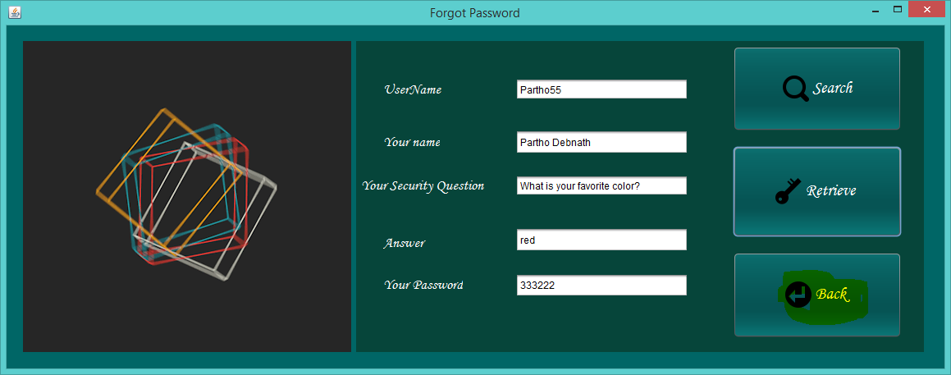

**Figure No.27: Testing Password retrieves portion.**

# Home page testing:

# Part-1:

# Description:

After login to the system user will show this home page where user will find all the requirement of that application. The screenshot is given below.

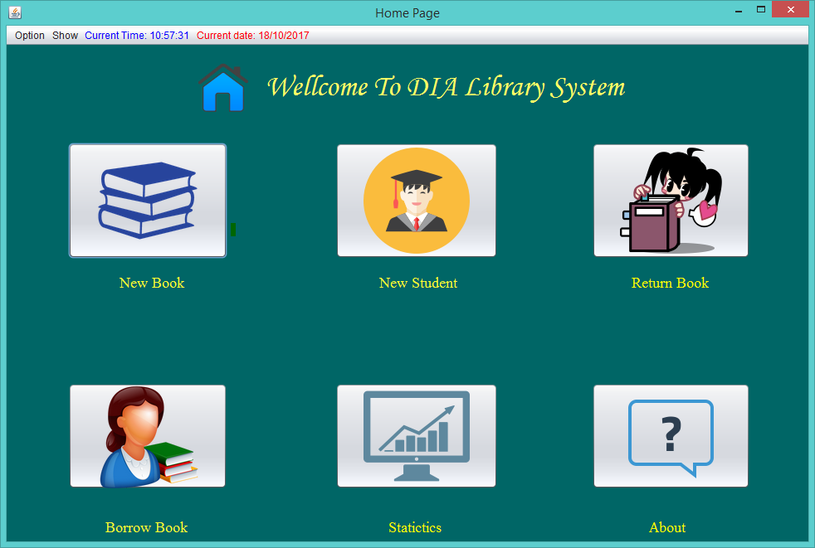

**Figure No.28: Testing Home page portion.**

# Part-2:

# Description:

In this home page user will show the correct current date and time in the top section of menu bar and also get some menu items as option. And also get some buttons named New book, New student, Return book, Borrow book, Statistic and About. one window will appear to that user. The screenshot is given below.

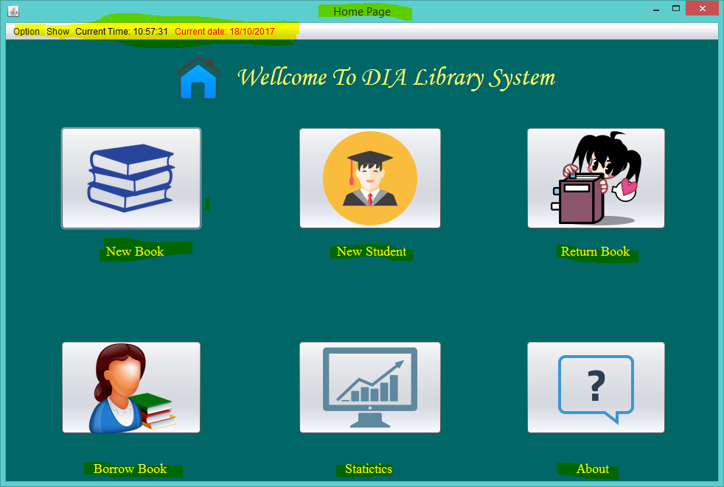

**Figure No.29: Testing Home page portion.**

# Part-3:

# Description:

If user wants to add new book he has to click on new book button.

After that his window will appear.

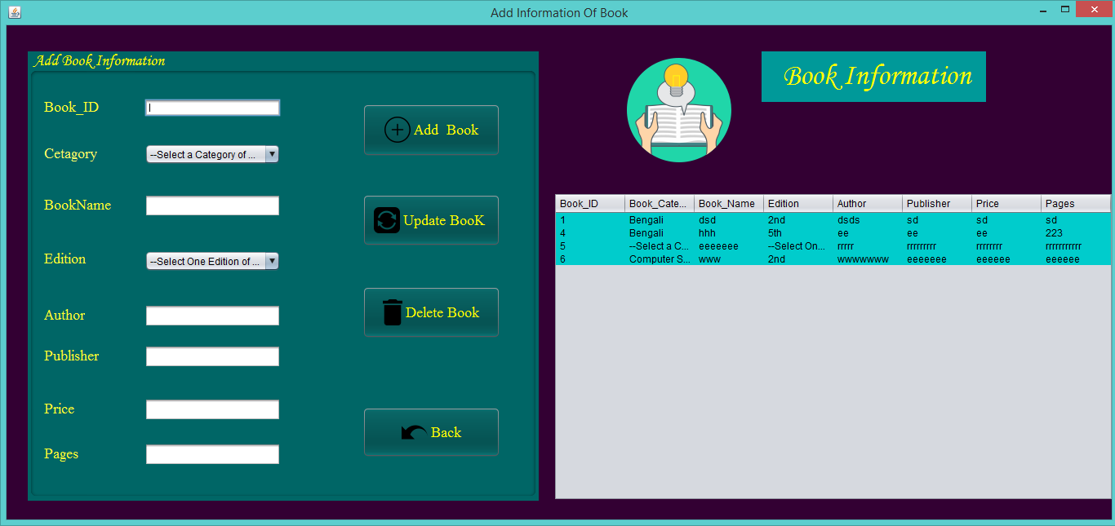

**Figure No.30: Testing Home page portion.**

# Part-4:

# Description:

If user wants to add new student he has to click on new student button and this window will appear to that user. The screenshot is given below.

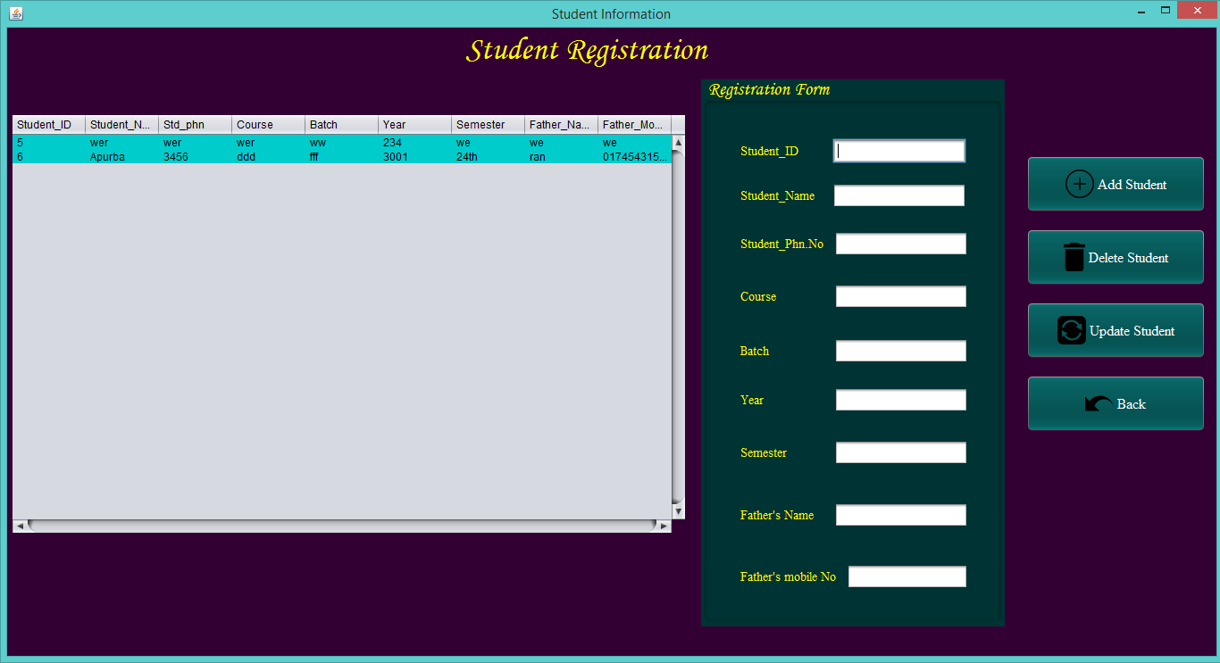

**Figure No.31: Testing Home page portion.**

# Part-5:

# Description:

If user wants to add Borrow book, he has to click on “Borrow Book” button and this window will appear to that user. The screenshot is given below.

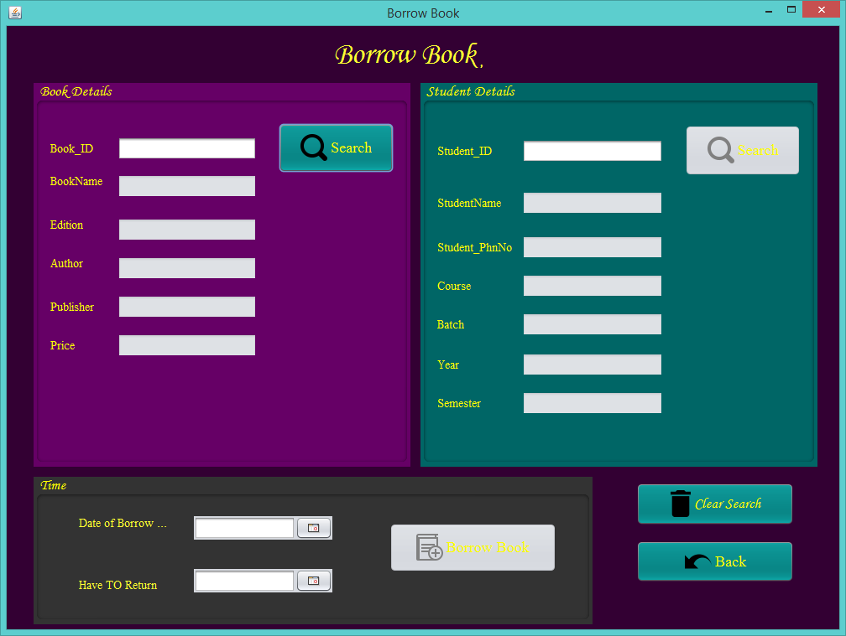

**Figure No.32: Testing Home page portion.**

# Part-6:

# Description:

If user wants to add Return book, he has to click on “Return Book” button and this window will appear to that user. The screenshot is given below.

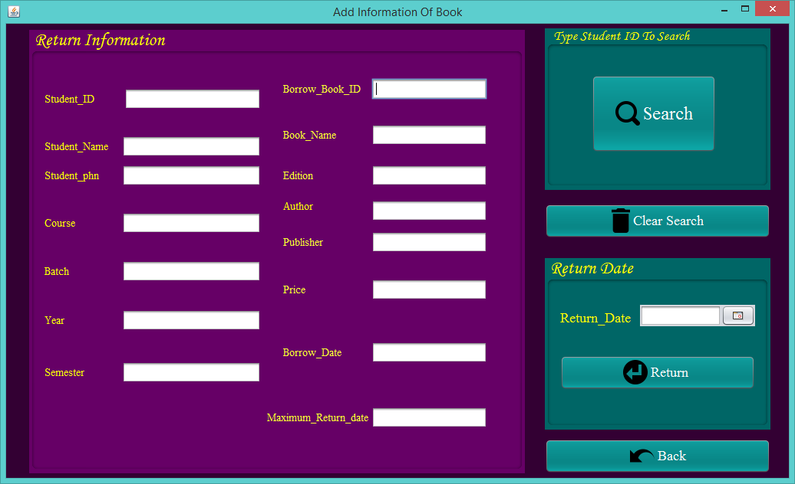

**Figure No.33: Testing Home page portion.**

# Part-7:

# Description:

If user wants to show statistics, he has to click on “statistics” button and this window will appear to that user. The screenshot is given below.

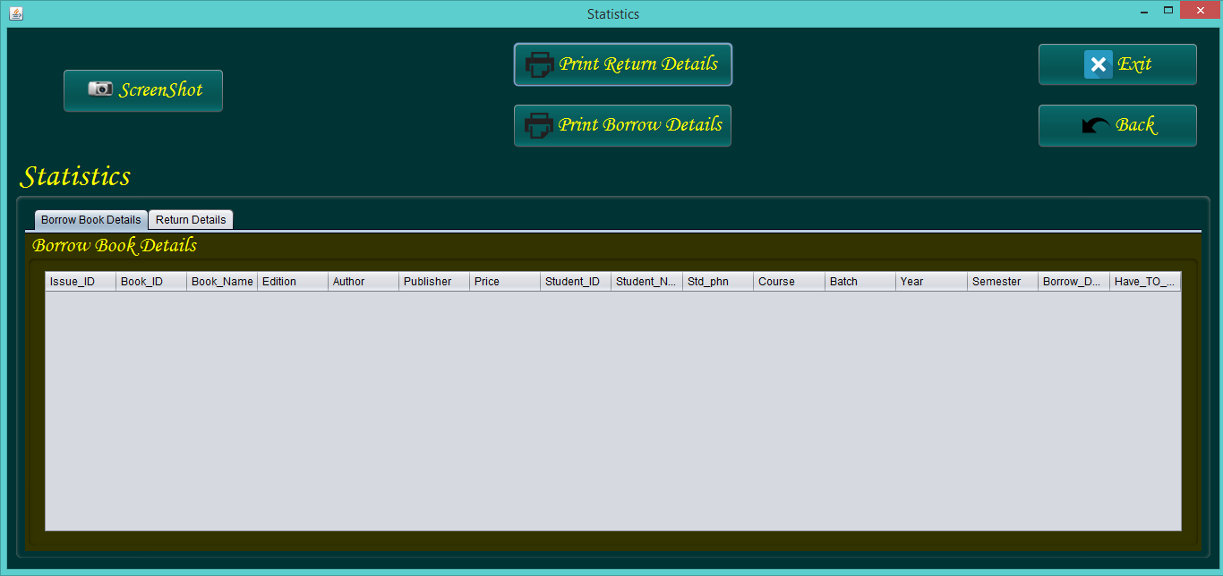

**Figure No.34: Testing Home page portion.**

# New Book portion testing:



# Part-1:

# Description: If the fields are empty.

**If the fields are empty** than this message will show after clicking on the “Add Book” or “Update Book” button.

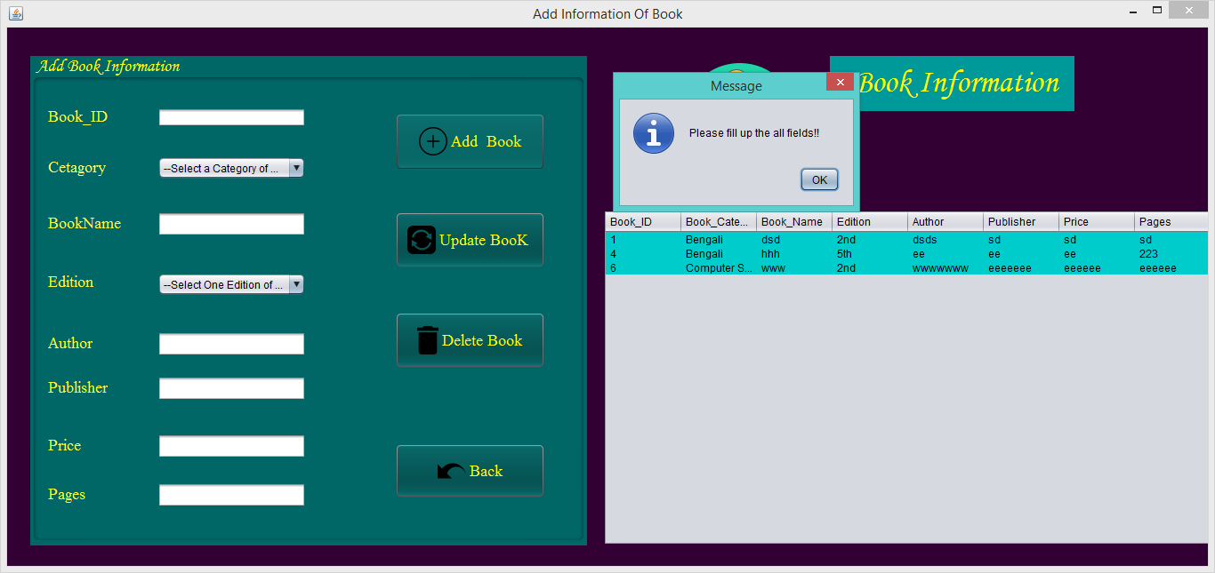

**Figure No.35: Testing New Book portion.**

# Part-2:

# Description: If the fields are empty.

**If the fields are empty** than this message will show after clicking on the “Delete Book” button.

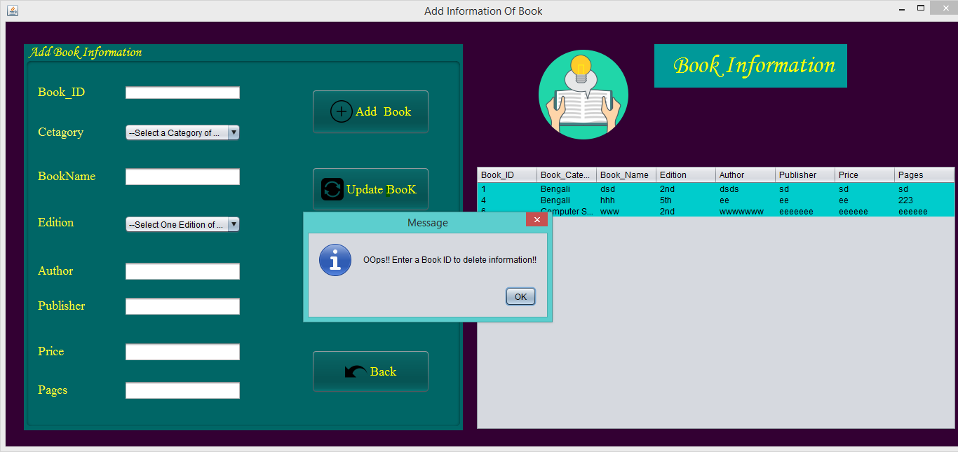

**Figure No.36: Testing New Book portion.**

# Part-3:

# Description: In order to add new book information.

First user has to fill up the all fields and then have to click on “Add book” button. After that this following message will show after clicking on the “Add Book” button.

Here User doesn’t need to type any book id because book id will generate automatically.

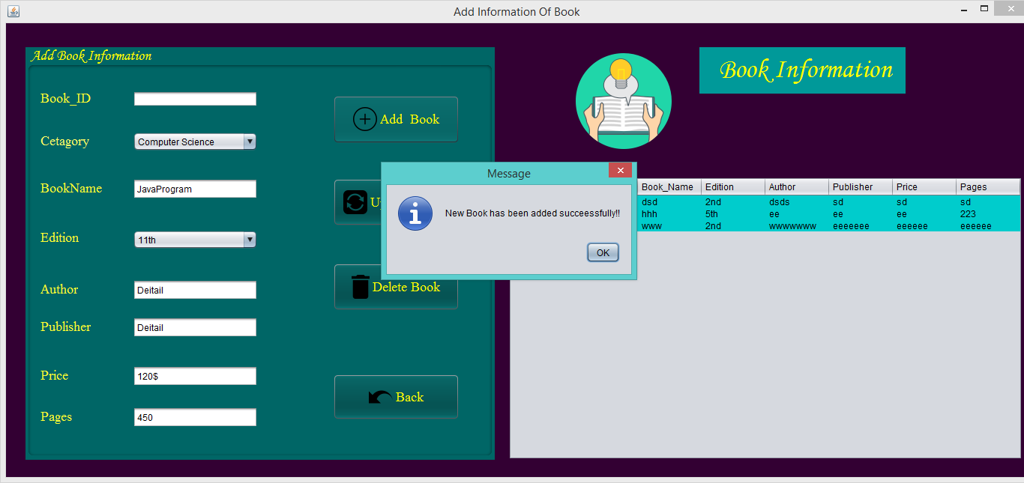

**Figure No.37: Testing New Book portion.**

# Part-4:

# Description:

After click on “ok” the **all fields will be cleared** and the **record will be saved in the following table.**

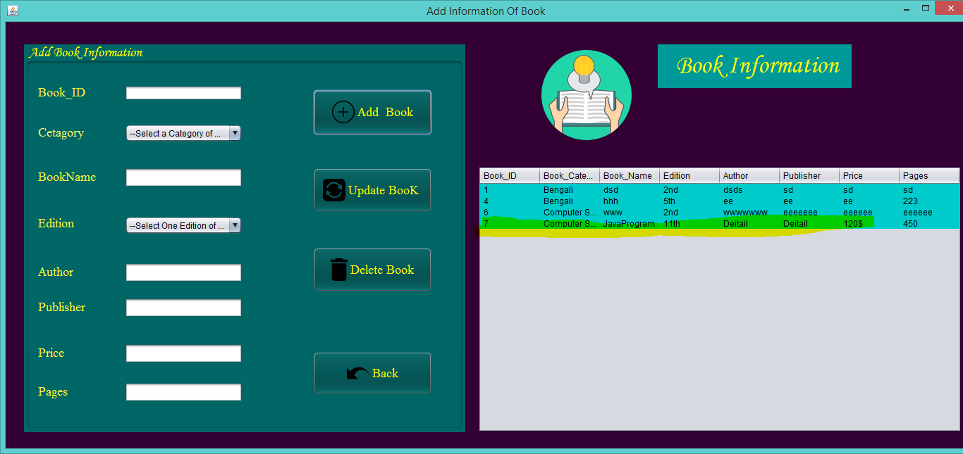

**Figure No.38: Testing New Book portion.**

# Part-5:

# Description: In order to update a book’s information.

First user has to type the book id of which book’s information is required to be updated. After that, user has to fill up the all fields with updated information and then have to click on “Update book” button. This following message will show after clicking on the “Update Book” button.

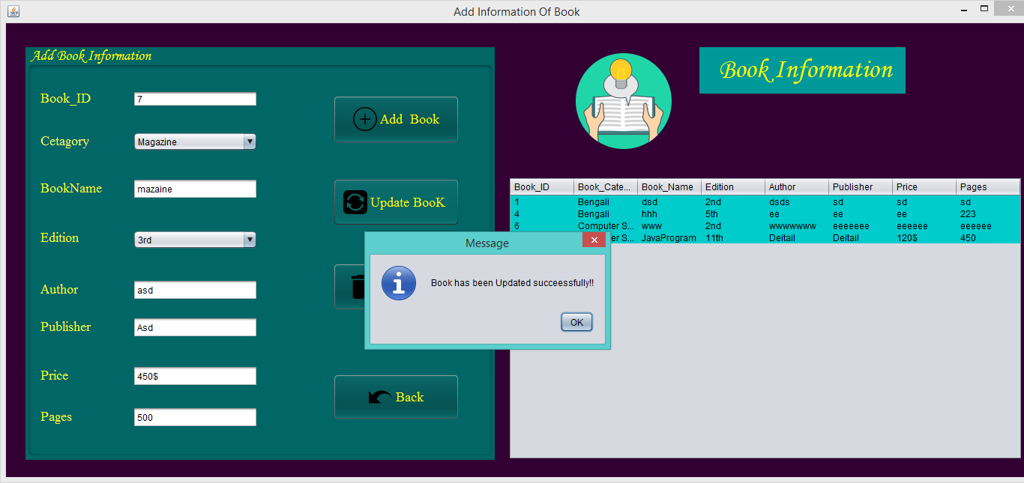

**Figure No.39: Testing New Book portion.**

# Part-6:

**Description:**

After click on “ok” the **all fields will be cleared** and the **record will be saved in the following table.**

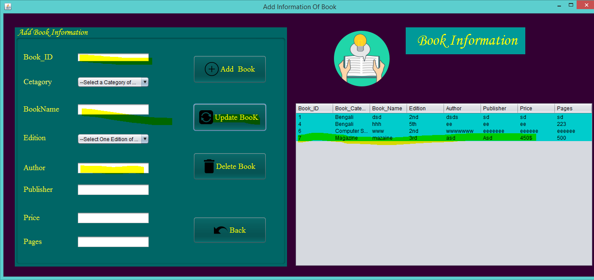

**Figure No.40: Testing New Book portion.**

# Part-7:

# Description: In order to delete a book’s information.

First user has to type the book id of which book’s information is required to be deleted. After that, user has to click on “Delete book” button. This following message will show after clicking on the “Delete Book” button.

**Now I want to delete Book_id 7:**

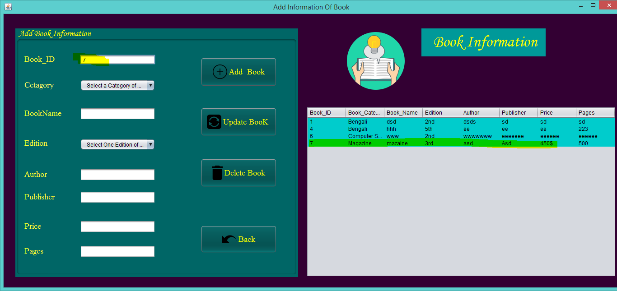

**Figure No.41: Testing New Book portion.**

**Now click on delete button:**

**Confirm message shown.**

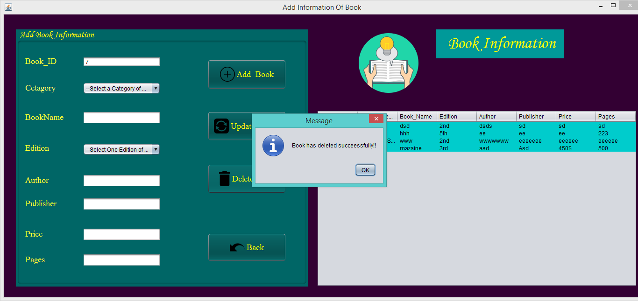

**Figure No.42: Testing New Book portion.**

**Now book id 7 is not in the table.**

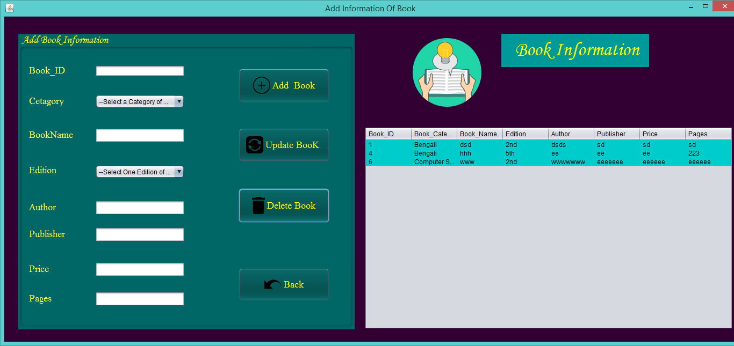

**Figure No.43: Testing New Book portion.**

# Part-8:

**Description:**

If user enter an invalid id that was not registered yet and try to update or delete that id from database than one error message will show to the user.

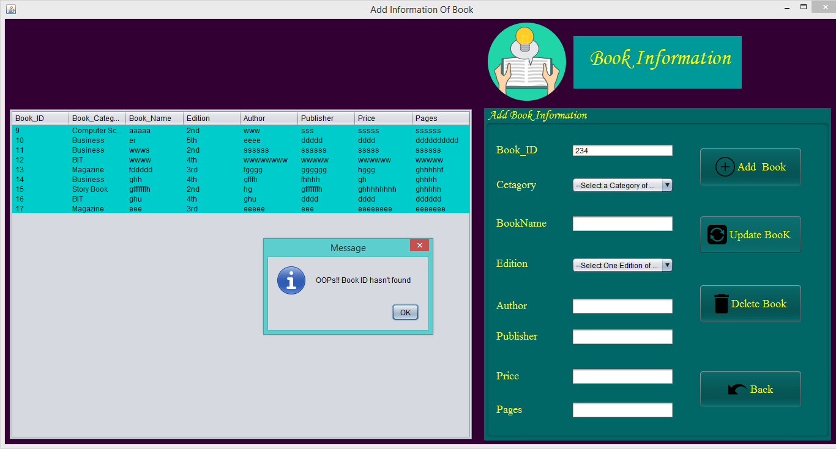

**Figure No.44: Testing New Book portion.**

# Part-9:

# Description:

**After, click on back button. It will come to the Home page again.**

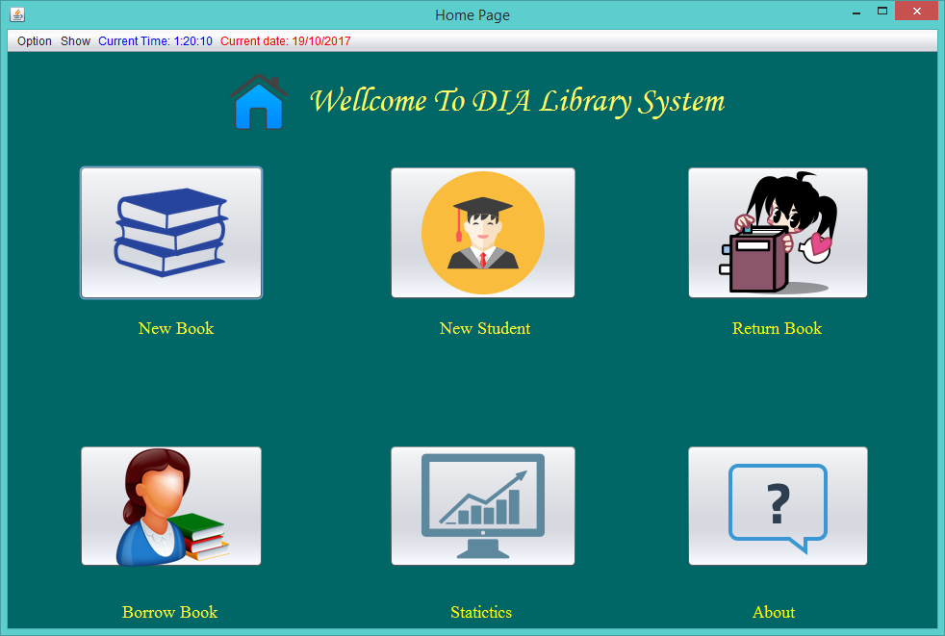

**Figure No.45: Testing New Book portion.**

# New Student portion testing:



# Part-1:

# Description: If the fields are empty.

**If the fields are empty** than this message will show after clicking on the “Add Student” or “Update Student” button.

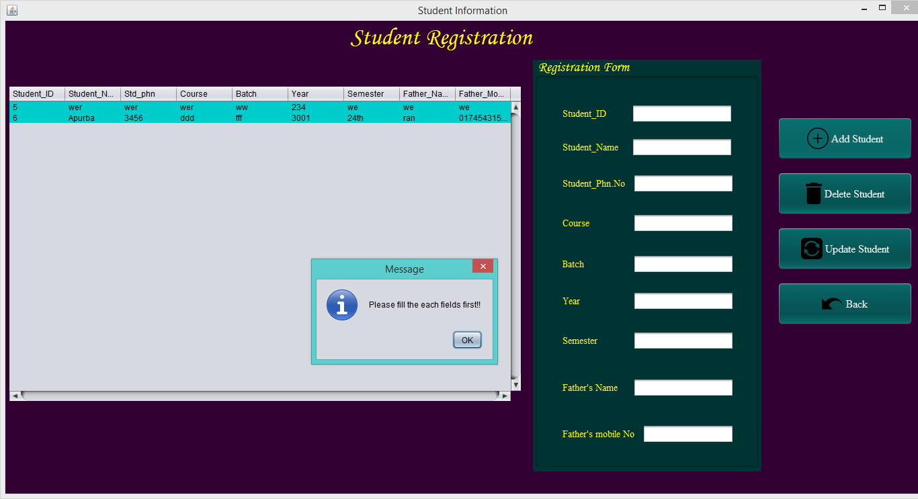

**Figure No.46: Testing New Student portion.**

# Part-2:

# Description:

**If the fields are empty** than this message will show after clicking on the “Delete Student” button.

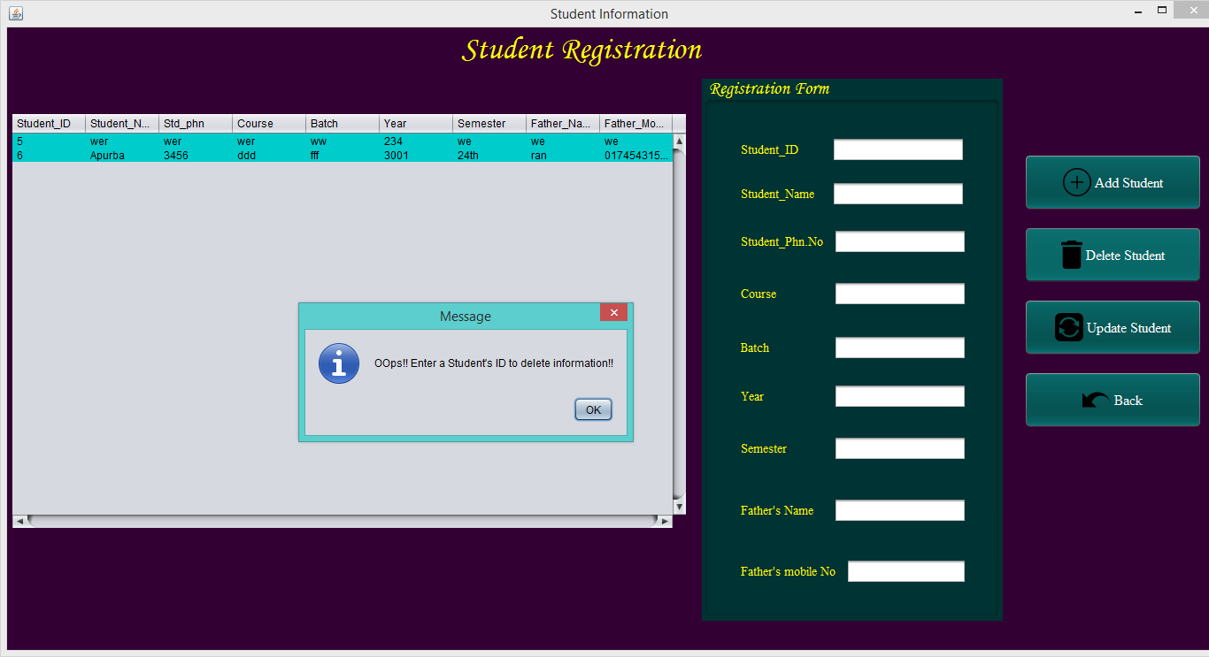

**Figure No.47: Testing New Student portion**

# Part-3:

# Description: In order to add new student information.

**First user has to fill up the all fields and then have to click on “Add Student” button.** After that this following message will show after clicking on the “Add Student” button.

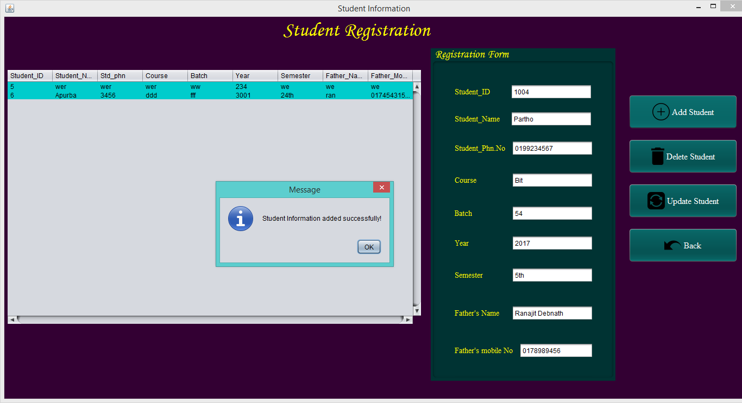

**Figure No.48: Testing New Student portion.**

# Part-4:

# Description:

After click on “ok” the **all fields will be cleared** and the **record will be saved in the following table.**

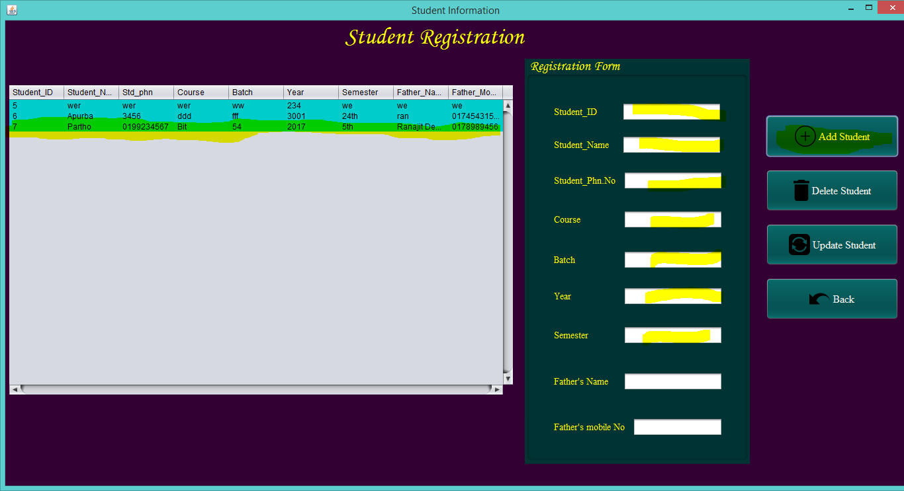

**Figure No.49: Testing New Student portion.**

# Part-5:

# Description: In order to update a student’s information.

First user has to type the student id of which student’s information is required to be updated. After that, user has to fill up the all fields with updated information and then have to click on “Update student” button. This following message will show after clicking on the “Update student” button.

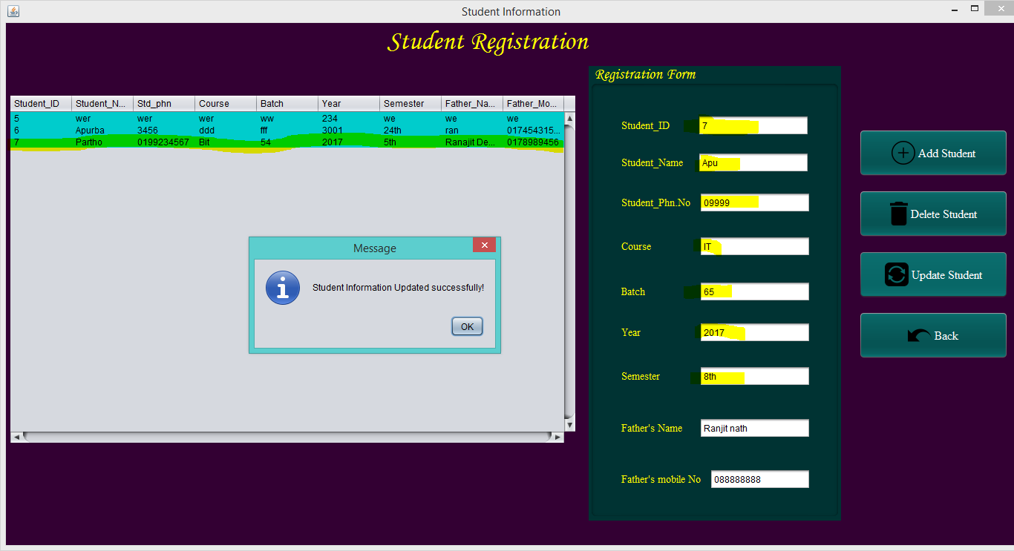

**Figure No.50: Testing New Student portion.**

# Part-6:

**Description:**

After click on “ok” the **all fields will be cleared** and the **record will be saved in the following table.**

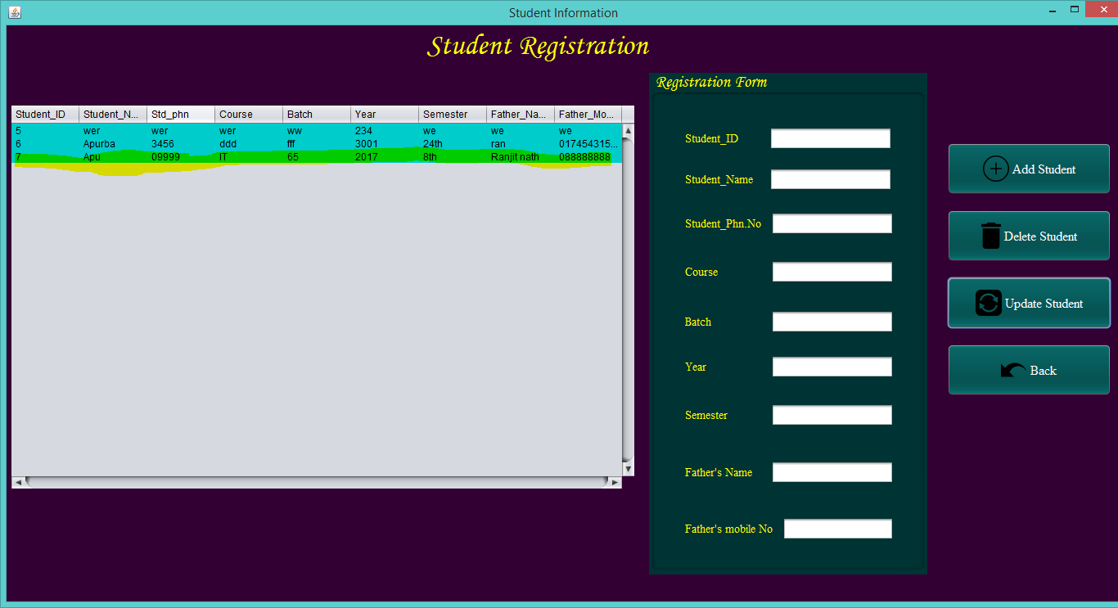

**Figure No.51: Testing New Student portion.**

# Part-7:

# Description: In order to delete a student’s information.

First user has to type the student id of which student’s information is required to be deleted. After that, user has to click on “Delete student” button. This following message will show after clicking on the “Delete student” button.

I want to delete student id 7:

I have type the id as 7 and click on “Delete Student” button

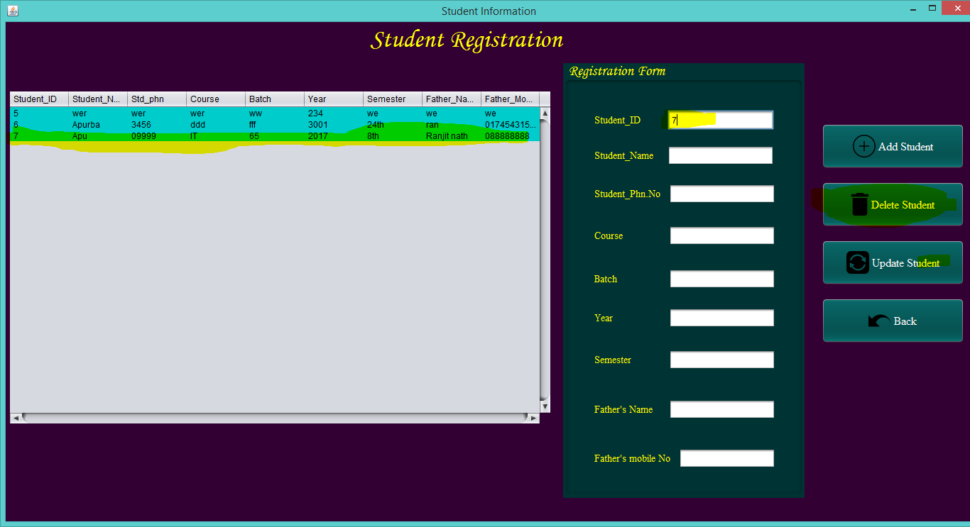

**Figure No.52: Testing New Student portion.**

**The confirmation message will be showed.**

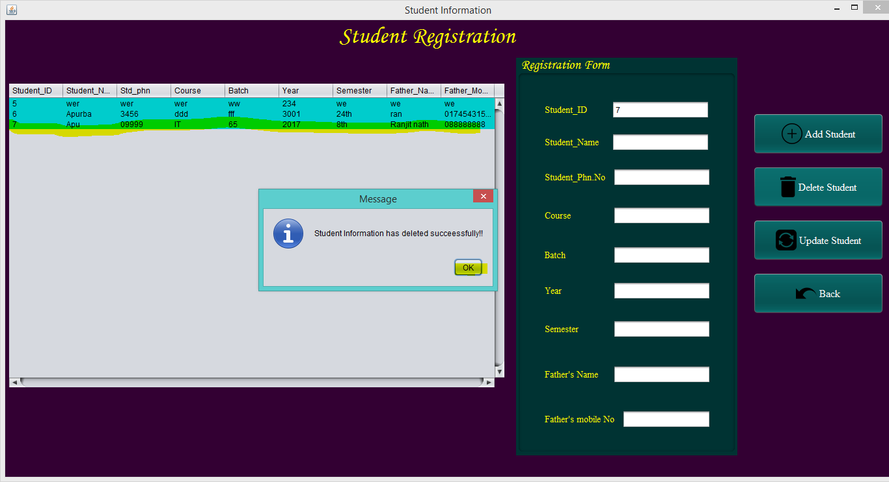

**Figure No.53: Testing New Student portion.**

After click on “ok” the **all fields will be cleared** and the **record will be saved in the following table.**

**Id 7 isn’t in the table now.**

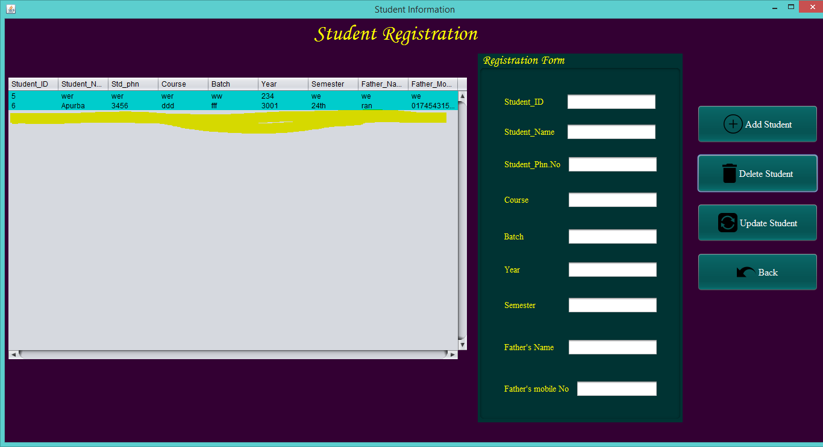

**Figure No.54: Testing New Student portion.**

# Part-8:

**Description:**

If user enter an invalid id that was not registered yet and try to update or delete that id from database than one error message will show to the user.

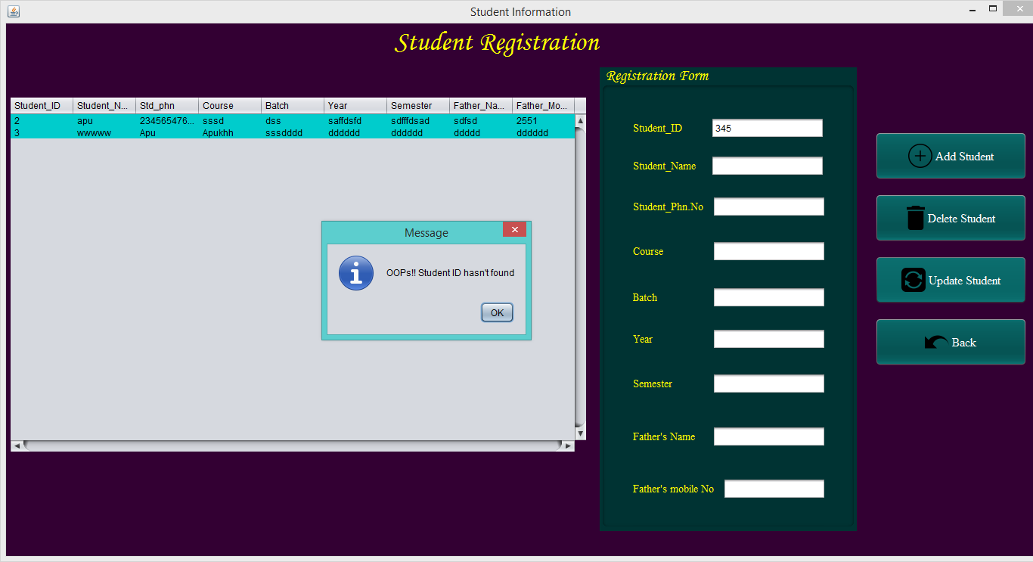

**Figure No.55: Testing New Student portion.**

# Part-9:

# Description:

After, click on back button. It will come to the Home page again.

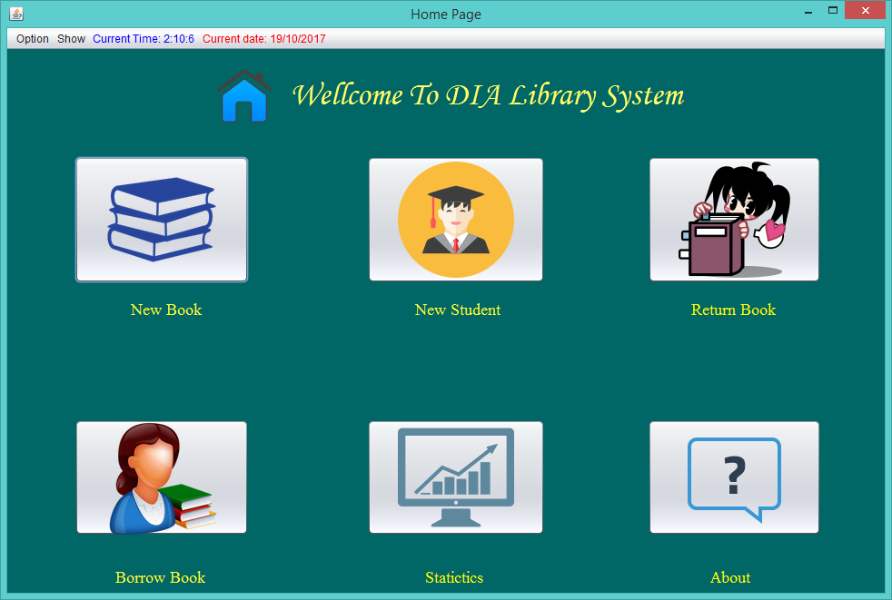

**Figure No.56: Testing New Student portion.**

# Borrow Book portion testing:



This page will appear after clicking on this button.



**Figure No.57: Testing Borrow Book portion.**

# Part-1:

# Description:

**If the book id is not correct** than this message will show after clicking on the “Search Book” button.

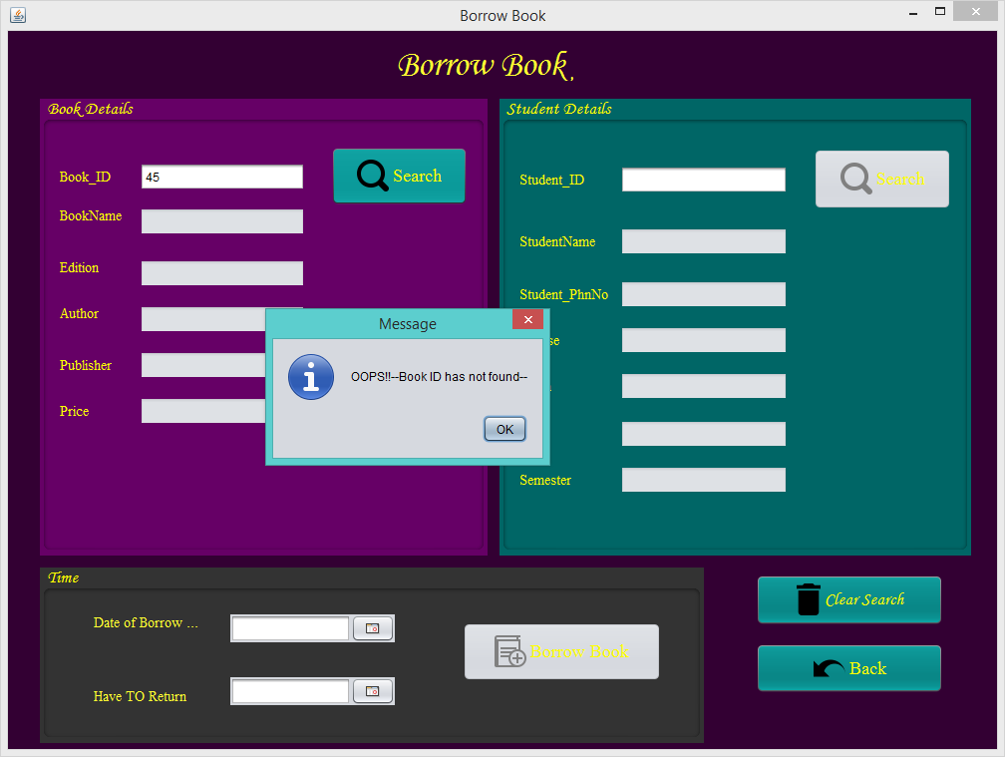

**Figure No.58: Testing Borrow Book portion.**

# Part-2:

# Description:

**If the fields are empty** than this message will show after clicking on the “Search Book” button.

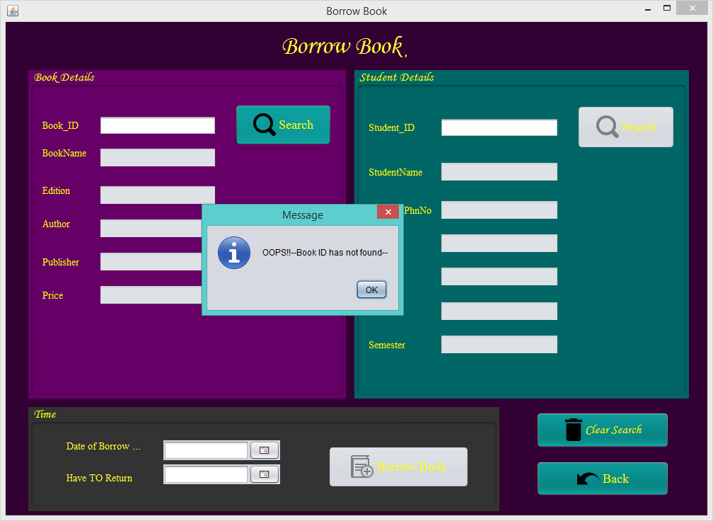

**Figure No.59: Testing Borrow Book portion.**

# Part-3:

# Description:

First user have to search a correct book id and then 2nd the search button for searching a student id will be activate and will show the result about all information of that specific book.

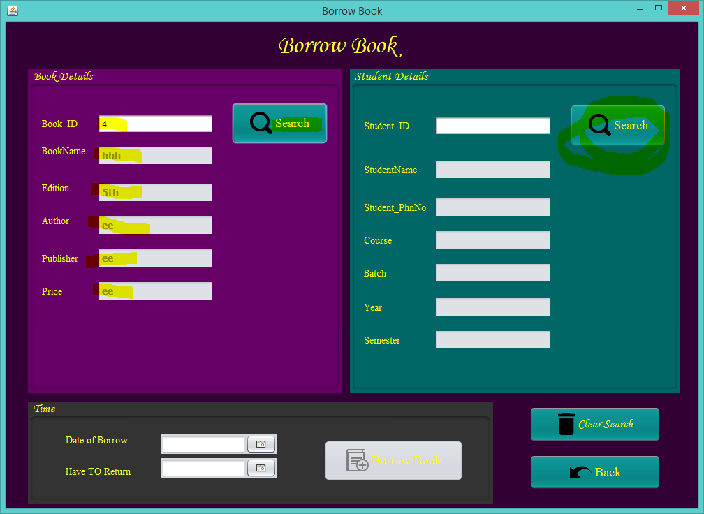

**Figure No.60: Testing Borrow Book portion.**

# Part-4:

# Description:

Now user can search with correct student id. After, search with a correct student id “Borrow book” button for borrowing a book with this book id and student id will be activated and user will get all the information about that specific student in those fields.

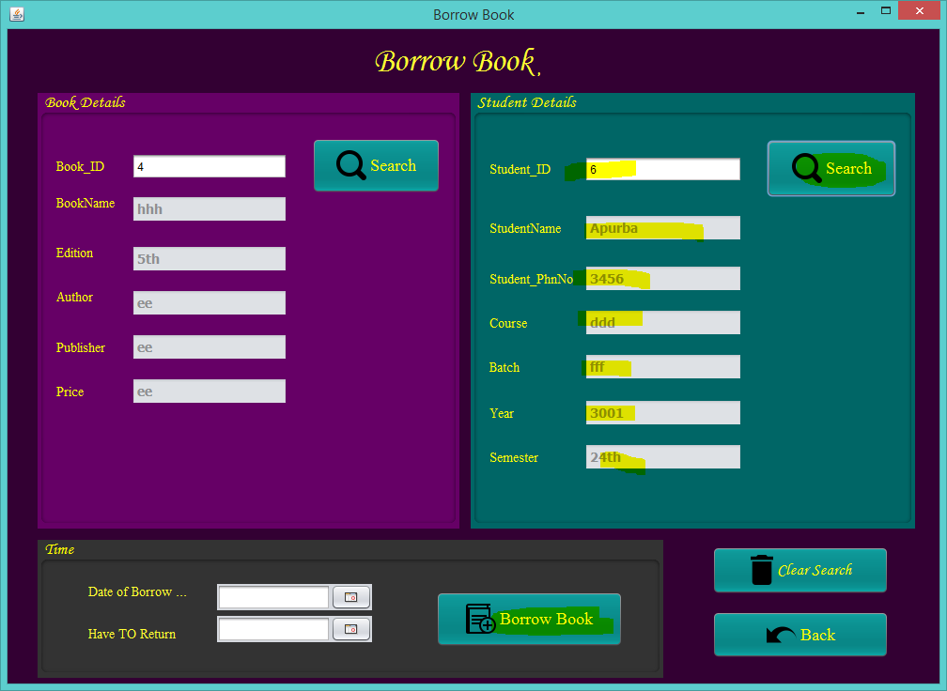

**Figure No.61: Testing Borrow Book portion.**

# Part-5:

# Description:

If user doesn’t type any correct student id in that field than this message will appear to user and the “Borrow Book” button will not be activated.

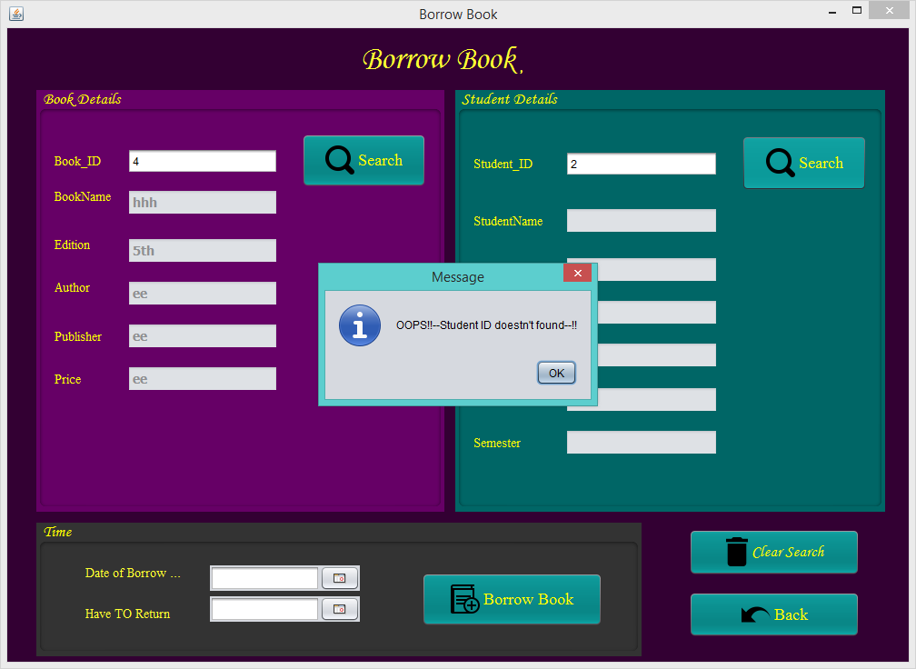

**Figure No.62: Testing Borrow Book portion.**

# Part-6:

# Description:

From this section, user can chose a borrow date manually. It cannot be before current dates. All the dates before current date are deactivated successfully. The screenshot is given below.

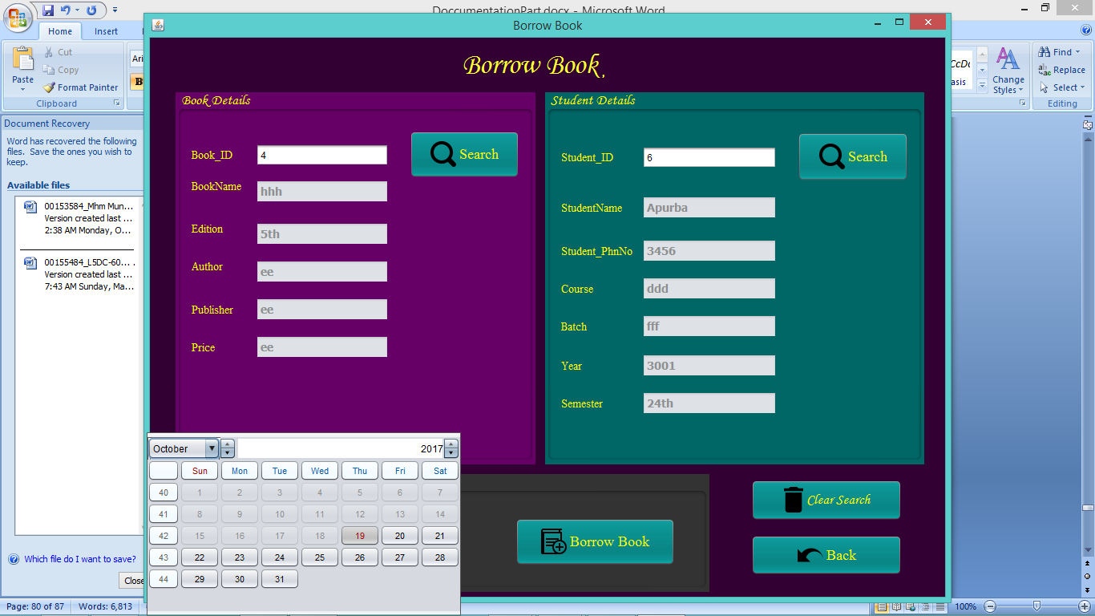

**Figure No.63: Testing Borrow Book portion.**

# Part-7:

# Description:

From this section, user can chose a maximum return date manually. It cannot be before current dates. All the dates before current date are deactivated successfully. The screenshot is given below.

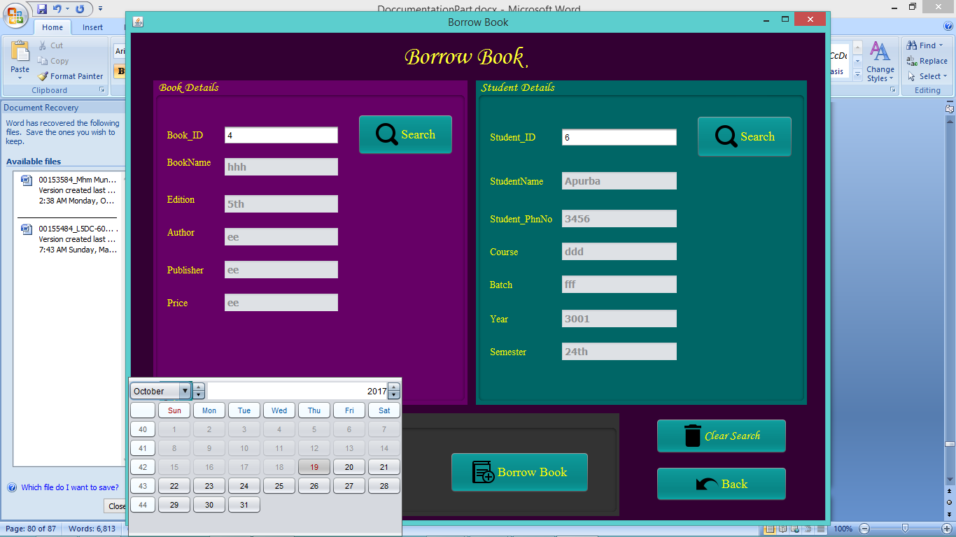

**Figure No.64: Testing Borrow Book portion.**

# Part-8:

# Description:

If user doesn’t select any borrow dates and click on “Borrow Book” button than this message will appear to user.

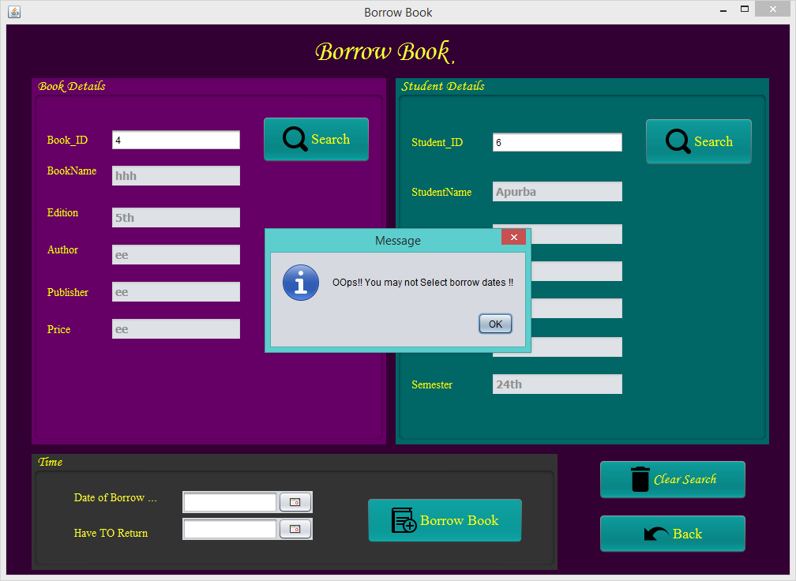

**Figure No.65: Testing Borrow Book portion.**

# Part-9:

# Description:

If user doesn’t select any maximum return dates and click on “Borrow Book” button than this message will appear to user.

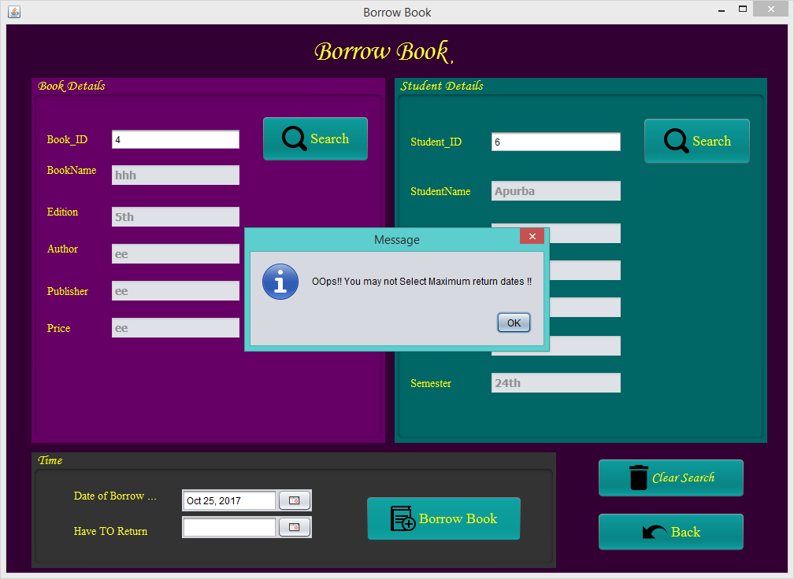

**Figure No.66: Testing Borrow Book portion.**

# Part-10:

# Description:

If user correctly search with a book id and a student id and click on “Borrow Book” button than this message will appear to user.

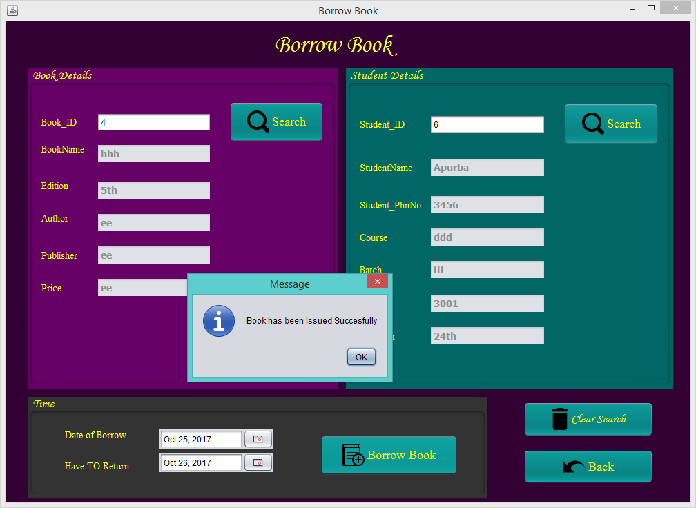

**Figure No.67: Testing Borrow Book portion.**

# Part-11:

# Description:

.After that if user click on this “Ok” than all record will save to the borrow details and all the fields will clear automatically.

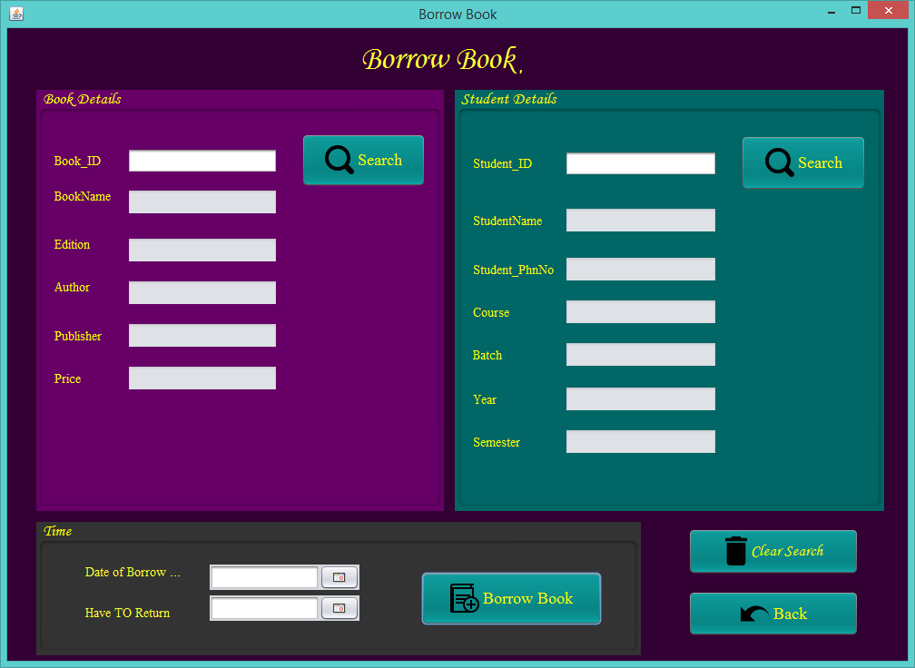

**Figure No.68: Testing Borrow Book portion.**

# Part-12:

# Description:

If user click on this “Clear search” button than all the fields will be cleared.



**Figure No.69: Testing Borrow Book portion.**

# Part-13:

# Description:

If user click on this “Back” button than it will come to the home page again.

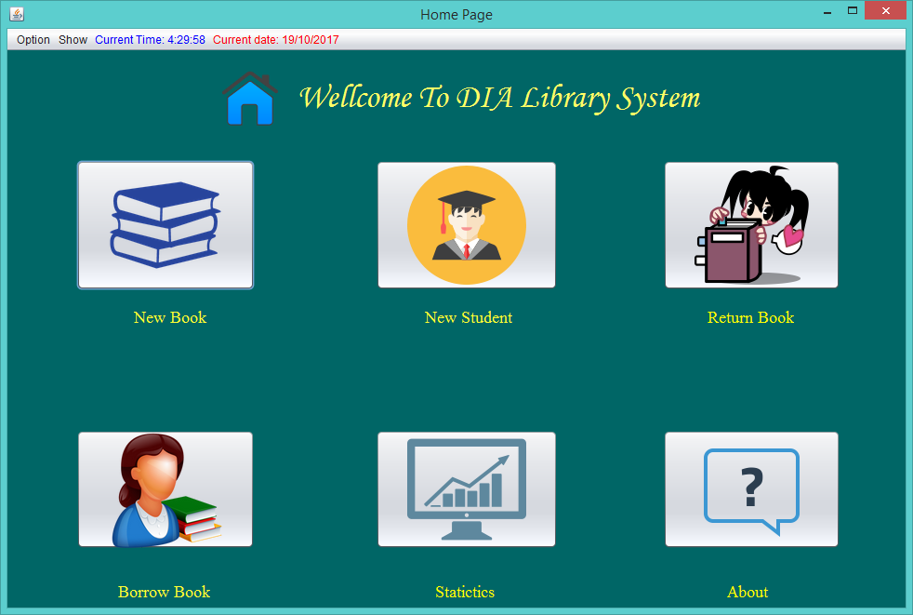

**Figure No.70: Testing Borrow Book portion.**

# Return Book portion testing:

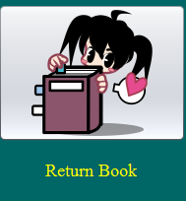

If any user clicks on that above button then this window will appear to the user.



**Figure No.71: Testing Return Book portion.**

# Part-1:

# Description:

**If the issue id is not correct that means this id may not valid or no book was issued with that id** than this message will show after clicking on the “Search Book” button.

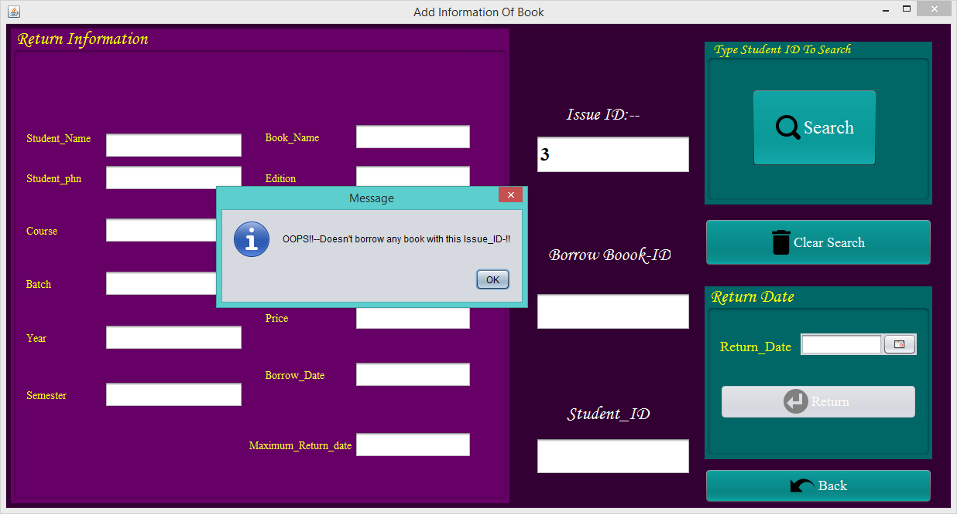

**Figure No.72: Testing Return Book portion.**

# Part-2:

# Description:

First user has to search a correct issue id who borrowed a book with a specific book id. After that, user will show the result about all information of that specific book.

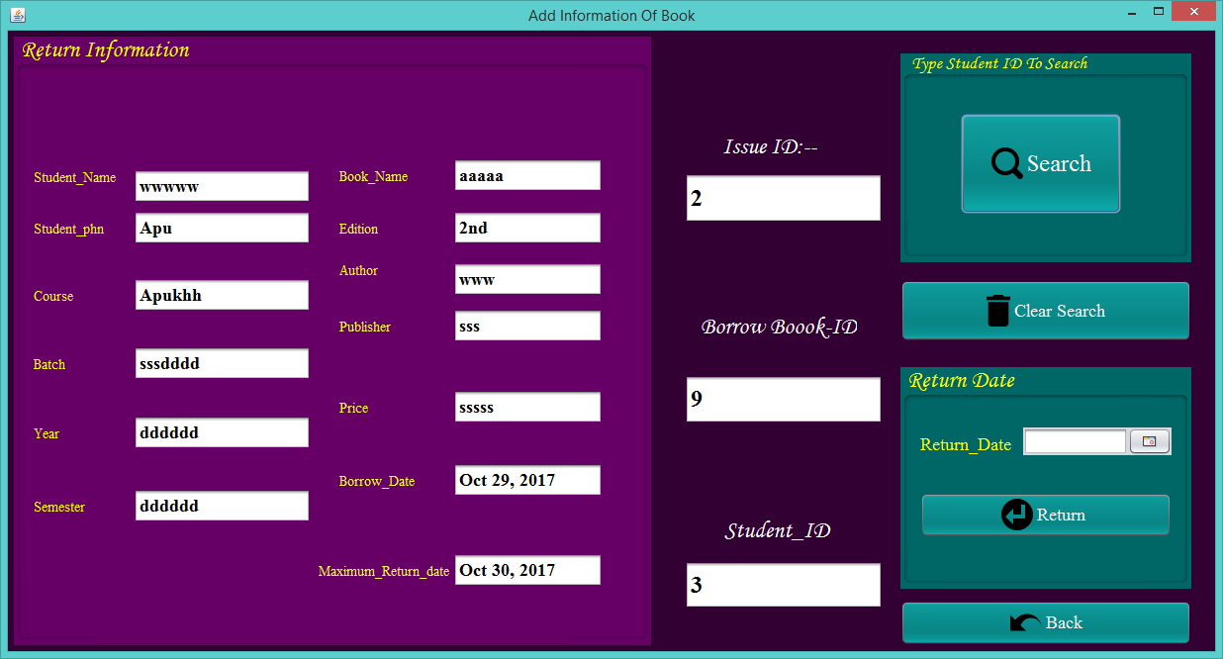

**Figure No.73: Testing Return Book portion.**

# Part-3:

# Description:

From this section, user can chose a return date manually. It cannot be before current dates. All the dates before current date has deactivated successfully. The screenshot is given below.

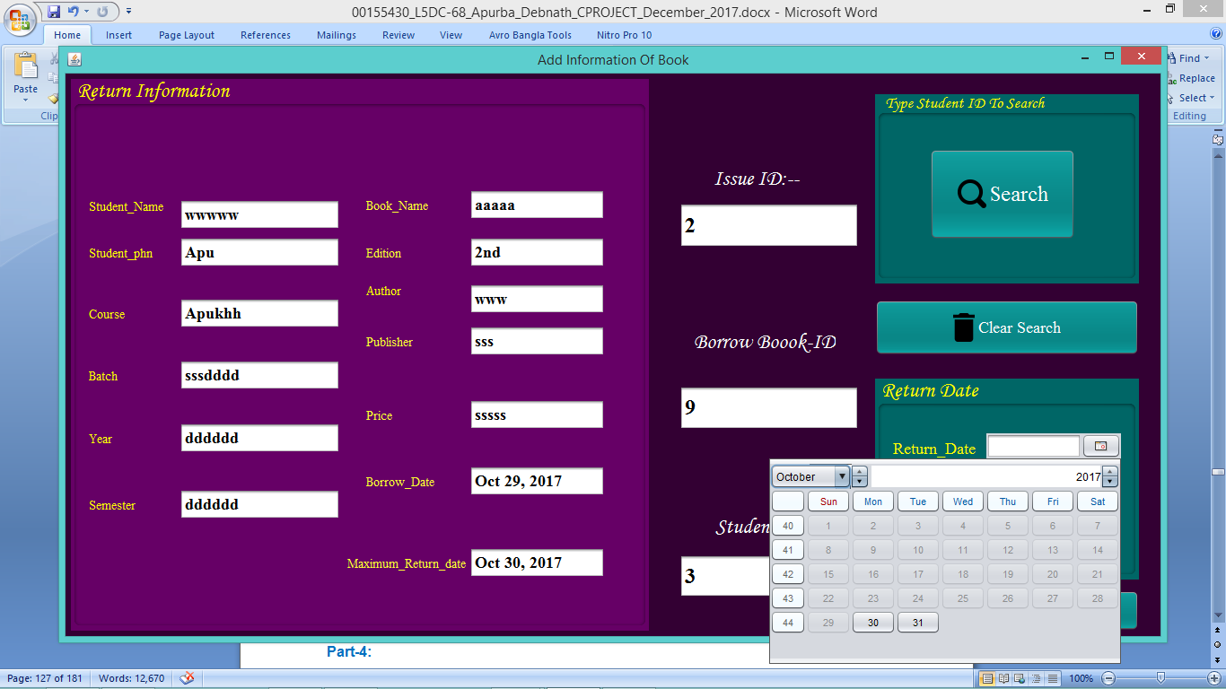

**Figure No.74: Testing Return Book portion.**

# Part-4:

# Description:

If user perfectly searches with a correct issue id and select a return dates and click on the “Return book” button than this confirm message will be appeared to that user.

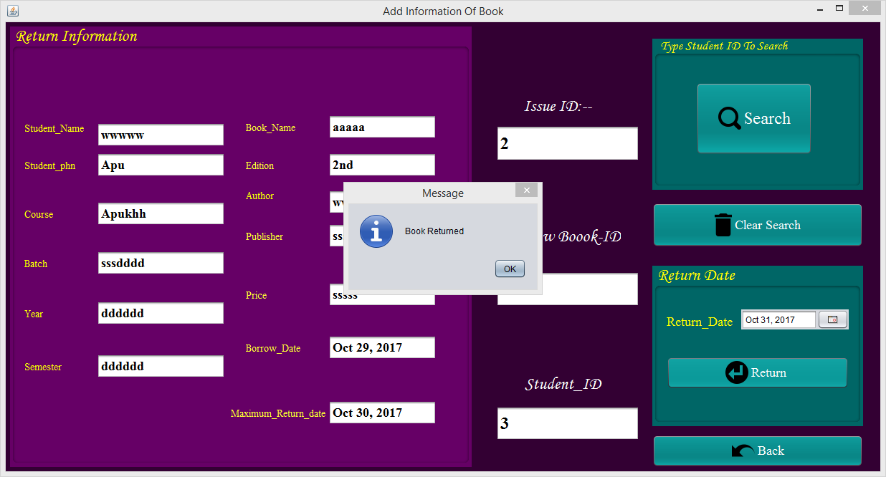

**Figure No.75: Testing Return Book portion.**

# Part-5:

# Description:

.After that if user click on this “Ok” than all record will save to the return details of statistic and all the fields will clear automatically.

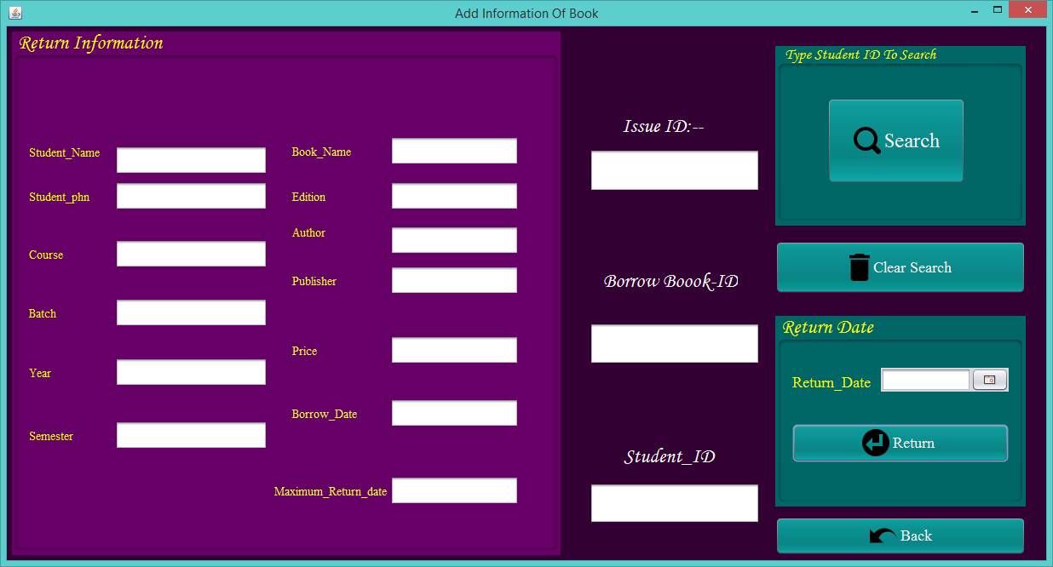

**Figure No.76: Testing Return Book portion.**

# Part-6:

# Description:

If user doesn’t select any return date than this warning mesaage will be appeared to the user.

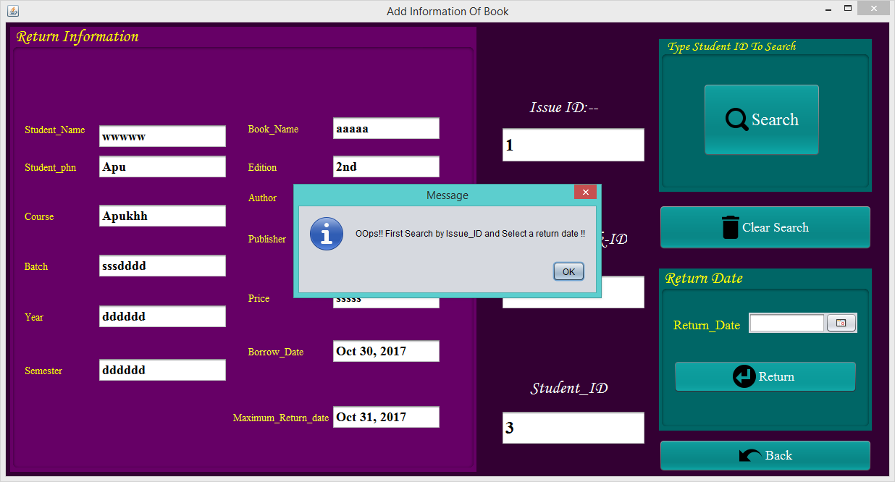

**Figure No.77: Testing Return Book portion.**

# Part-7:

# Description:

If user click on this “Clear search” button than all the fields will be cleared.

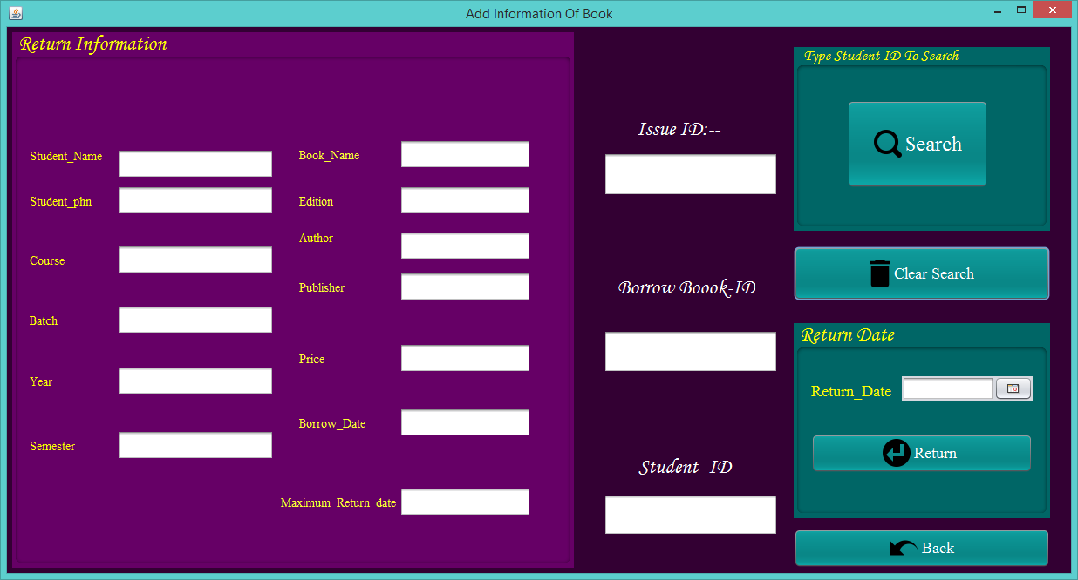

**Figure No.78: Testing Return Book portion.**

# Part-8:

# Description:

If user click on this “Back” button than it will come to the home page again.

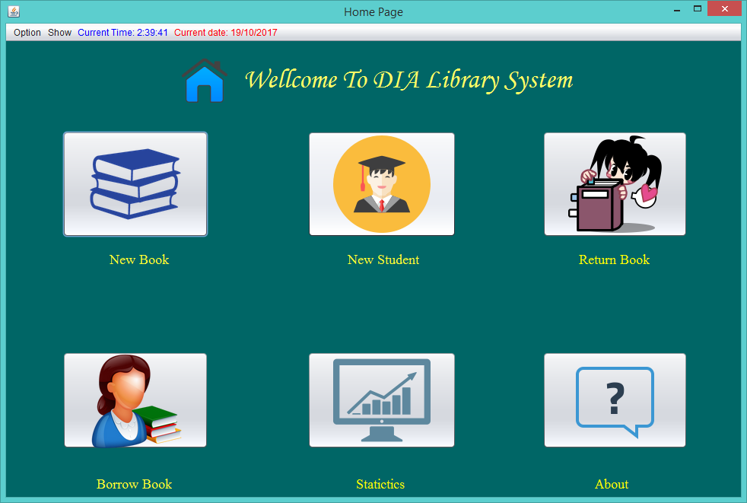

**Figure No.79: Testing Return Book portion.**

# Statistics portion testing:



# Part-1:

# Description:

When user clicks on this button then this following window will be appeared. User can show the borrow details and return details from these two tables.

**All return details appeared.**

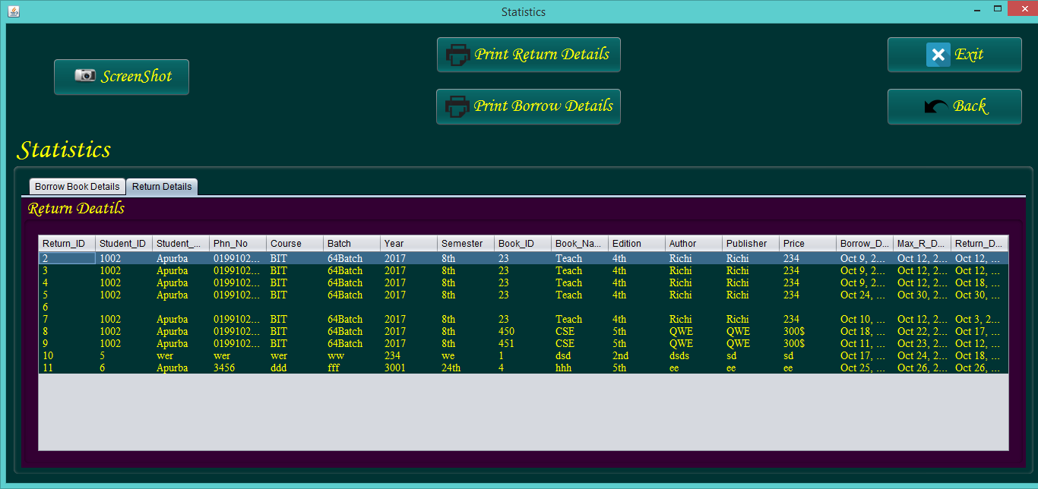

**Figure No.80: Testing Statistics portion.**

**All borrow details appeared.**

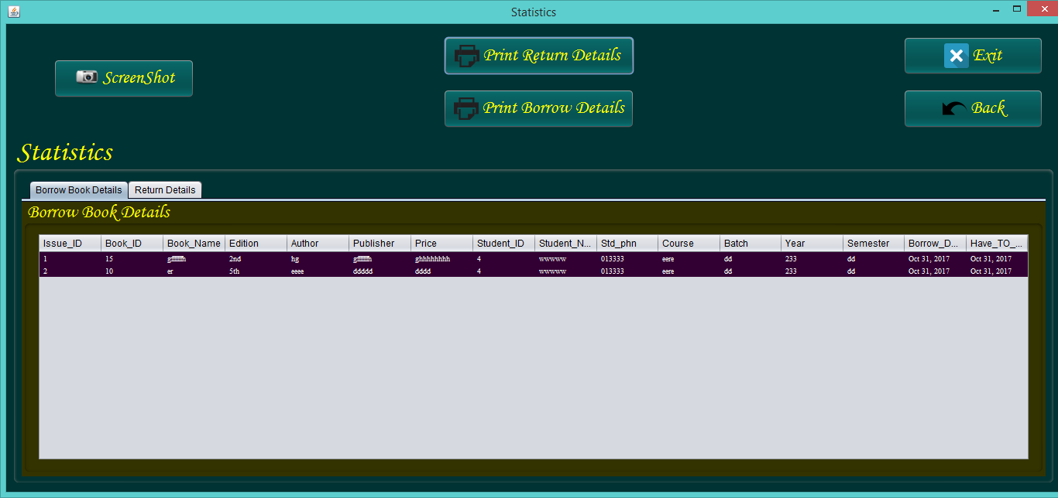

**Figure No.81: Testing Statistics portion.**

# Part-2:

# Description:

Now in this borrow details, if the user wants to return a book form issue id 2.



**Figure No.82: Testing Statistics portion.**

# Part-3:

# Description:

The user has to enter issue id 6 and click on search button. After that, get 10 as book id and student id as 4 which were issued with this issue id. Now user has to select a return date and click on return. Then it will appear a confirm message. The following testing screenshot is given below.

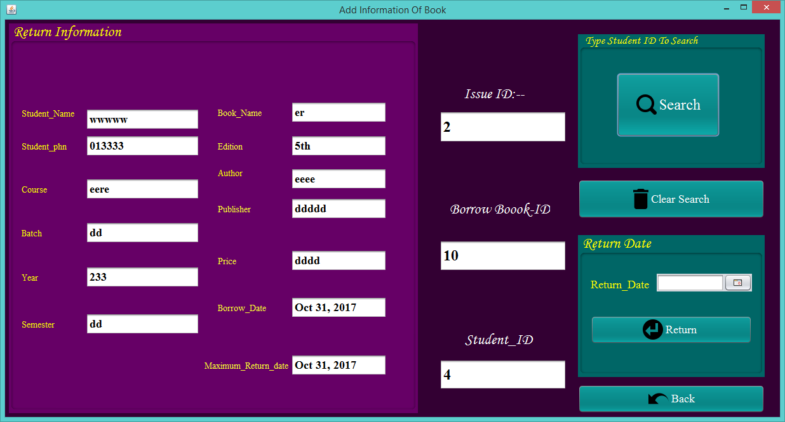

**Figure No.83: Testing Statistics portion.**

# Part-4:

# Description:

User has to select a return date in order to return this book.

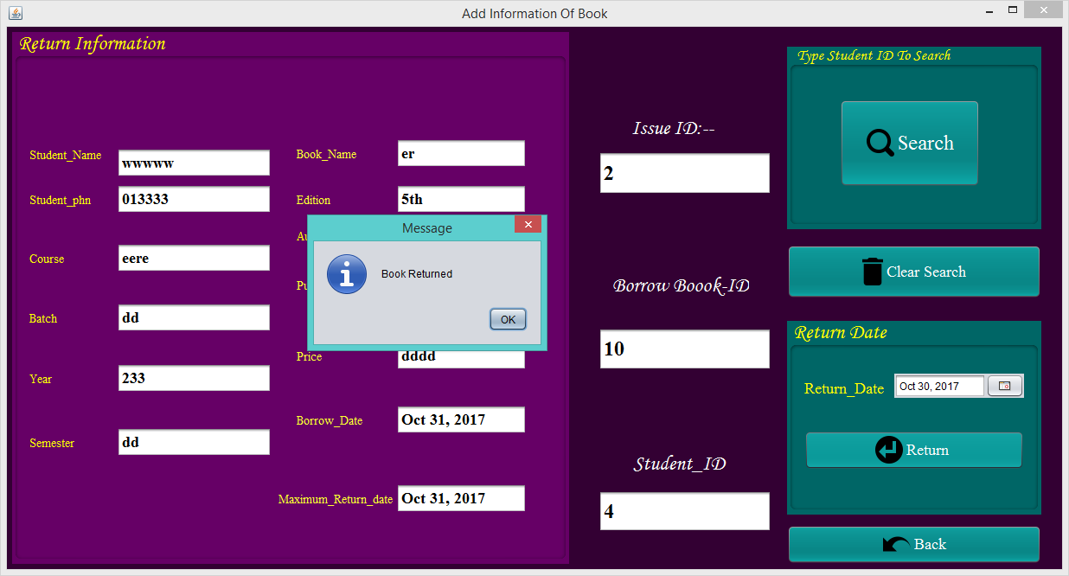

**Figure No.84: Testing Statistics portion.**

# Part-5:

# Description:

Now check the borrow details again. And the issue id 2 with the borrow book id 10 and student id 4 are not exist in the borrow details now. It has been deleted successfully.

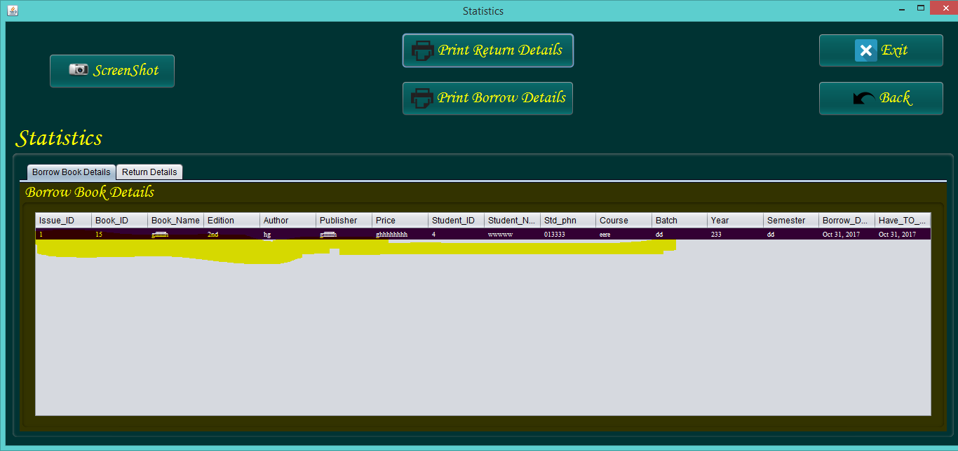

**Figure No.85: Testing Statistics portion.**

# Part-6:

# Description:

That issue id 1 with the borrow book id 10 and student id 4 has been added to the return details successfully. The following screenshot is given below.

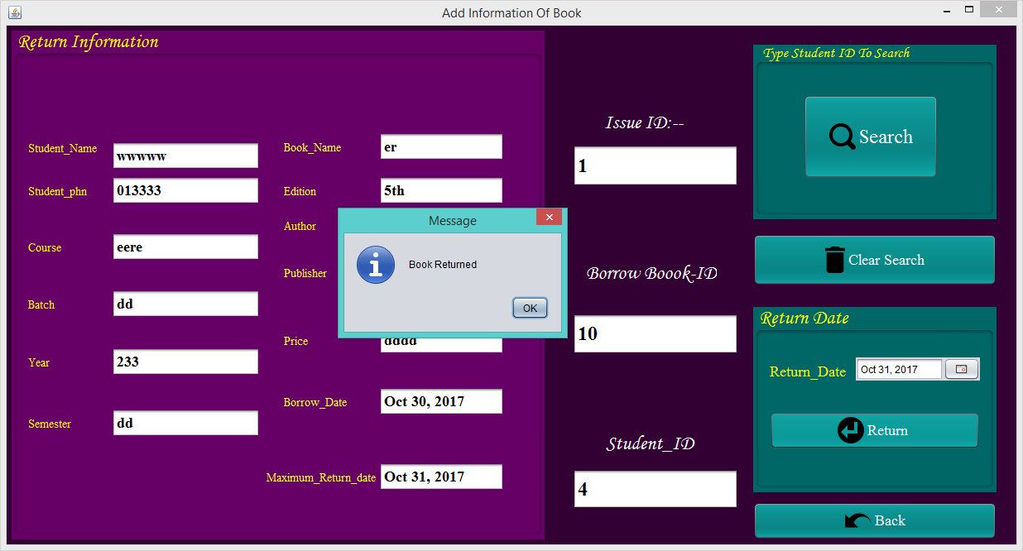

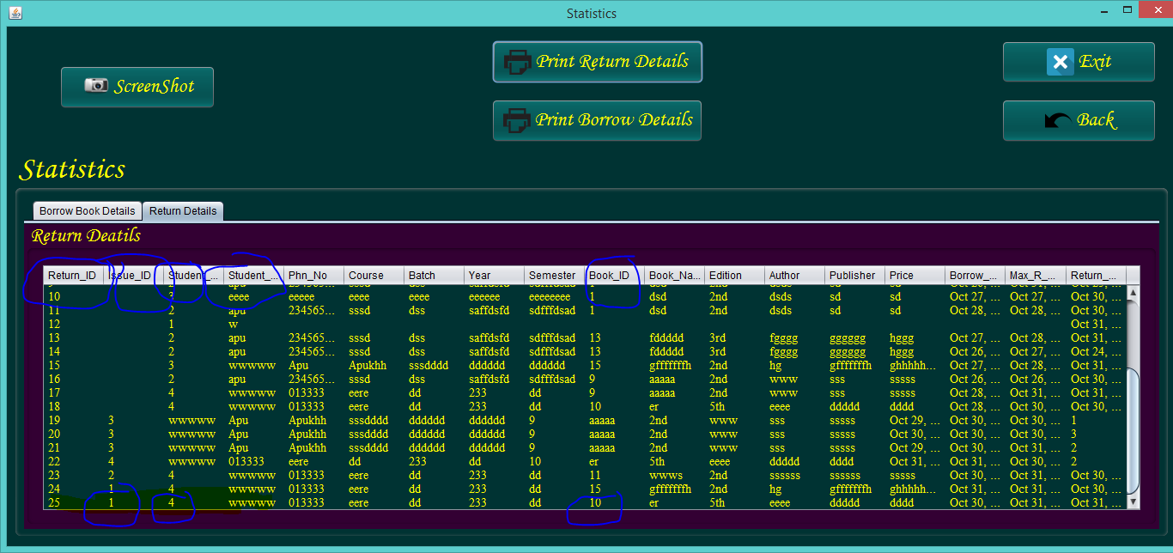

**Figure No.86: Testing Statistics portion.**

# Part-7:

# Description:

If user clicks on “Screenshot” button then screenshot of this whole window will be captured viewing a confirm massage.

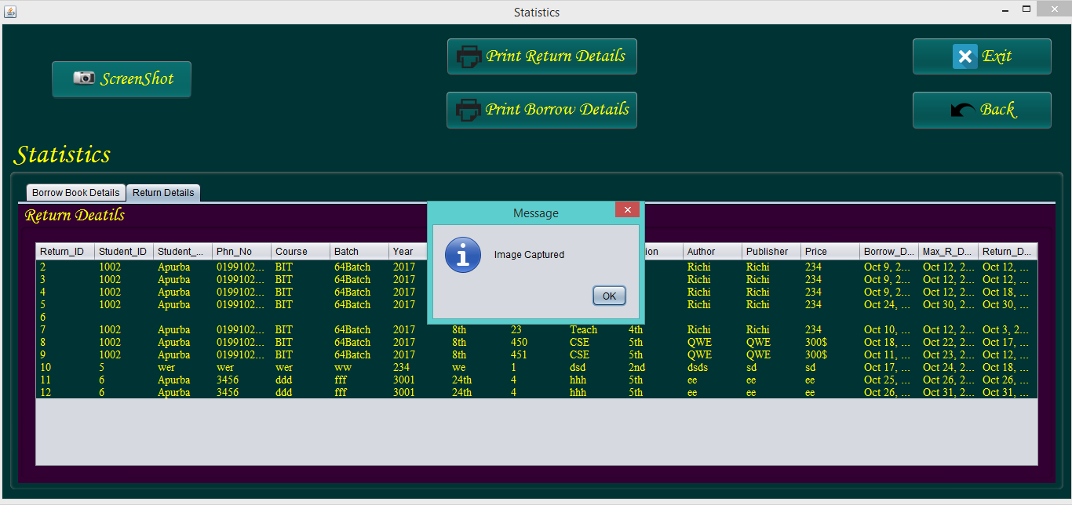

**Figure No.87: Testing Statistics portion.**

# Part-8:

# Description:

If any user clicks on the “Print Return Details” button then the print function will ready for print.

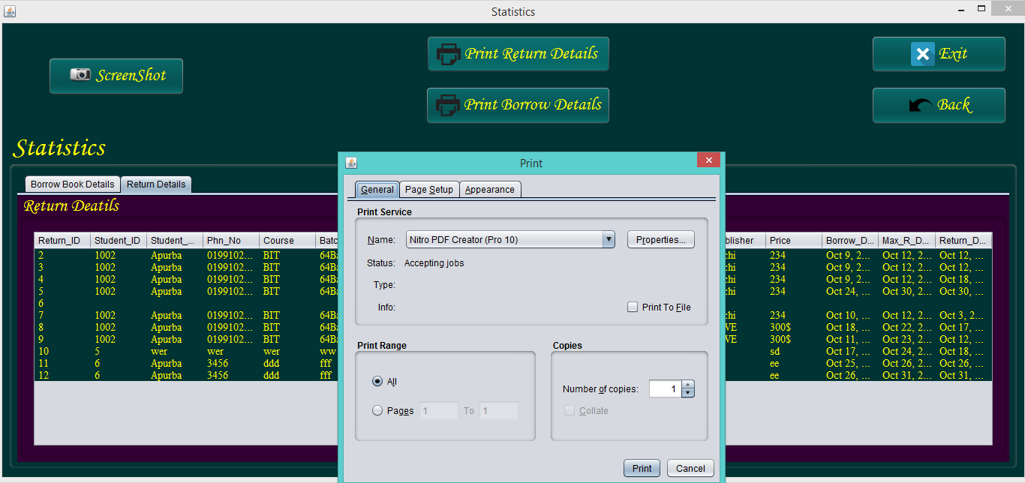

**Figure No.88: Testing Statistics portion.**

# Part-9:

# Description:

If user doesn’t have any printer, it can be saved as pdf file.

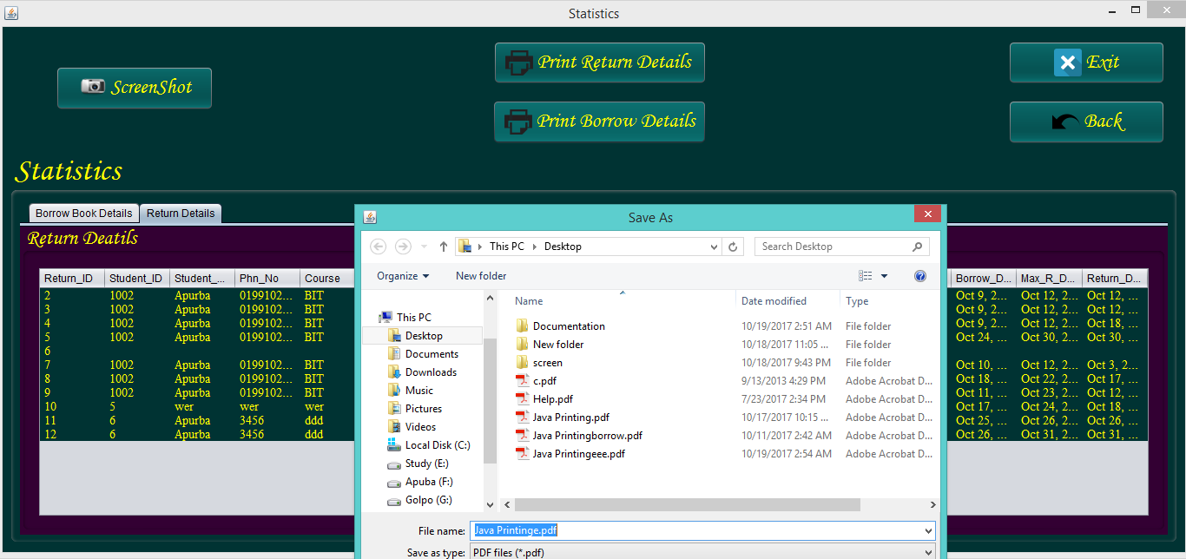

**Figure No.89: Testing Statistics portion.**

# Part-10:

# Description:

Print result of return details

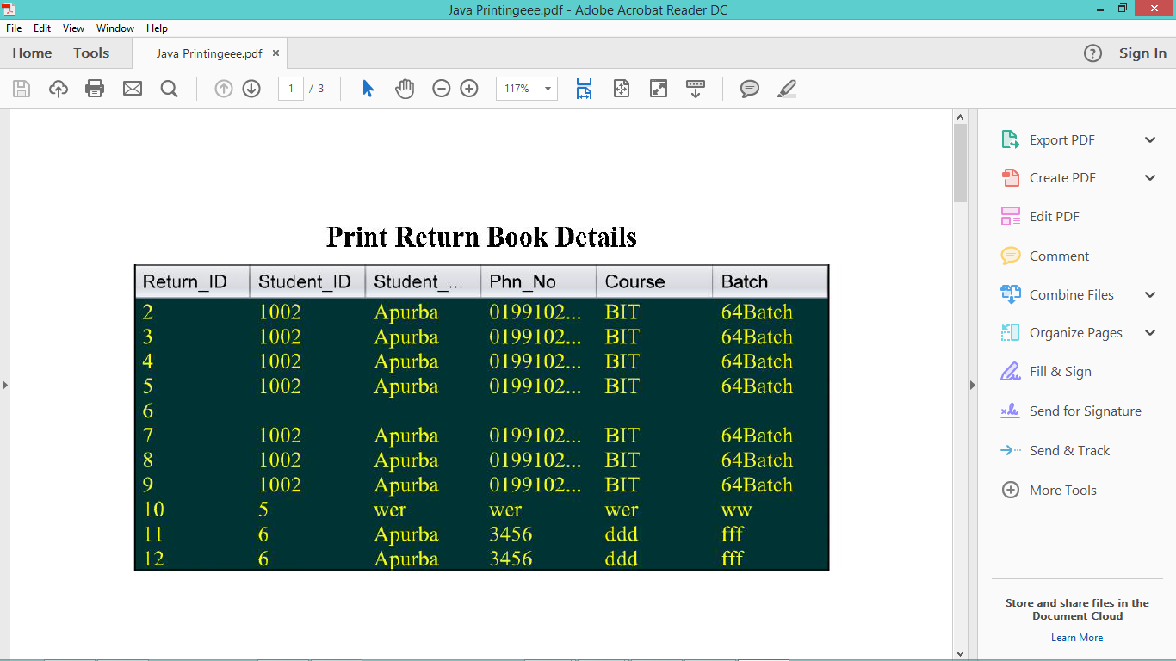

**Figure No.90: Testing Statistics portion.**

# Part-9:

# Description:

Print result of borrow details

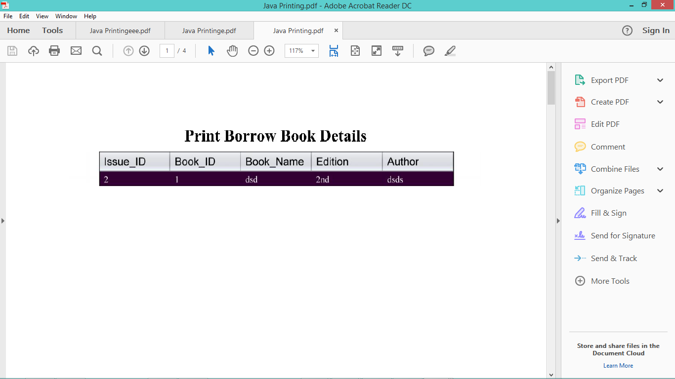

**Figure No.91: Testing Statistics portion.**

**About portion testing:**

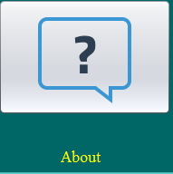

# Part-1:

# Description:

When user clicks on this button then this following window will be appeared.

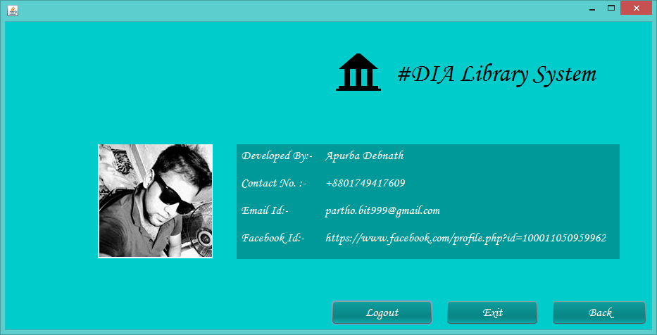

**Figure No.92: Testing About portion.**

# Part-2:

# Description:

If user click on this “Back” button than it will come to the home page again.

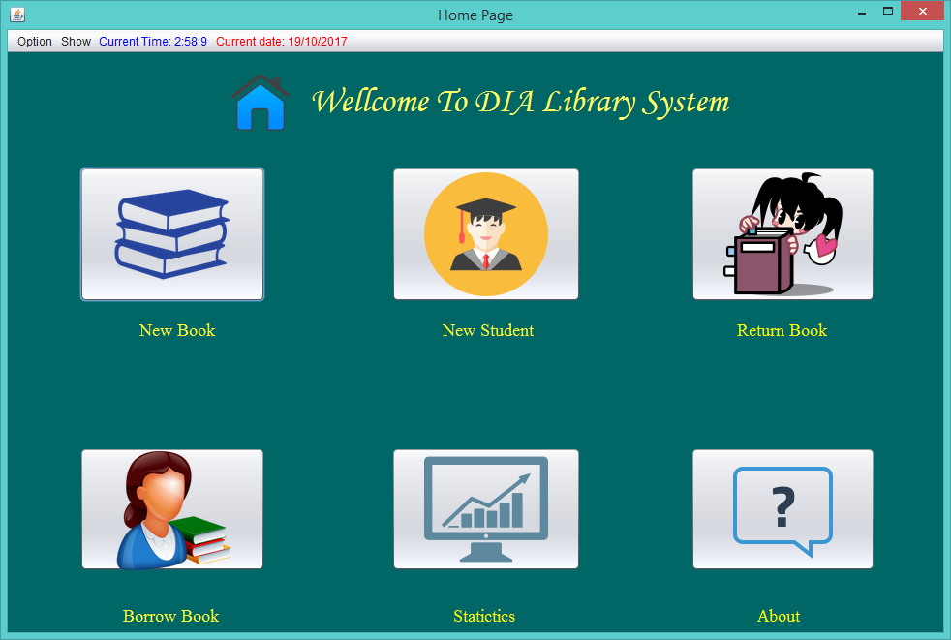

**Figure No.93: Testing About portion.**

# Part-3:

# Description:

If user click on this “logout” button than it will come to the login page again.



**Figure No.94: Testing About portion.**

# Usability testing:

|  |  |  |  |
| --- | --- | --- | --- |
| Page name | Expected pages | Actual pages | Status |
| Login Page | **login_form.java**  **NewAccount.java**  **Javaconnect.java(class)**  **Forgot.java**  **Loading.java** | **login_form.java**  **NewAccount.java**  **Javaconnect.java(class)**  **Forgot.java**  **Loading.java** | **Success** |
| Create Account | **login_form.java**  **NewAccount.java**  **Javaconnect.java(class)** | **login_form.java**  **NewAccount.java**  **Javaconnect.java(class)** | **Success** |
| Forget password  page | **login_form.java**  **Javaconnect.java(class)**  **Forgot.java** | **login_form.java**  **Javaconnect.java(class)**  **Forgot.java** | **Success** |
| Home page | **login_form.java**  **Javaconnect.java(class)**  **NewBook.java**  **ReturnBook.java**  **Borrow_Book.java**  **Statistics.java**  **Student.java**  **About.java**  **HomePage.java** | **login_form.java**  **Javaconnect.java(class)**  **NewBook.java**  **ReturnBook.java**  **Borrow_Book.java**  **Statistics.java**  **Student.java**  **About.java**  **HomePage.java** | **Success** |
| Book Information  page | **Javaconnect.java(class)**  **NewBook.java**  **HomePage.java** | **Javaconnect.java(class)**  **NewBook.java**  **HomePage.java** | **Success** |
| Student Information  page | **Javaconnect.java(class)**  **Student.java**  **HomePage.java** | **Javaconnect.java(class)**  **Student.java**  **HomePage.java** | **Success** |
| Borrow Book  Page | **Javaconnect.java(class)**  **Borrow_Book.java**  **HomePage.java** | **Javaconnect.java(class)**  **Borrow_Book.java**  **HomePage.java** | **Success** |
| Return  Book  page | **Javaconnect.java(class)**  **ReturnBook.java**  **HomePage.java** | **Javaconnect.java(class)**  **ReturnBook.java**  **HomePage.java** | **Success** |
| Statistics  page | **Javaconnect.java(class)**  **Statistics.java**  **HomePage.java** | **Javaconnect.java(class)**  **Statistics.java**  **HomePage.java** | **Success** |
| About page | **login_form.java**  **About.java**  **HomePage.java** | **login_form.java**  **About.java**  **HomePage.java** | **Success** |

# 8. Implementation

# Introduction:

Implementation is a method that turns the strategies and plan into action. In a word, here implementation is the required process that turns the system to be operational. In this section, I will describe about the required implementation plan for this system and about the required training plan which will enable user to use this system easily.

# Implementation Plan:

Implementation plan or strategies is a section which represent the overall deployment strategies in order to address the entire required elements as deliverables for the required system. So it is the vital and most important phase for a system development. It is initially written in design phase and planned before. The implementation plan should be checked before start in order to confirm all the assumptions are made or not and time frames that are given is realistic or not. There are several types of implementation plan such as Big bang, parallel, pilot etc.

# These are described below:

* **Big bang installation:**

Big bang installation is the strategy where we can replace the current system with the new system. This replacement process is occurred in a period of time. The implementation is so faster with big bang adoption than other methods like pilot, parallel adoption phase etc.

* **Pilot installation:**

In pilot installation strategy we can run the current system beside the new system until the current system will replaced with the new system. This is a software and hardware migration process which includes rolling out the new system with a small group of user for testing and evolutions.

* **Parallel installation:**

In this implementation we can install both systems at the same time in a parallel way until the new system is considered to be successfully completed.

* **Phased Installation or adoption:**

In this implementation process we can roll out the new system inclemently.

(Rouse, n.d.)

But in order to be a unique system and I don’t require any of these. There is no need to change the current system with a new one. So, the system doesn’t require implementing by using these approaches.

# Data Migration:

After installation of this system, user needs to send some data into database by creating a new user account in order to login to this system. After that, the database matches those data during login to this system. After that, when user add new book’s information or new student’s information then all the information will transfer to the database. Thus all the data that are inserted by human is transferred or retrieve from database. Thus data migration works.

# Training:

Training is also the important part for understanding the all functionalities of the project and it will say how the system will work and behave. Some plan should be carried out outside the project for training to trainee and there should be involve a learning professional such as a training instructor, consultant or advisor. But for this proposed system only a personal computer like laptop or desktop will be required. The system has a simple, easy, efficient and user friendly interface so there will no need any kind of training and user will easily installed this software and can be also used it easily.

# 9. Critical Appraisal

# Introduction:

In this part of documentation, I have to describe about the system strengths and weakness and also about the further development. In this section, I will describe about how to make this system even better than previous development.

# System strengths:

* Efficient computerized system that reduces the human mistakes.
* Easy to use
* User friendly GUI.
* Highly secured.
* More efficient for managing a library.
* More efficient for librarian or library manager.
* No internet connection required to manage and run it.
* Reduces time and effort.
* Easy to manage.

# System weakness:

* Platform specific as it is a desktop based application only.
* Can be added some additional features.
* Only requirement specific.

# Further development:

There are many additional features that can be added in future as further development.

1. Can be added a late fine functions for late return.
2. Can be added a super admin for giving the permission to access and manage this application.
3. Can be made this application more users friendly.
4. Can be added a student section for their use.
5. Can be made this application more dynamic.

# Conclusion:

A library management system is essential for both student and teacher for their learning purpose. It basically help librarian to manage library in an effective way. So I have developed this system. I have used java as programming and sqlite database to develop this system. As it is my first project in java, I have learnt many things from it. I have learnt how to make a project step by step in the time duration. The time is a important fact for this. I don’t enough skill before but now I have learnt how to analysis, design, implementation, test etc. In further development, I will try to add extra functionalities to this project in order to make this project more efficient for librarian.

# References:

businessdictionary.com *http://www.businessdictionary.com/definition/economic-feasibility.html*, [Online], Available: <http://www.businessdictionary.com/definition/economic-feasibility.html> [08 Oct 2017].

DSDM Atern Handbook (2008) *www.agilebusiness.org*, [Online], Available: <https://www.agilebusiness.org/content/moscow-prioritisation-0> [07 Oct 2017].

evirtualservices.com *http://www.evirtualservices.com/technical-feasibility*, [Online], Available: <http://www.evirtualservices.com/technical-feasibility> [08 Oct 2017].

investopedia.com *www.investopedia.com*, [Online], Available: <http://www.investopedia.com/terms/f/feasibility-study.asp> [08 Oct 2017].

Katimuneetorn, P. (2008) *www.umsl.edu*, [Online], Available: <http://www.umsl.edu/~sauterv/analysis/F08papers/Katimuneetorn_Feasibility_Study.html> [08 Oct 2017].

Katimuneetorn, P. (2008) *www.umsl.edu*, [Online], Available: <http://www.umsl.edu/~sauterv/analysis/F08papers/Katimuneetorn_Feasibility_Study.html> [07 Oct 2017].

Marc Clifton, J.D. (2003) *www.codeproject.com*, 29 Sep, [Online], Available: <https://www.codeproject.com/Articles/5097/What-Is-DSDM> [08 Oct 2017].

Mazonde, L. (2017) *www.bibliotechzw.com*, 07 Jul, [Online], Available: <https://www.bibliotechzw.com/blog/5-reasons-why-a-library-should-use-a-library-management-system/> [7 Oct 2017].

michaelbierman (2017) *michaelbierman.wordpress.com*, 15 Sep, [Online], Available: <https://michaelbierman.wordpress.com/2010/09/15/project-feasibility-should-we-include-ethical-feasibility/> [08 Oct 2017].

nasuharaizam (2012) *dataalgo.wordpress.com*, 10 Dec, [Online], Available: <https://dataalgo.wordpress.com/2012/12/10/library-management-system-2/> [07 Oct 2017].

Rouse, M. *searchsoftwarequality.techtarget.com*, [Online], Available: <http://searchsoftwarequality.techtarget.com/definition/SSADM> [07 Oct 2017].

Rouse, M. *whatis.techtarget.com*, [Online], Available: <http://whatis.techtarget.com/definition/pilot-conversion> [09 Oct 2017].

Teach-ICT *www.teach-ict.com*, [Online], Available: <http://www.teach-ict.com/as_a2_ict_new/ocr/A2_G063/331_systems_cycle/prototyping_RAD/miniweb/pg6.htm> [07 Oct 2017].

# Appendices

# Requirement Catalogue:

**Error handling:**

* This Library management system handles expected and non- expected error in ways that prevent loss in information.

**Performance requirements:**

* This system shall accommodate higher number of books and users without any fault.

**Safety requirements:**

* System use shall not cause any harm to system users.

**Security requirements:**

* System will use secured database.
* Normal user can just information but they cannot edit or modify anything expect their personal and some other information.

# Catalogue is given below:

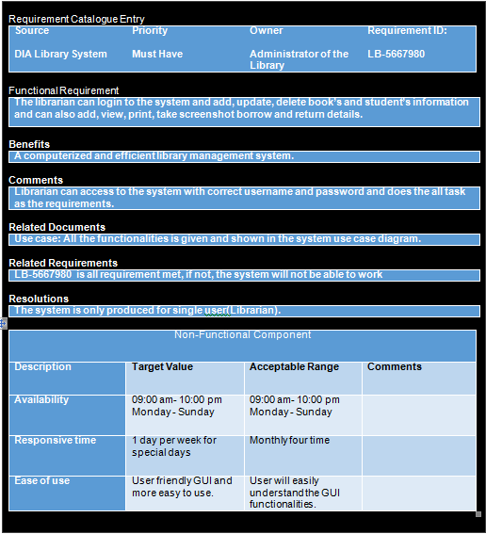

**Figure No.95: Requirement catalogue.**

# Use Case description:

# About use case diagram:

In use case diagram, I have described the main functionalities of the system. It is a methodology of system analysis that described the interaction between the each elements of the system. It identifies, clarify and organize system requirements. A use case diagram contains four components.

1. Actor
2. Use case
3. The relationship between actor and use case.
4. System boundary.

# Explanation of the use case diagram of the system:

In this use case diagram the actor is only librarian. A librarian means the man who actually administrates the library. Only librarian will use this application. So, I have mentioned one actor as librarian. At first, user or librarian has to create his or her personal account for login to this system. Here, librarian can also add, delete, update books and student’s information and can also add borrow and return details and also can print or take screenshot of those details. I have mentioned these functionalities as use cases. The system name is “DIA library system”. So, I have also mentioned “DIA library system” as system boundary.

# 3. Test script

|  |  |  |  |  |
| --- | --- | --- | --- | --- |
| Unit test-1 | | | | |
| Test class-  User | **Designed by: Apurba Debnath** | | | |
| Data source:  User Entry | **Objectives:**  **Test primary functionalities.**  **Unit-1** | | **Tested by: Apurba debnath** | |
| Test case | **Description** | **Task** | **Expected result** | **Actual Result** |
| 1. | **User Registration** | First of all, user need to click on signup button for this then should fill up the all fields and after that user have to click on “Create” button for create new account. | If user filled up the all fields then all the records will save on the database and will show a confirm message whether “fill up the all fields and select your security question” will show as a message. | Record added to database  Successfully. |
|  |  |  |  |  |

|  |  |  |  |  |
| --- | --- | --- | --- | --- |
| Unit test-2 | | | | |
| Test class-  User | **Designed by: Apurba Debnath** | | | |
| Data source:  User Entry | **Objectives:**  **Test primary functionalities.**  **Unit-2** | | **Tested by: Apurba debnath** | |
| Test case | **Description** | **Task** | **Expected result** | **Actual Result** |
| 1. | **User login** | First of all, user need type their specific user name and password in order to login to the system. | If user type the correct username and password and click on “login” button then the user can login to the system otherwise one error message will show as “Incorrect username or password” | If user give correct username and password than the user can login to the system otherwise not. |

|  |  |  |  |  |
| --- | --- | --- | --- | --- |
| Unit test-3 | | | | |
| Test class-  User | **Designed by: Apurba Debnath** | | | |
| Data source:  User Entry | **Objectives:**  **Test primary functionalities.**  **Unit-3** | | **Tested by: Apurba debnath** | |
| Test case | **Description** | **Task** | **Expected result** | **Actual Result** |
| 1. | Retrieve password. | If user forgot password, first of all user need to click on forget password button. After that, he can retrieve that by his username and the answer of the security questions. | If user write the correct username and press on search button than name and security question will automatically retrieve and then user need to give the answer of that question and have to click on “retrieve ” button then the password will retrieve automatically. | Correct password will retrieve for giving correct information. |

|  |  |  |  |  |
| --- | --- | --- | --- | --- |
| Unit test-4 | | | | |
| Test class-  User | Designed by: Apurba Debnath | | | |
| Data source:  User Entry | Objectives:  Test primary functionalities.  Unit-4 | | Tested by: Apurba debnath | |
| Test case | Description | Task | Expected result | Actual Result |
| 4. | Progress bar or loading page is working or not. | After login to the system one progress bar or a loading page will show. | After login on the system on progress bar will show. | Progress bar has showed after login to the system. |

|  |  |  |  |  |
| --- | --- | --- | --- | --- |
| Unit Testing-5 | | | | |
| Test class-  User | **Designed by: Apurba Debnath** | | | |
| Data source:  User Entry | **Objectives:**  **Unit-5**  **(The main functionalities)** | | **Tested by: Apurba debnath** | |
| Test case | **Description** | **Task** | **Expected result** | **Actual Result** |
| 1. | Home Page  testing | After showing progress bar, user will show a home page. Here, user will get many buttons and will show a menu bar and current date and time. | If user comes to the home page then user will show many button for essential works as his requirements and also show current date and time and an option menu bar. Everything will work correctly. | Everything of the home page is working perfectly as the user requirements. |

|  |  |  |  |  |
| --- | --- | --- | --- | --- |
| Unit Testing -6 | | | | |
| Test class-  User | **Designed by: Apurba Debnath** | | | |
| Data source:  User Entry | **Objectives:**  **Unit-6**  **(The main functionalities)** | | **Tested by: Apurba debnath** | |
| Test case | **Description** | **Task** | **Expected result** | **Actual Result** |
| 1. | “New Book” portion testing. | If user will need to add new book or update or delete any book from system database than user will be required to click on “New Book” portion of home page and user will do all the task. | User fills up the all fields and tries to add or update information then system will add or update that information and will provide confirmation message otherwise will provide error message. For update or delete valid book id is required to type otherwise error will occur. | User can add, delete, update book’s information successfully and for update and delete without a valid id error will be occurred. |
| Unit Testing-7 | | | | |
| Test class-  User | **Designed by: Apurba Debnath** | | | |
| Data source:  User Entry | **Objectives:**  **Unit-7**  **(The main functionalities)** | | **Tested by: Apurba debnath** | |
| Test case | **Description** | **Task** | **Expected result** | **Actual Result** |
| 1. | “New Student” portion testing. | If user will try to add new student or update or delete any student from system database than user will be required to click on “New Student” portion of home page and user will do all the task. | User fills up the all fields and tries to add or update information then system will add or update that information and will provide confirmation message otherwise will provide error message. For update or delete, valid student id is required to type otherwise error will occur. | User can add, delete, update student’s information successfully and for update and delete without a valid id error will be occurred. |

|  |  |  |  |  |
| --- | --- | --- | --- | --- |
| Unit Testing-8 | | | | |
| Test class-  User | **Designed by: Apurba Debnath** | | | |
| Data source:  User Entry | **Objectives:**  **Unit-8**  **(The main functionalities)** | | **Tested by: Apurba debnath** | |
| Test case | **Description** | **Task** | **Expected result** | **Actual Result** |
| 1. | “Borrow Book” portion testing. | If user want to add borrow information then   1. Required to search with valid book id or will get error. 2. Required to select 2 dates. | If user do this task perfectly then user can add borrow book for a specific student id otherwise system will give error message. | User can add borrow information for a valid student and book id successfully. |

|  |  |  |  |  |
| --- | --- | --- | --- | --- |
| Unit Testing-9 | | | | |
| Test class-  User | **Designed by: Apurba Debnath** | | | |
| Data source:  User Entry | **Objectives:**  **Unit-9**  **(The main functionalities)** | | **Tested by: Apurba debnath** | |
| Test case | **Description** | **Task** | **Expected result** | **Actual Result** |
| 1. | “Return Book” portion testing. | If user want to add return information then   1. Required to search with valid issue id or will get error. 2. Required to select return date also. | If user do this task perfectly and click on “Return “button then user can add return book for a specific issue id otherwise system will give error message. | User can add return information against a valid issued id successfully. |

|  |  |  |  |  |
| --- | --- | --- | --- | --- |
| Unit Testing-9 | | | | |
| Test class-  User | **Designed by: Apurba Debnath** | | | |
| Data source:  User Entry | **Objectives:**  **Module-2**  **(The main functionalities)** | | **Tested by: Apurba debnath** | |
| Test case | **Description** | **Task** | **Expected result** | **Actual Result** |
| 1. | “Statistic” portion testing. | If user wants to show all return and borrow details information, user will require click on “Statistic” button. | Here, user can show details of return and borrow information and can print that information and also can take screenshot. | User can show all return information and borrow information successfully and can also print that or can take screenshot successfully. |

# User Guide

User Guide!!

*Create New Account for librarian: -*

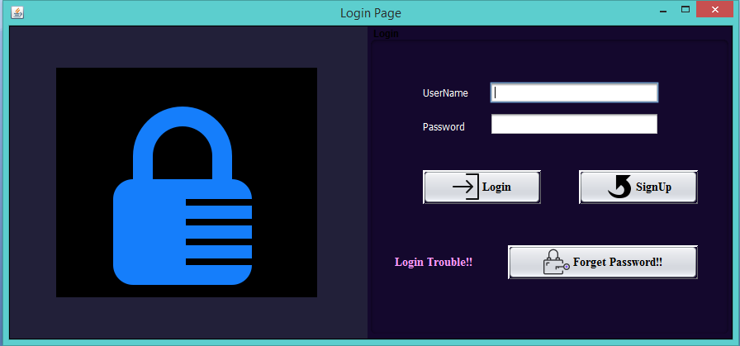

Choose any Username and Fill up all fields …..And then Click Create Button to create new Account…….And must remember your Username, Password and Your Security Question and Answer.

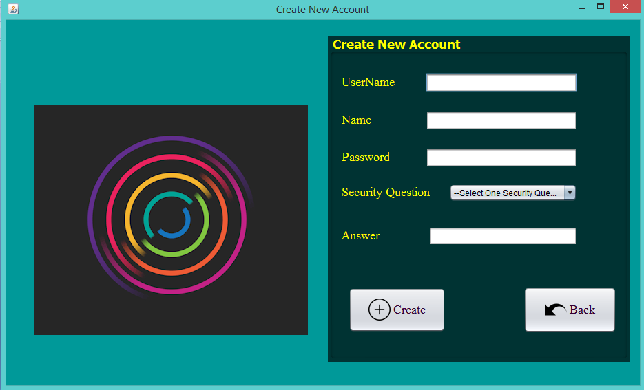

Login Section:

Here, you have to type your correct Username and Password according to your fill up information in the New Account section.



Then Press on”Login” Button….

When you give your correct Username and Password …One Progress Bar will show in order to entering the #DIA Library System…

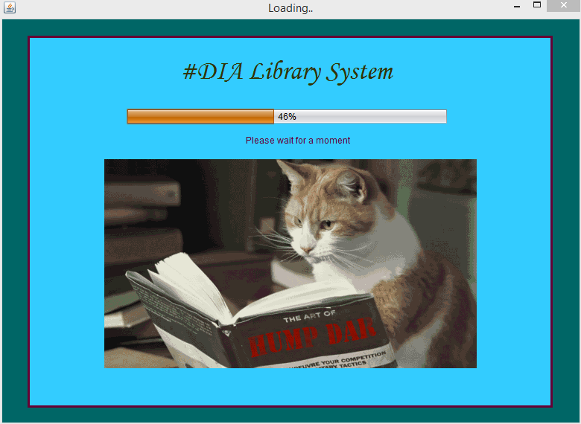

Otherwise, If you will face any problem during Login to the Software or Forget your correct password…….

Then…..Press on ….”Forget Password” Button…..You can retrieve your password……

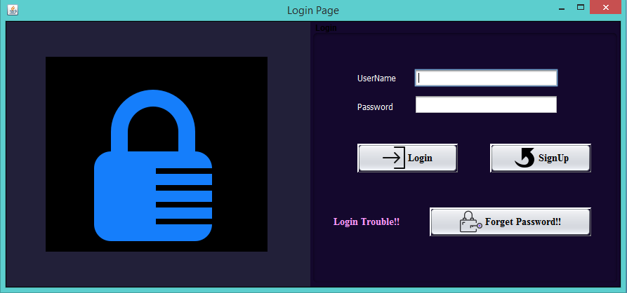

After that, one window will show like it.

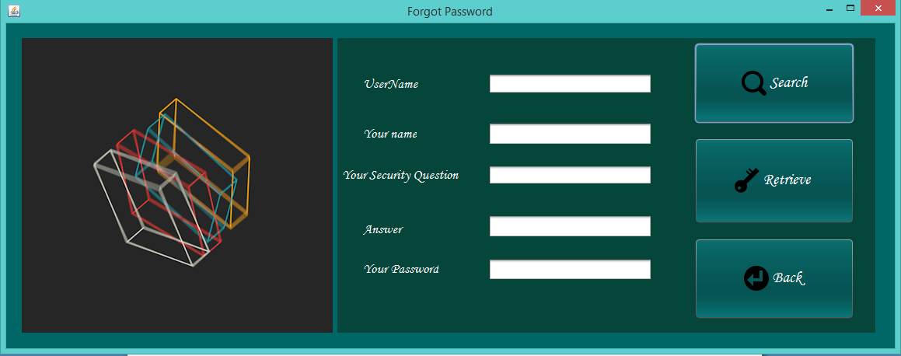

When you type your correct Username and click on Search….

Your Name and Your Security Question will automatically retrieve in those 2 fields….

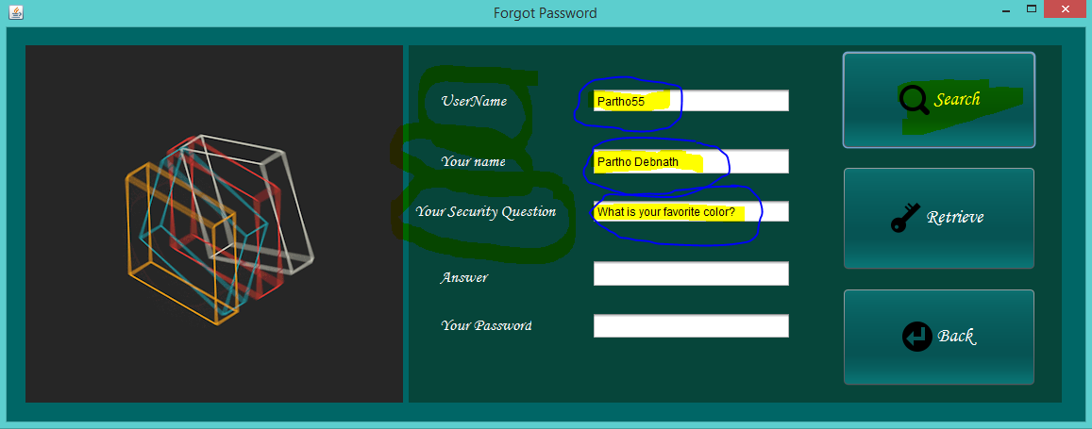

Now, you have to give the correct answer of Your Security Question in the “Answer” field...

And Then Click On “Retrieve” Button…..Your password will retrieve automatically.

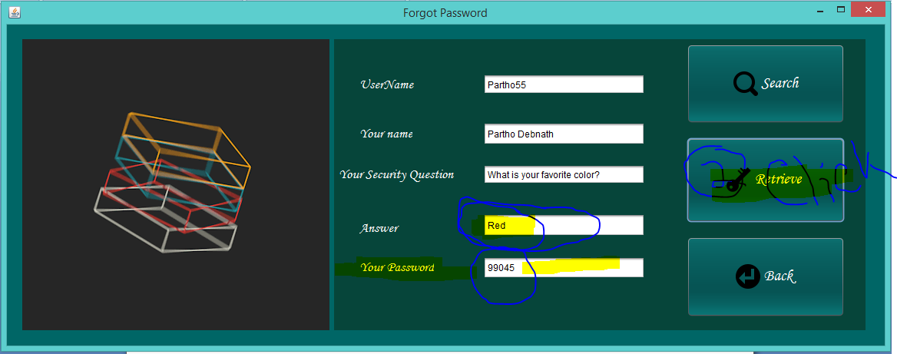

Home Page: Here you find the all requirements of this Software.

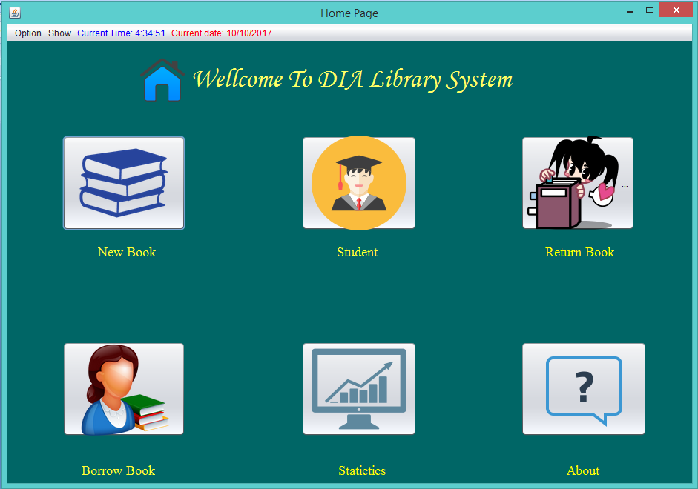



When you click on this button one window will show where you can add, delete and Update information of books.

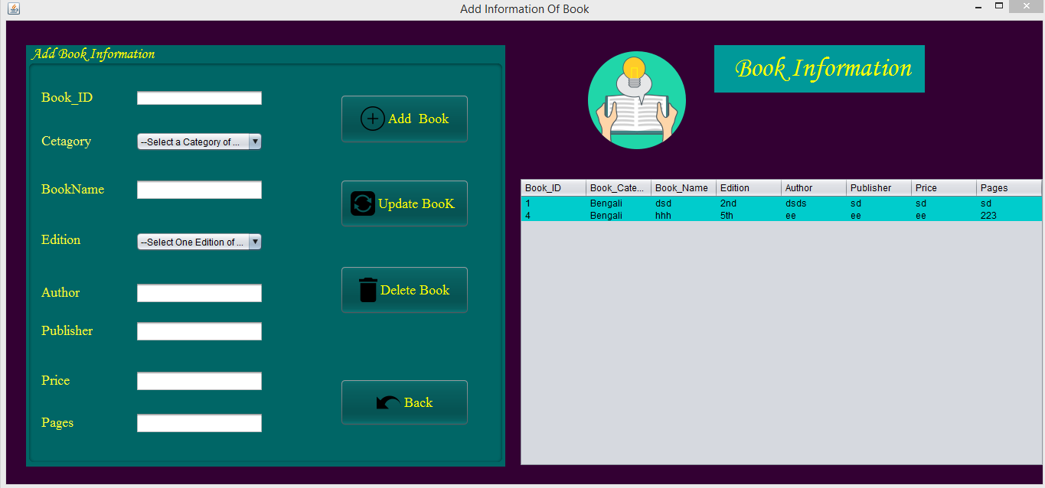

Here, **You will Show all Information**

Click Button

To **Update Book’s**

**Information**

Click Button

To **Add Book’s**

**Information**

Click Button

To **back** to the previous page

Click Button

To **Delete Book’s**

**Information**



Click Here ,

To add new Student’s Information

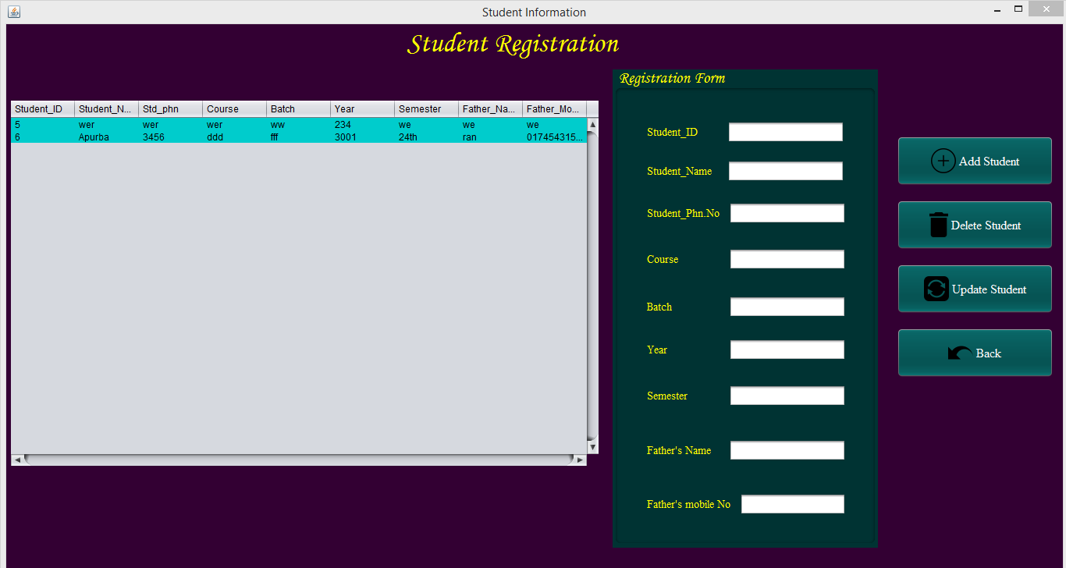

Click Button

To **back** to the

previous page

Click Button

To **Update Student’s**

**Information**

Click Button

To **delete Students’s**

**Information**

Click Button

To **Add Student’s**

**Information**

Here, You have type all information that you want to add

Here, **You will Show all Information**



Click Here ,

To add Borrow Book’s Information

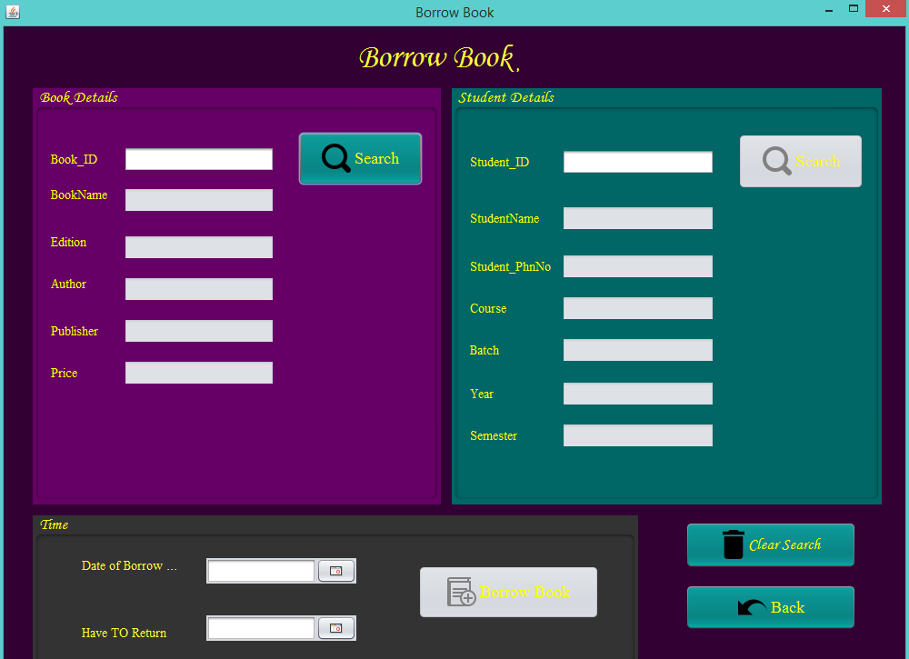

CLICK

Here to Clear all fields

Click Here ,

To find a Book

Click Here ,

To Search a Student

Click Here ,

To add Borrow Book’s Information

Select a Borrow date and A Maximum

Return date from here

Click Here ,

To BacK to the Previous pages

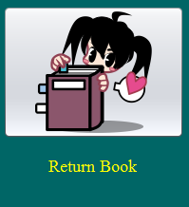

Click Here ,

To add Return

Details

